

Educating for Environmental Change

2022-2023 Annual Report


INDIANA UNIVERSITY

SCHOOL OF EDUCATION
DEPARTMENT OF EARTH AND ATMOSPHERIC SCIENCES
ENVIRONMENTAL RESILIENCE INSTITUTE

Executive Summary
We present this report summarizing our professional development activities in support of the Educating for Environmental Change (EfEC) teacher professional development project. During the 2022-2023 academic year, faculty from Indiana University (IU) planned and facilitated an ambitious series of new programs for the EfEC project. Since 2017, as part of IU’s Grand Challenge “Prepared for Environmental Change” project, EfEC has helped educators overcome barriers to teach the science and policy of environmental change and improve the teaching and learning of environmental education throughout Indiana and beyond.

Over the course of the summer and academic year, the project brought together IU faculty and graduate students from three IU departments (Earth and Atmospheric Sciences, Biology, Physics); four IU schools (College of Arts & Sciences, O’Neill School of Public and Environmental Affairs, School of Education; Luddy School of Informatics, Computing, and Engineering); the WonderLab Museum of Science, Technology, and Health; and local veteran science teachers to co-design, develop, and support a range of professional development workshops for Indiana K-12 teachers.

Central to this year’s program was the development of six new one-day workshops pertaining to a broad array of topics at the intersection of science and public policy. Workshop topics included: (1) geoengineering, (2) environmental justice, (3), climate modeling, (4) fostering optimism through creativity, (5) climate change and human health, and (6) integrating media literacy into instruction. Each of these workshops emphasized data-driven content and research-based pedagogy as well as a combination of field and laboratory investigations designed to foster and engage student-scientists. Each of the full-day Saturday workshops provided the participating educators with classroom-ready supplies and resources as well as stipends and meals.

The participating educators represented school districts throughout Indiana and included elementary, middle, and high school teachers from urban, suburban, and rural school districts from faraway locations such as Clay High School (South Bend, IN) and local school districts such as Monroe County Community Schools (Bloomington, IN). Participants also included educators from informal learning environments such as the Children’s Museum of Indianapolis and the WonderLab Museum of Science, Health, and Technology.

In addition to the six one-day workshops, IU faculty also facilitated four “First Tuesday” events for teachers. EfEC First Tuesday events were designed to be shorter, more informal evening science-education programs focused on scientific topics pertaining to environmental change. To better accommodate participating teachers’ schedules, two of these workshops were held virtually and two were held in-person. Topics of the First Tuesday programs included: (1) the pandemic, natural disasters, and the teachable moment; (2) biodiversity loss; (3) the future of nuclear power; and (4) rivers and environmental change.

Note: This report summarizes each of the 2022-2023 EfEC academic year programs as well as findings from the teacher professional development workshop evaluations and includes information about the EfEC Summer Science Institute, held June 19-23, 2023. It does not include, however, evaluation data from the summer science Institute as those data are still being analyzed.
Introduction
Educating for Environmental Change (EfEC) is a professional development program aimed at helping K-12 educators overcome barriers to teach the science and policy of environmental change. The program is led by faculty from the IU School of Education, in partnership with four IU science departments, the IU Environmental Resilience Institute, and WonderLab Museum of Science, Technology, and Health, together with local veteran science teachers. EfEC workshops emphasize data-driven content and research-based pedagogy as well as a combination of field and laboratory investigations designed to foster and engage student-scientists. Workshop topics include a broad array of critical issues at the intersection of science and public policy including climate change, natural disasters, environmental justice, and geoengineering. In 2020, EfEC was awarded the Indiana Governor's Award for Environmental Education and Outreach.

This project is designed to address a major gap in environmental education. Indiana’s teachers contend with multiple barriers to effectively teach their students about climate change and its causes, including a lack of training in climate science, misinformation in the media, local and state resistance, and a dearth of grade-appropriate resources. Although 72% of Hoosiers agree that our schools should teach the causes, consequences, and potential solutions of climate change, finding the right mix of information and activities that can fit neatly into existing Indiana education standards (which are among the weakest in the nation on climate education) can be extraordinarily challenging for teachers. Our proposal builds on six years’ track record leading environmental education programs for K-12 teachers across Indiana and surrounding states. This program has enabled us to build a vibrant learning community of educators interested in bringing dynamic, interdisciplinary education about the environment to Hoosier students.

The project is led by Dr. J. Adam Scribner, Director of STEM Education Initiatives, IU School of Education, and Dr. Michael Hamburger, Professor of Geophysics, Department of Earth & Atmospheric Sciences. Utilizing activities co-designed by IU environmental scientists and local veteran science teachers, EfEC helps elucidate and deepen educator understanding of key concepts related to environmental change including the causes, impacts, and steps to mitigate the severity of climate change. EfEC offers intensive multi-day summer science Institutes and one-day academic-year programs on specific topics related to environmental change. Since 2017, we have led twelve professional development workshops with more than 325 teachers, who have gone on to reach an estimated 30,000+ students.

The program was funded initially through internal funding from the IU Office of the Vice President for Research, in collaboration with participating IU Schools. Starting in 2020-21, the program has relied in part on external funding from local foundations. Our expansion from summer workshops to academic year programming was supported by a grant from the Brabson Family Foundation. The current year’s academic-year and summer programs were supported by generous grants from two anonymous foundations, with matching funds from IU’s Center for Rural Engagement.

We present here results from three interconnected programs: our six academic-year workshops, our four “First Tuesdays” continuing education seminars for teachers, and our 2023 summer science institute.

Academic-Year Workshops
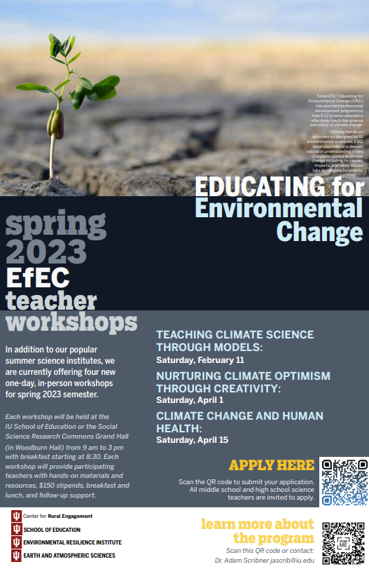
During the 2022-2023 academic year, with support from our funding partners, faculty from Indiana University conducted a series of six one-day Educating for Environmental Change workshops. The workshops are intended to complement and expand our professional development offerings by providing in-depth content on particular aspects of climate science and policy that may be of interest to teachers who participated in one of our summer workshops. They also may be relevant to particular disciplines—or in some cases interdisciplinary topics—that are of special interest to individual teachers. They are conducted on Saturdays during the academic year, typically from 9 AM – 3 PM, with breakfast and lunch (and a stipend) offered to participating teachers.
Sample workshop recruitment poster

The workshops often count toward professional development credit hours required by many school districts. Teachers are provided with textbooks, curricular materials, lab supplies, and new ideas that they can bring back to their classrooms. In addition to the K-12 in-service teacher participants, many of our workshops included future teachers—graduate students and pre-service teachers from the IU School of Education.

The workshops were organized and introduced by Dr. Adam Scribner, Director of STEM Education Initiatives, and conducted with support from the IU School of Education staff. The workshops typically included 17-22 teacher participants and were led by 1-3 faculty and students from other IU departments and schools.

Table 1. Summary of 2022-23 EfEC Academic-year Workshops
Workshop Date | Workshop Title | Number of Participants | IU Faculty Lead, Affiliation
October 29, 2022 | Geoengineering | 19 | Dr. Ben Kravitz and Dr. Paul Goddard, Earth and Atmospheric Sciences
December 10, 2022 | Environmental Justice | 20 | Dr. David Konisky, Dr. Deidra Miniard, O’Neill School of Public and Environmental Affairs
February 11, 2023 | Teaching Climate Science Through Models | 13* | Dr. Paul Staten, Earth and Atmospheric Sciences
April 1, 2023 | A Time for Hope – Nurturing Climate Optimism Through  Creativity | 17 | Dr. Kirstin Milks, Monroe County Community School Corporation  Dr. J. Adam Scribner, IU School of Education
April 15, 2023 | Climate Change and Human Health | 21 | Dr. Gabriel Filippelli, IUPUI Professor of Earth Science; Executive Director, IU Environmental Resilience Institute  Dr. Dana Habeeb, IU School of Informatics
April 29, 2023 | Science, Critical Thinking, and Disinformation Integrating Media Literacy into Instruction | 20 | Chris Sperry, Ithaca College, Lead, Project Look Sharp
*Note: tornadoes the night before the workshop prevented some participants from coming
Participant Recruitment
Teachers were recruited for the academic-year workshops using science education and environmental education email listservs including the Environmental Education Association of Indiana (EEAI) and the Hoosier Association of Science Teachers, Incorporated (HASTI) listservs. We also recruited teachers by presenting EfEC at the National Science Teachers Association (NSTA) and HASTI conferences (held in Atlanta, GA and Indianapolis, IN, respectively) the Indiana Sustainability Summit (Indianapolis), and the IU Bloomington and IU School of Education social media accounts. Recruitment posters, flyers, and postcards were created and hung in different IU departments across campus (see the sample recruitment flyer above). Workshop information was posted to the EfEC webpage, hosted by the IU School of Education, with links to electronic sign-up forms.

Recruitment priority was given to teams of K-12 science teachers from the same school district, with an emphasis on at-risk schools with underserved minority and low-income students. Our connection with IU’s Holland Summer Science enrichment programs, directed toward underrepresented minorities in STEM disciplines, helped with recruitment from predominantly minority school districts in Indianapolis and South Bend.

Workshop Descriptions and Photos

Workshop One: Geoengineering
This Climate Engineering Teaching Module consists of five complete lessons with engineering activities, co-designed by IU climate scientists and veteran science teachers, that encourage creative technological designs to slow global warming, including in-class experimentation demonstrating the potential cooling effect resulting from brightening marine clouds. The hands-on activities will be supplemented with knowledge about current climate engineering research and how it may help limit the negative impacts of climate change. Each lesson aligns with Indiana state science standards and the Next Generation Science Standards. This workshop is ideal for middle- and high-school science teachers who already teach climate change topics or who have already attended the EfEC summer science institute.

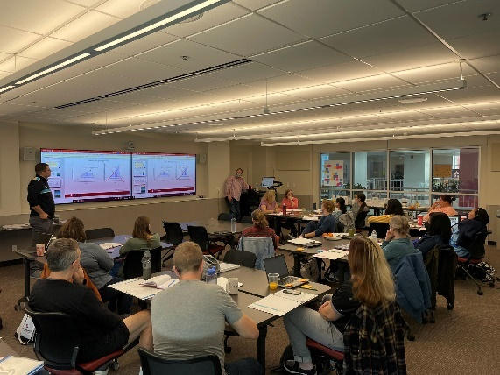
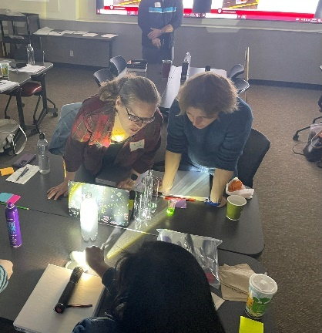

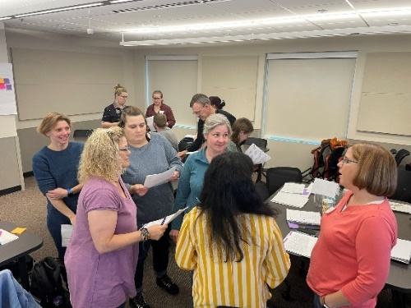
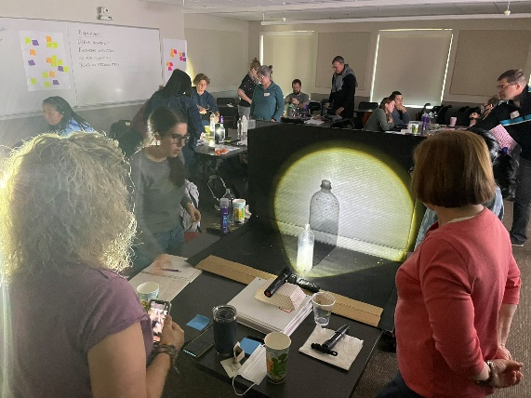

Figure 1. Images from the October 29 Geoengineering workshop. Dr. Paul Goddard (upper left) presents introductory material to workshop participants, while much of the workshop time was devoted to hands-on and collaborative activities.

Workshop Two: Climate Justice
This workshop builds on the successes of previous EfEC workshops by incorporating social dimensions of climate change and environmental concerns. This module will help teachers explore how racial and social inequality is related to climate change, environmental harms, and the energy system. This workshop is ideal for middle and high school science educators.

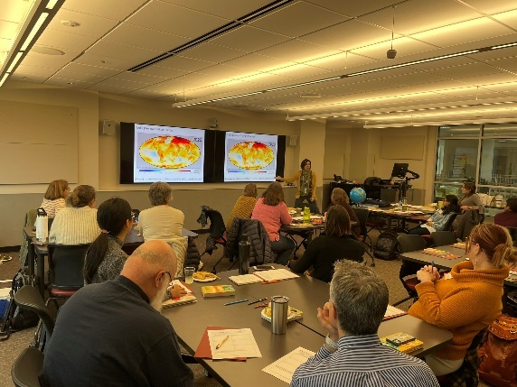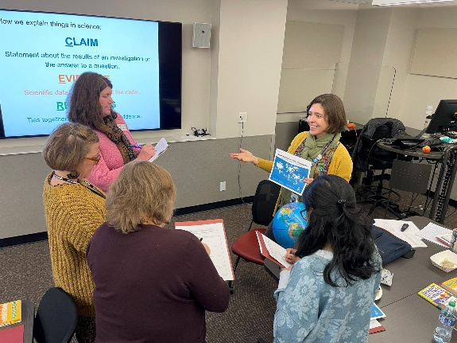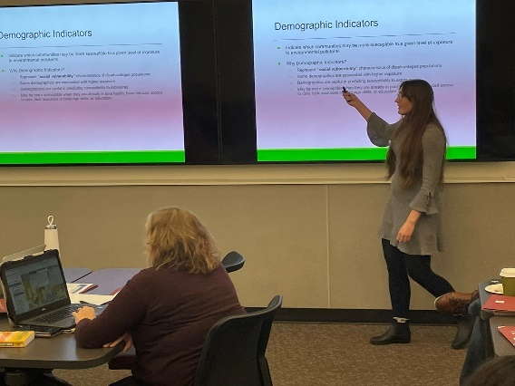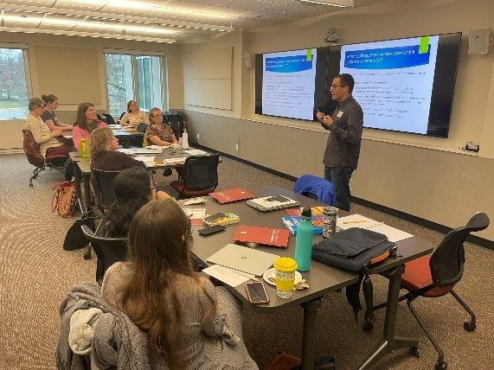
Figure 2. Images from the December 10 environmental justice workshop. The program was led by Dr. David Konisky (lower right) with hands-on activities led by Dr. Diedra Miniard (lower left) and Dr. Kirstin Milks (upper photos).

Workshop Three: Teaching Climate Science through Models
Indiana’s new science standards emphasize the use of models by students. Climate scientists use climate models and supercomputers to understand our changing climate, and to make projections about our future. But what climate models can students use?

This workshop will introduce teachers to a collection of models that can be used to teach students about climate processes and how humans are causing climate change. These models can be accessed from any connected computer or smartphone, and teach students that a model does not need to be complicated to be powerful, and all models – from the simple to the complex – have strengths and limitations. Teams of middle and high-school science teachers are encouraged to apply, but all educators who have an interest in the topic are welcome.

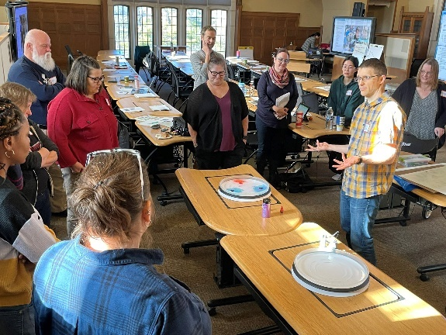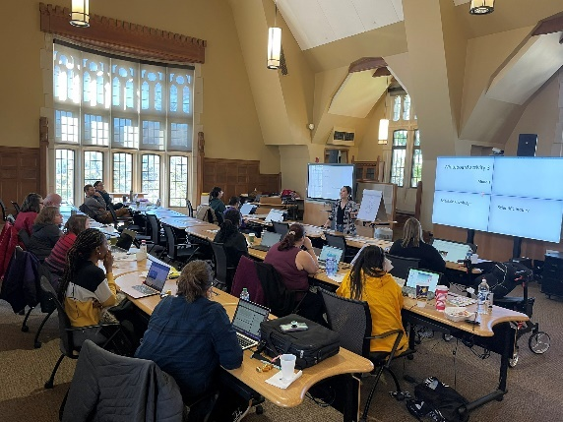
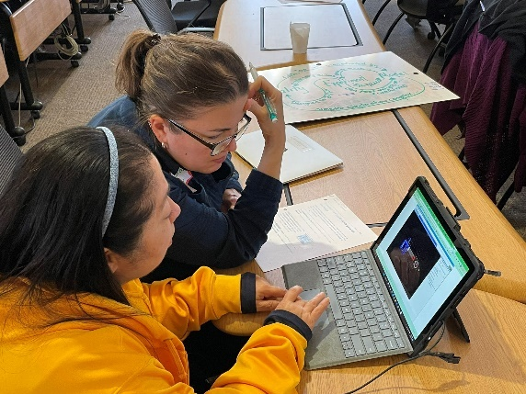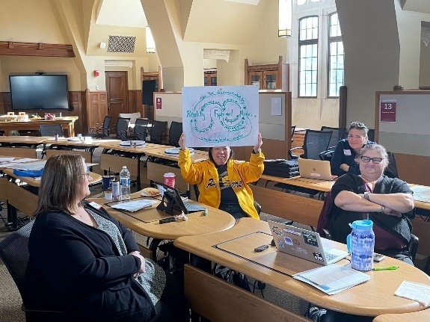
Figure 3. Images from the February 11 climate modeling workshop. The program was led by Dr. Paul Staten (upper left) with hands-on and computer modeling activities.

Workshop Four: A Time for Hope: Fostering Climate Optimism through Creativity
How can we help students and teachers build climate resilience by problem-solving for a better world? Join Dr. Kirstin Milks for exemplar lessons that harness the healing power of cutting-edge climate science by having students dream up sci-fi worlds of the future -- and how humans in those worlds can not only survive but collaborate to thrive!

This interdisciplinary workshop is designed to foster student interest in climate science, politics, economics, and culture by bringing standards-aligned science lessons and play-informed activities, plus a renewed sense of hope and purpose, to your classroom. Teams of elementary and middle-school teachers from many disciplines (ELA, art, social studies, and science) are encouraged to apply, but all educators who have an interest in the topic are welcome.

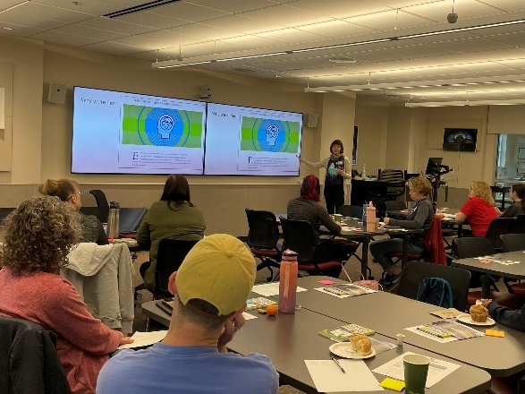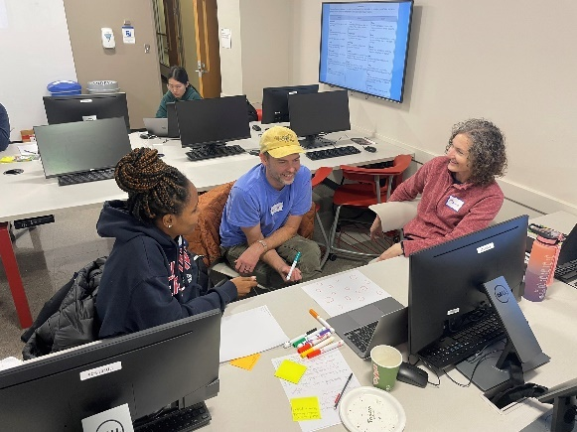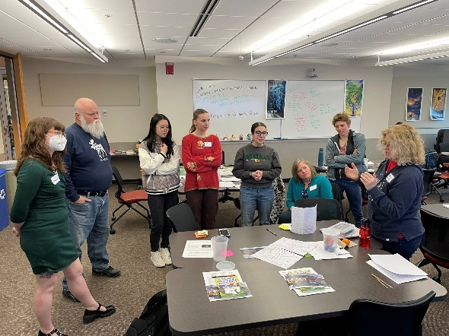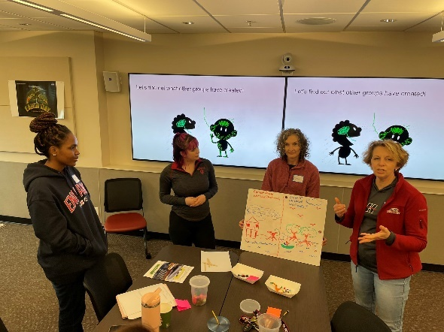
Figure 4. Images from the April 1 climate optimism workshop. The program was led by Dr. Kirstin Milks (upper left) but focused on hands-on activities and interactive discussions with participants.

Workshop Five: Climate Change and Human Health
From extended heat waves to flooding to drought, climate change is already impacting the lives and livelihoods of Hoosiers. And climate change is increasingly a priority of health-care professionals and the medical training community as people are suffering from pulmonary and heart disease as well as stress and mental health issues. This workshop will focus on what we can do to mitigate those human health impacts by discussing the science behind them, the ways that local and regional planning impact environmental and personal health, and the educational tools that can be developed to frame the key challenges. Led by Dr. Gabriel Filippelli and Dr. Dana Habeeb.

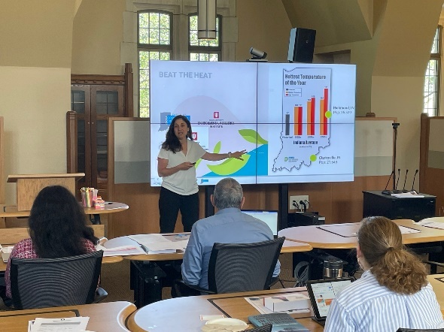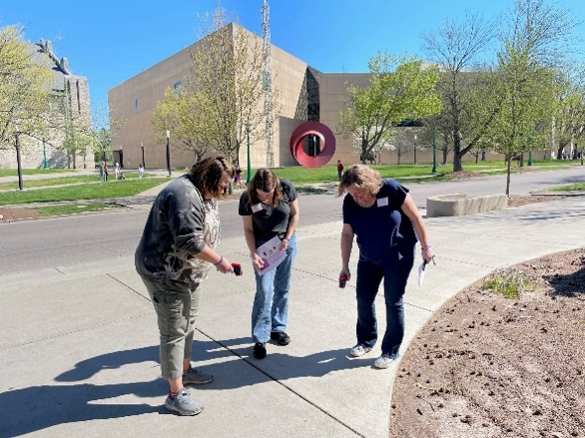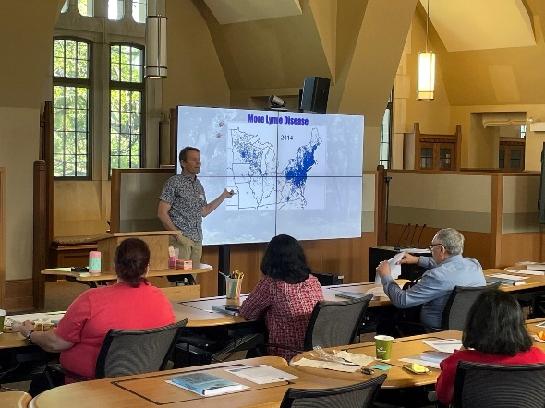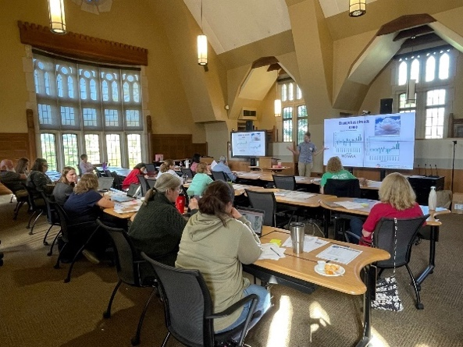
Figure 5. Images from the April 15 Climate Change and Human Health workshop. The program was conducted at IU’s Social Science Research Commons, and led by Dr. Gabe Filippelli (left image).

Workshop Textbook
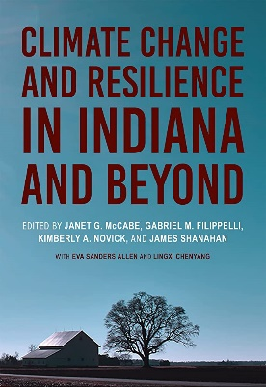
A new book from Indiana University Press and the Environmental Resilience Institute shines a spotlight on the potentially devastating long-term impacts of climate change in Indiana and what Hoosiers can do to create resilient, equitable communities. Climate Change and Resilience in Indiana and Beyond gives readers a detailed roadmap for how policymakers, community leaders, and engaged Indiana residents can interpret and navigate the stresses posed by environmental change to the state’s economy and health, while also protecting the natural resources and systems Hoosiers depend on. Forty-six researchers contributed to the book, sharing their expertise on climate, water, energy, natural systems, and more.
Workshop Six: Science, Critical Thinking, and Disinformation, Integrating Media Literacy into Instruction

How can we engage our students in developing the habits of thinking needed for our hypermediated, “post-truth” world – while addressing our core science content and standards? Award-winning teacher and media literacy trainer, Chris Sperry, will lead this interactive workshop that will give educators the pedagogy, models, and practical resources for integrating curriculum driven, inquiry-based media analysis into the secondary science curriculum. We will focus on climate change and other potentially polarizing topics using an approach that teachers well-reasoned discernment of the science and metacognition about student’s own confirmation biases.

About the Facilitator: Chris Sperry is the Director of Curriculum and Staff Development for Project Look Sharp, a media literacy initiative at Ithaca College that he co- founded in 1996. He has over 40 years of experience as a 6-12 teacher and instruction coach He is the co-author and producer of over 500 media literacy lessons that integrate media decoding and critical thinking into the curriculum including over 100 for secondary science. He is co-author with Cyndy Scheibe of the book Teaching Students to Decode the World: Media Literacy and Critical Thinking Across the Curriculum, ACSD Jan 2022.
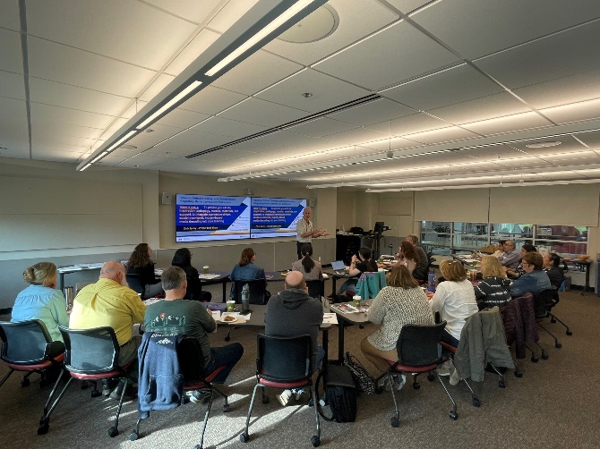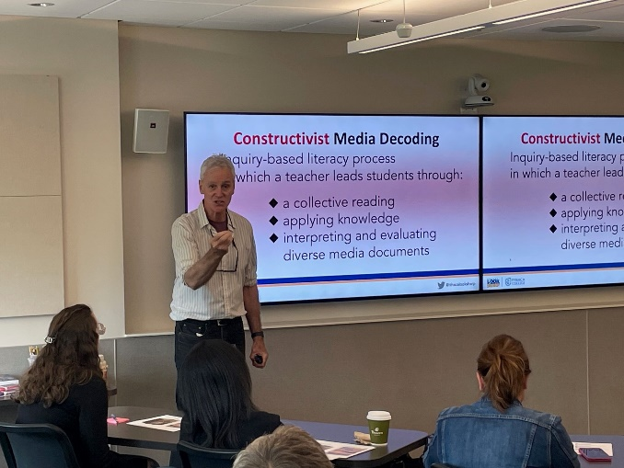
Figure 6. Images of Chris Sperry from Project Look Sharp leading teachers through exercises aimed at helping their students recognize disinformation and think critically.

Workshop Evaluations
We view rigorous assessment as a critical component of all our workshops. At the end of each workshop, we conduct quantitative and qualitative reviews of the content and process. In turn, we integrate this feedback into revision and planning for future workshops. Examples of workshop feedback are presented here. More complete assessments are planned as part of academic publications on the impact of our professional development programs.
Teacher Workshop Evaluations
At the end of each of the academic-year workshops, participants completed evaluations. The evaluations provided information about teacher perceptions of the workshop as well as the appropriateness, utility, and transferability of specific activities within the workshops into each educators’ specific disciplines of teaching. This report summarizes the findings from the evaluations and compares them where appropriate.
Respondent Information
For the five workshops completed at the time this report was generated, educator post-workshop evaluations were completed by a total of 92 educators. Details on participation in individual workshops are shown in Table 1. The educators represented elementary, middle, and high schools from urban, suburban, and rural school districts from locations throughout the state of Indiana - including faraway districts such as Clay High School (South Bend, IN) and local districts such as Monroe County Community Schools (Bloomington, IN). Participants also included educators from informal learning environments such as the Children’s Museum of Indianapolis and the WonderLab Museum of Science, Health, and Technology. Note: IU faculty and graduate students were also invited to attend, but they did not complete workshop evaluations.

Summary of Findings
Respondent Information
The post-workshop evaluation was completed by 92 participants who participated in six EfEC workshops (note: some of the teachers had to leave the workshops early and did not complete the evaluations). Of them, 56 identified as high school (grades 9-12) teachers (60.87%), 14 identified as middle school (grades 6-8) teachers (15.22%), and 9 identified as elementary (grades 3-5) teachers (9.78%). The other respondents were composed of university students (masters or PhD students) and other informal educators including educators from the Children’s Museum of Indianapolis and the WonderLab Museum of Science, Health, and Technology.

Workshop Evaluation Responses
Respondents were asked to indicate their overall rating of the professional development workshop using a 5-point scale (1 = poor, 2 = good, 3 = good, 4 = very good, 5 = excellent). Overall responses for the program are reported below:
- 92% (85 of the 92) of the participating teachers rated their training as excellent, 8% (7 of the 92) rated their training as very good. No respondents rated their training as good, fair, or poor.

The workshop evaluations also asked respondents to rate their level of agreement (1= strongly disagree, 2 = disagree, 3 = neither agree or disagree, 4 = agree, 5 = strongly agree) with four evaluative statements. Overall responses for the program are reported with their mean in Figure 6:
Figure 6. Summary of Assessment scores from all six academic-year workshops.

Workshop Evaluation Qualitative Feedback
On the post-evaluation survey, the participant teachers were asked to explain what aspects of the workshop they found most valuable. The responses were coded and grouped into the following themes. Those are presented below along with sample comments from the respondents.
- Exemplar classroom activities and resources
  - Activities that allow students to explain concepts help me see how I can apply them.
  - I loved the activities for children to collect data and experience the scientific process.
  - I loved the computer simulations and graphs.
  - I enjoyed my first time learning about climate justice and how scientists are working on explaining facts and showing evidence in personal and positive ways.
- Curricular connections
  - The hands-on activities and simulations were inspiring.
  - The prepared lab resources, also real-life practice, were most valuable.
  - The engineering design lessons will help with developing my students’ own ideas about ways to combat climate change!
  - I can connect environmental justice with climate change and UN sustainable development goals.
- Pedagogical strategies
  - Good structure always helps.
  - I now have more methods to approach existing topics in my class, such as race and justice.
  - I can set up labs for kids to actually see what we’re talking about.
  - I can use models to start open-ended questioning.
  - I am thinking about using sample decoding questions to establish clear objectives for discussions and give students more ownership by asking inquiry Questions.

On the post-workshop survey, participants were asked to explain how they intend to use the information, resources, and activities from this workshop when they return to the classroom. Again, all 92 teachers addressed this request. Some of the teachers explained several ways they would use the products of the workshops. The responses were coded and grouped into the following themes. They are presented below along with sample comments from the respondents.
- Implement activities/lessons/concepts
  - I will modify the aforementioned lessons for middle-school level.
  - I will use the station rotation activities with little/no modification and adapt them to my new advanced placement earth science chemistry lessons.
  - I will use the urban heat island lesson and discuss human health effects of climate change.
  - I will implement the air quality lesson. Also, the labs on respiratory diseases are great addition.
- Curriculum development
  - I will implement this into a future engineering or Earth Day events or maybe create a field trip program for MS/HS and definitely will do the cloud in a bottle activity as a pubic program.
  - I plan to design a similar module for environmental health for schoolteachers.
  - I can use this in the Girl Scouts’ climate change unit.
  - I have already decided to include two models into my syllabus page for reviewing fractions next week.
- Share information with peers
  - I will share with my educator groups and help my local community in any way I can.
  - I will share the C-Roads simulation and air quality information with other teachers at my school.
Lastly, on the post-workshop survey, the participant teachers were asked if they have any additional comments. A sample of their comments are below:
  - Well-organized and thoughtful!
  - I will reattend for sure!
  - Thanks for the books (I love getting books!).
  - My idea of models and modeling has changed!
  - I enjoyed the workshop, thanks you! It was very informative, a lot of resource and good structure.
  - Thank you for shining a little bit of positive light on climate change!
“Once again, I am leaving an EfEC workshop with curriculum materials, equipment, and connections that I will actually use in my classroom. Thank you very much!”
Martha Bowman, Middle School Science Teacher, 2023
First Tuesday Events
Overview
Our First Tuesday workshops were a new innovation in this year’s programming, allowing K-12 teachers to augment their knowledge about specific environmental issues in an informal setting, with a low barrier for participation. In order to maximize flexibility for teacher participation, we alternated between in-person and online seminars. The in-person events were held at the Irish Lion pub in Bloomington, setting an informal and welcoming atmosphere for audience participation. We plan to continue these events in subsequent academic years.

Table 2. Summary of First Tuesday Events
First Tuesday Date | Program Title | Event Format | Number of Participants | IU Faculty Lead, IU Department or School
November 1, 2022 | The Pandemic, Natural Disasters, and the Teachable Moment | Online | 17 | Dr. Michael Hamburger, Earth & Atmospheric Sciences
December 6, 2022 | Three Billion Missing Birds, What Can We Do? | In-person | 18 | Dr. Ellen Ketterson, Biology
February 7, 2023 | The Future of Nuclear Energy | In-person | 24 | Dr. Tim Londergan and Dr. Steven Vigdor, Physics
March 7, 2023 | Take Me to the River – Researching River Flood Plains | Online | 15 | Dr. Eric Barefoot, Earth & Atmospheric Sciences

Event Descriptions and Photos
First Tuesday Event One: The Pandemic, Natural Disasters, and the Teachable Moment
Dr. Michael Hamburger, Professor, Earth and Atmospheric Sciences at Indiana University will present “The Pandemic, Natural Disasters, and the Teachable Moment”. This program will help teachers turn recent disasters -- whether in our city or a thousand miles away – into meaningful classroom discussions for our students. The program’s driving questions are how can we be prepared, as teachers, to discuss these recent events, to share the science behind them, and to use these events to connect our students to the science that we study?

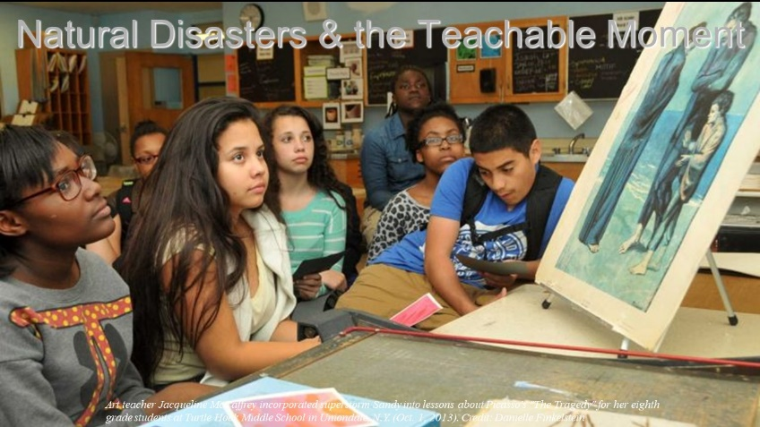

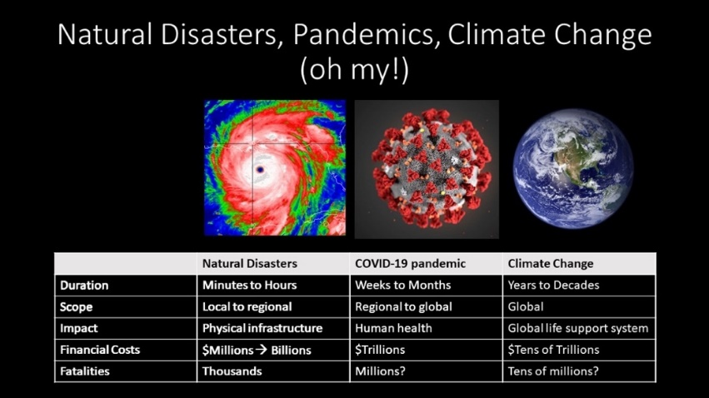
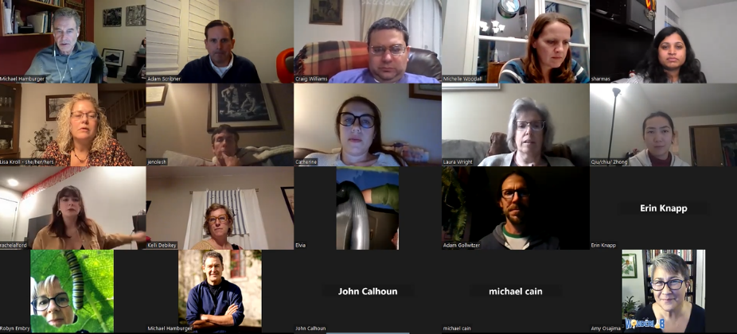

First Tuesday Event Two: Three Billion Missing Birds: What Can We Do?
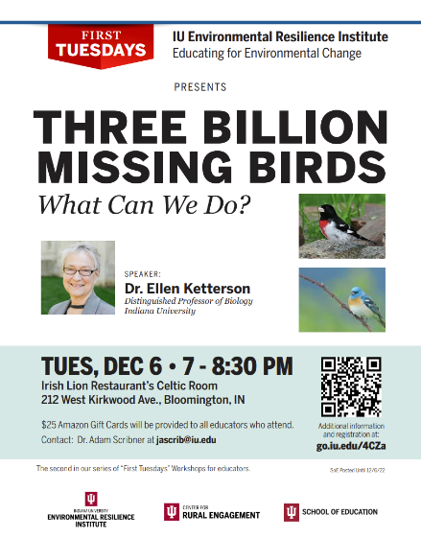
Dr. Ellen Ketterson and researcher Sarah Wanamaker will share their knowledge of the extent of the decline in bird populations in North America and globally over the past 50 years including the causes of the decline and information on what individuals can do to help. They will also share tools for students and adults to identify birds by sound and sight.
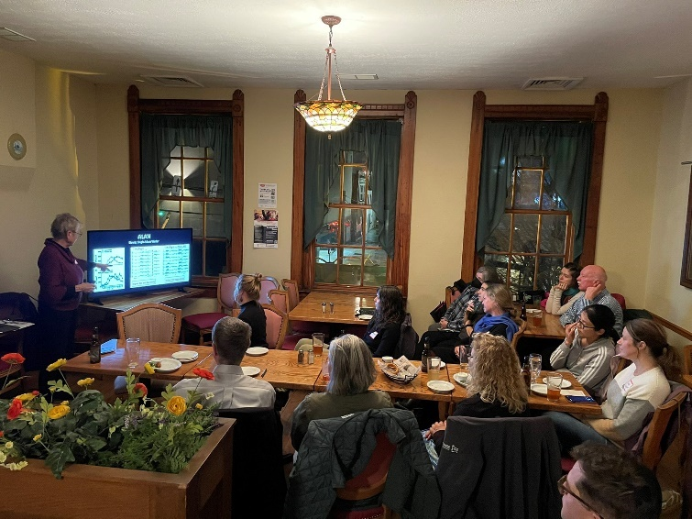
Sample recruitment flyer

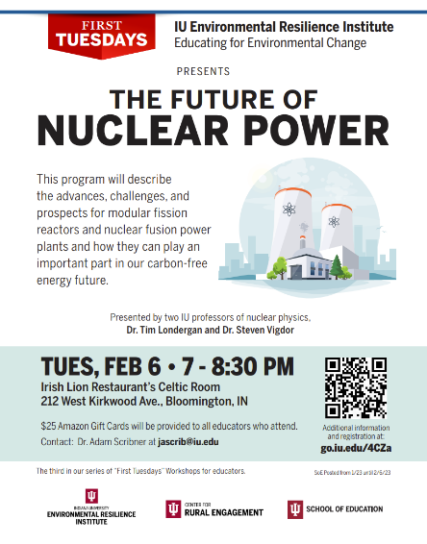
First Tuesday Event Three: The Future of Nuclear Power
Two professors of nuclear physics, Dr. Tim Londergan and Dr. Steven Vigdor, will present “the future of nuclear power”. Nuclear power is one among several alternatives for carbon-free energy production to address global climate change. There are two basic types of nuclear power, utilizing the fission of heavy nuclei or the fusion of very light nuclei. Past serious accidents at fission reactor plants and the daunting engineering problems facing attempts to harness thermonuclear fusion in power plants have led to great public skepticism about the future role of nuclear power. However, renewed interest in the design of small modular fission reactors and recent technical breakthroughs in achieving fusion energy have spawned a new nuclear industry featuring many start-up commercial companies. This program will describe the advances, challenges, and prospects for modular fission reactors and nuclear fusion power plants and how they can play an
Sample recruitment flyer
important part in our carbon-free energy future.

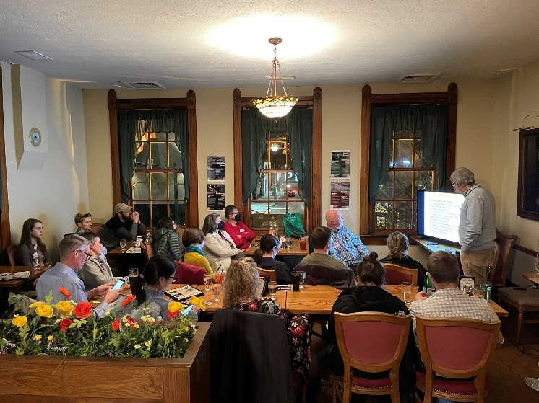

First Tuesday Event Four: Take Me to the River: Researching River Flood Plains
River floodplains and deltas are some of the most dynamic surface environments on Earth. However, because these landscapes are flat, it is difficult to perceive with the naked eye how fast they change over time, and how they are responding to a warming climate. Dr. Eric Barefoot will showcase some of the techniques geologists use to measure the impact of changing climate on these sensitive landscapes. The methods range from the high-tech (lasers mounted on satellites and drones), to the extremely low-tech (shovels and sticks). By combining different methods, we will see how seemingly flat, quiet marshlands transform in slow-motion, sometimes with disastrous outcomes.

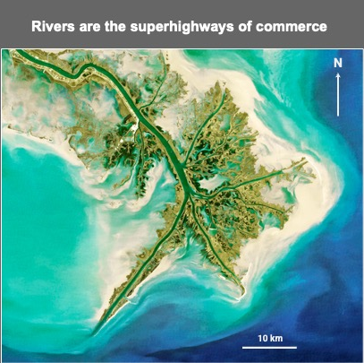
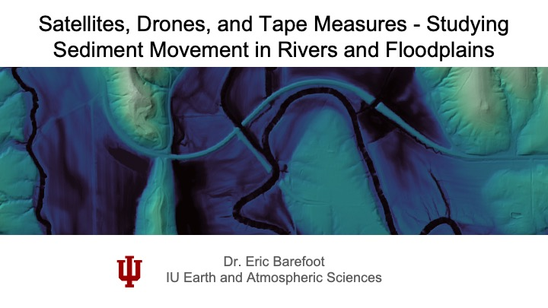

2023 Summer Science Institute
As in past years, this summer we conducted an intensive summer science Institute for middle and high school K-12 teachers on the IU Bloomington campus. Due to a combination of increased teacher demand and steadily growing curricular content, we significantly modified this summer's institute and expanded it from a three-days to a five-day residential workshop, June 19-23, 2023. We had a full cohort of 23 middle- and high-school teachers who stayed on campus for the duration of the program. A recruitment flyer and agenda for the workshop are below. Day one of the workshop focused on how we know the climate is changing, day two focused on what are the impacts of those changes, and day three focused on how we can best mitigate against the problems caused by climate change. The expansion to a full-week workshop allowed us to incorporate a fourth day of field-related activities at the IU Griffy Woods Research and Teaching Preserve as well as a fifth day that included time to discuss how we can cultivate optimism in our students and time for teachers to reflect on their learning. IU faculty leads are listed in Table 3. along with photos from the program. The summer science Institute also included evening programming at the IU Media School, WonderLab Museum of Science, Health, and Technology, and IU School of Education Make, Innovate, Learn Lab (MILL) Makerspace.

Sample recruitment flyer
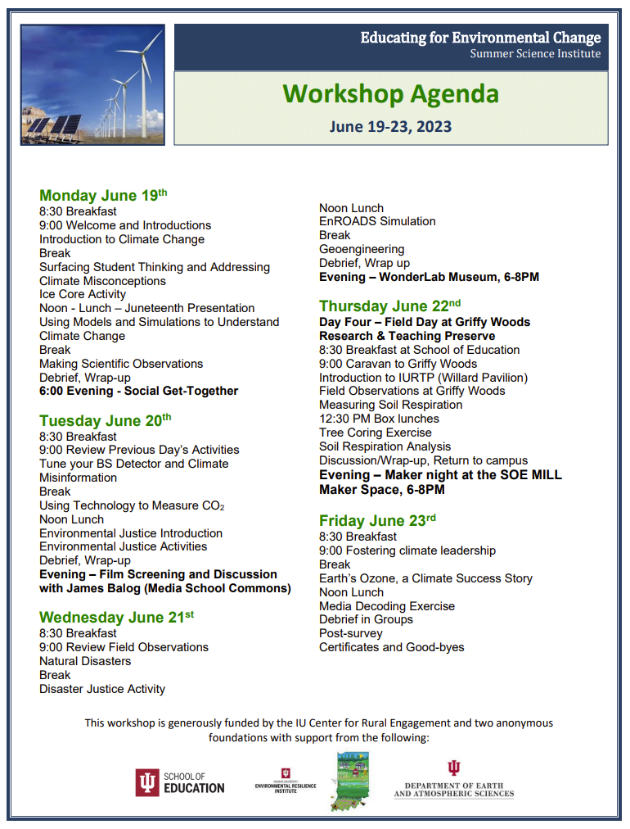

Agenda for the 2023 Summer Science Institute

Table 3. Indiana University Summer Science Institute Faculty participants
Name | IU Department | Disciplinary Focus | Presentation Topic(s)
Dr. Daniel Beverly | O'Neill School of Public and Environmental Affairs | Geochemical Cycling | Using Technology to Measure Greenhouse Gases
Dr. Andrea Goddard | Earth & Atmospheric Sciences | Geology | Making Field Observations
Dr. Paul Goddard | Earth & Atmospheric Sciences | Atmospheric Sciences | Geoengineering
Dr. Michael Hamburger | Earth & Atmospheric Sciences | Geophysics | Natural Disasters and Climate Change; Disaster Justice; Geoscience Field Observations
Dr. Cody Kirkpatrick | Earth & Atmospheric Sciences | Natural Disasters | Natural Disasters
Dr. David Konisky | O'Neill School of Public and Environmental Affairs | Environmental Justice | Environmental Justice
Dr. Ben Kravitz | Earth & Atmospheric Sciences | Atmospheric Sciences | Climate Change; Geoengineering
Dr. Tim Londergan | Physics | Nuclear Physics | Addressing Scientific Misconceptions; Earth's Ozone, A Climate Success Story
Dr. Sarah Mincey | Environmental Resilience Institute | Ecology and Conservation | Collective Action
Dr. Richard Phillips | Biology | Geochemical Cycling | Soil Respiration
Dr. J. Adam Scribner | School of Education | STEM and Science Education | Introducing the Topic of Climate Change; Surfacing Student Thinking; Using Model ice cores in the classroom; Integrating the EnROADS Simulation
Dr. Steven Vigdor | Physics | Nuclear Physics | Addressing Scientific Misconceptions

Summer Science Institute Photos

Summer Science Institute Day One

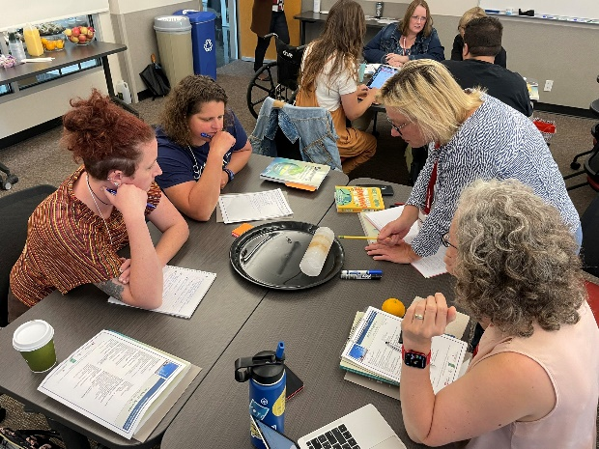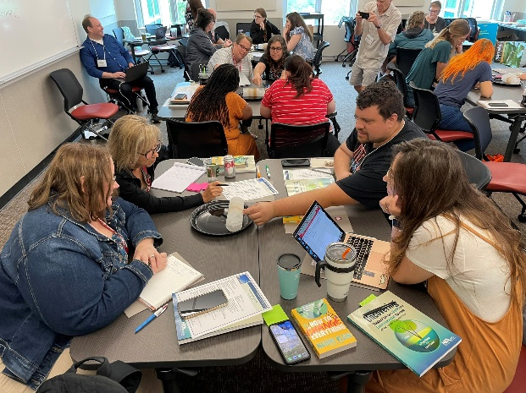

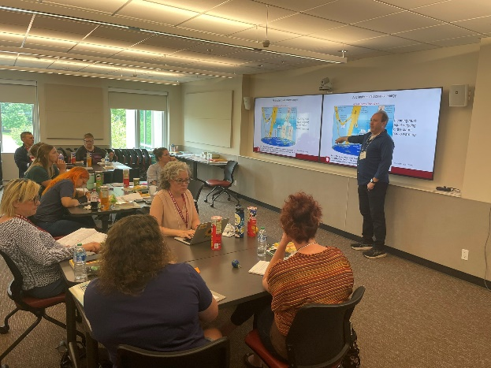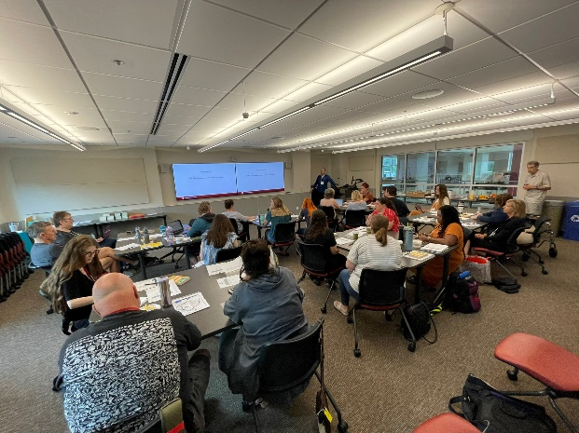
Figure 7. (Clockwise from top left) Two images of teachers conducting investigations of model ice cores, two images of Dr. Ben Kravitz leading the participating teachers in (1) an introduction to climate change science and (2) lessons on climate modeling.

Summer Science Institute Day Two

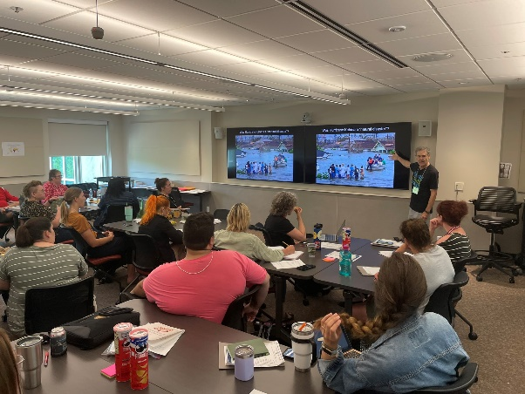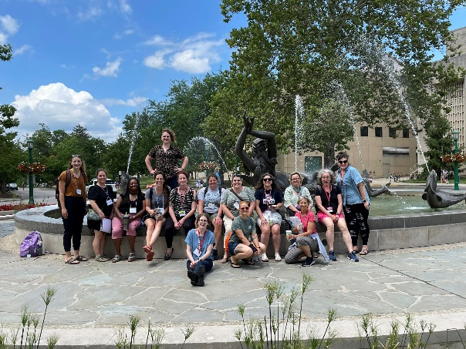

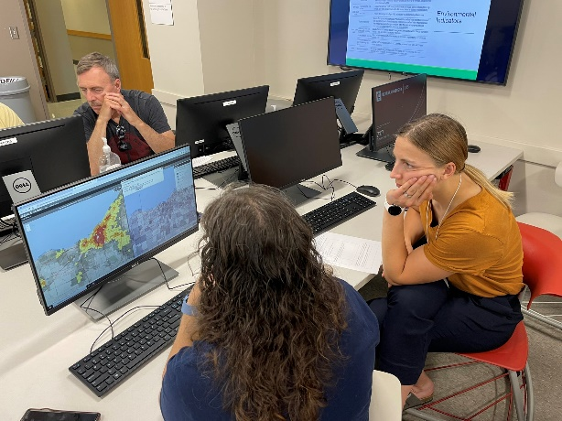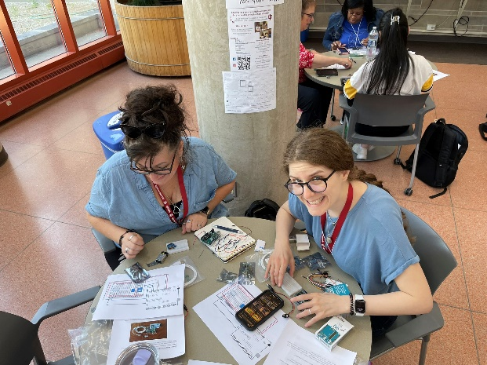

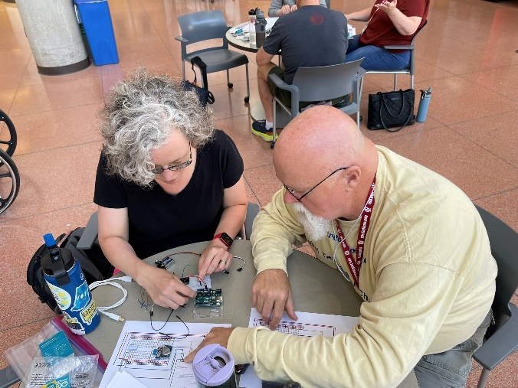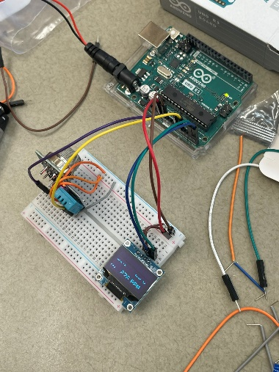
Figure 8. (Clockwise from top left) Dr. Michael Hamburger teaching about natural disasters and climate justice; A quick photo stop at Showalter Fountain on IU’s campus after conducting investigations in the biology building; Three images of participating teachers building and testing CO2 meters using Arduino technologies; Teachers investigating the EPA’s environmental justice screening tool.

Summer Science Institute Day Three

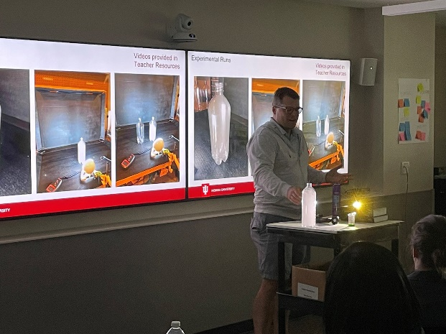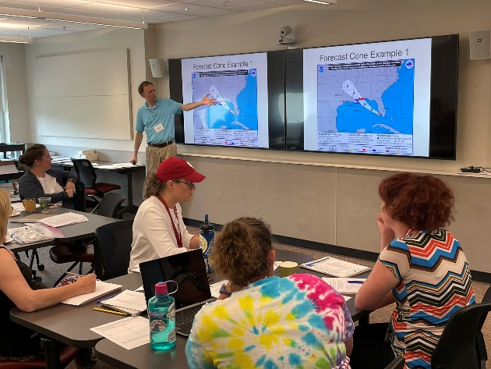
Figure 9. (Left) Dr. Paul Goddard demonstrating a lesson on geoengineering; (Right) Dr. Cody Kirkpatrick conducting a hurricane simulation.

Summer Science Institute Day Four

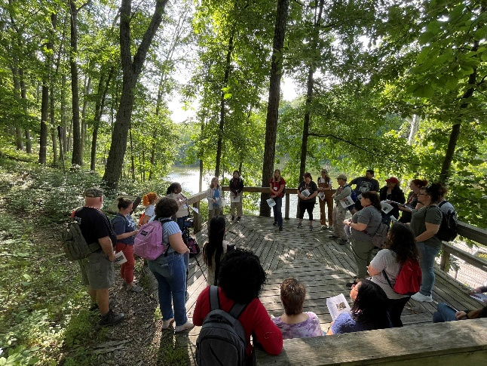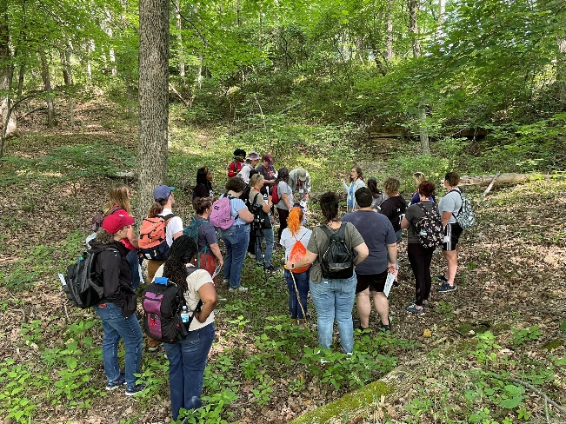

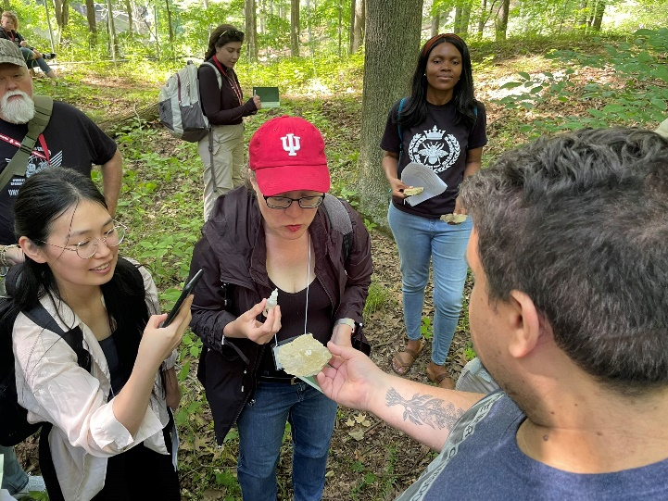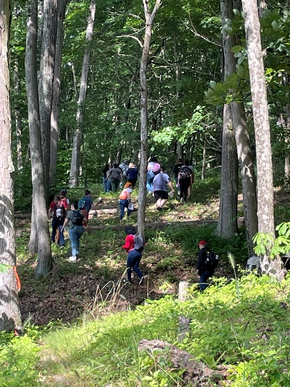
Figure 10. Images from field observation exercises at IU’s Griffy Woods Research and Teaching Preserve

Summer Science Institute Day Five

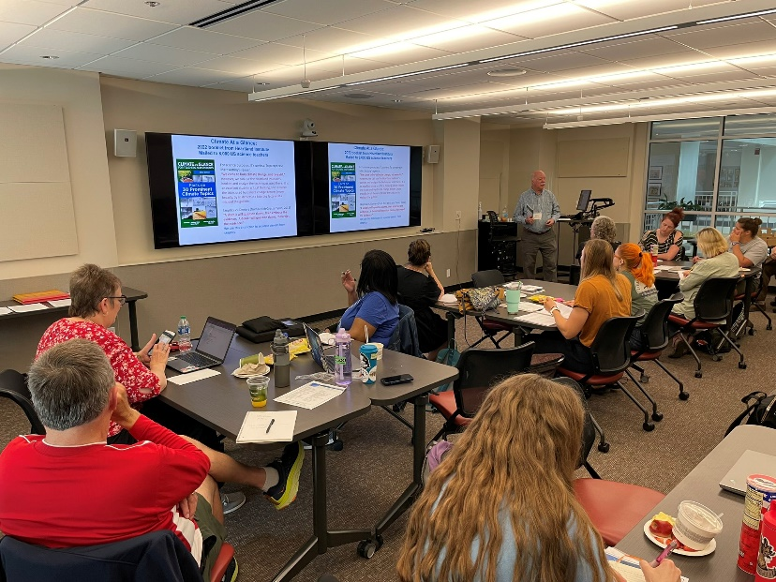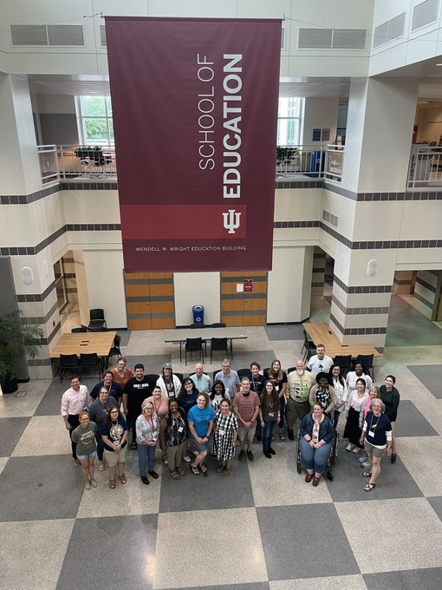
Figure 11. (Left) Dr. Tim Londergan talking about the Ozone Layer, “a climate success story”; (Right) a group photo.

Summer Science Institute Evening Activities

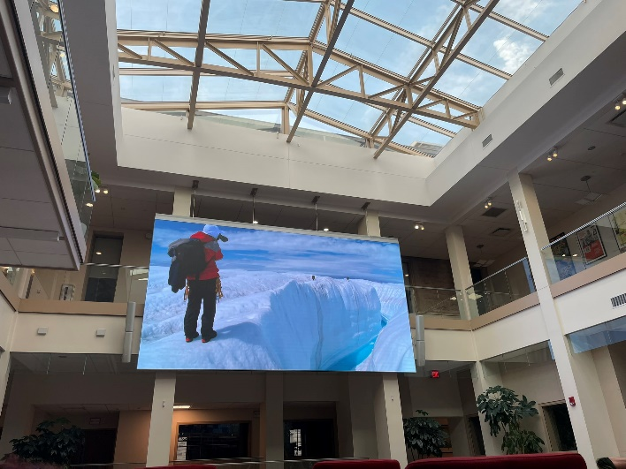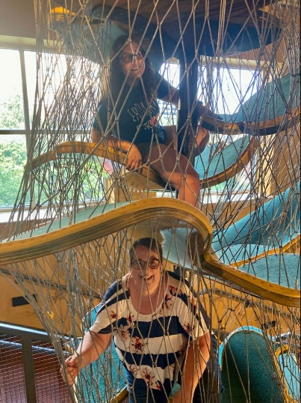

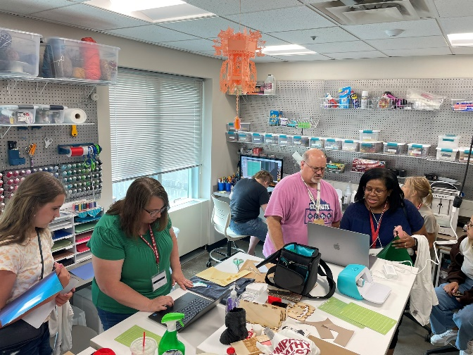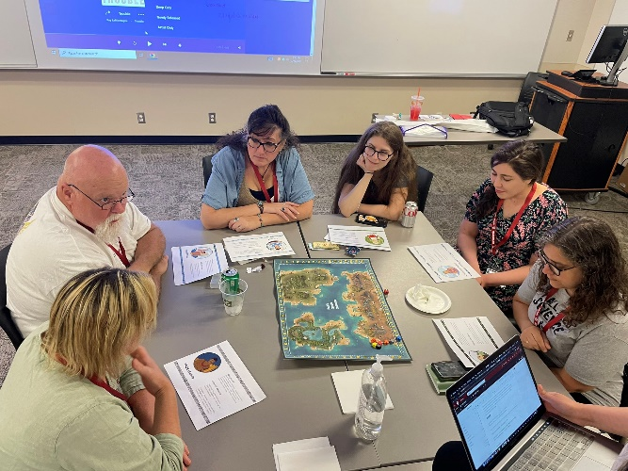
Figure 12. (Clockwise from top left) Watching the movie Catching Ice in the IU Media School; Having fun at WonderLab Museum; Playing an environmental education game developed by IU graduate students; “Making” in the IU School of Education Makerspace.

Summer Institute Evaluation
Teacher Workshop Evaluations
At the end of each of the EfEC Summer Science Institute, participants completed program evaluations. The evaluations provided information about teacher perceptions of the workshop as well as the appropriateness, utility, and transferability of specific activities within the workshops into each educators’ specific disciplines of teaching. This report summarizes the findings from the evaluations and compares them where appropriate.
Respondent Information
The educator post-workshop evaluations were completed by 23 educators. The educators represented middle, and high schools from urban, suburban, and rural school districts from locations throughout the state of Indiana.

Summary of Findings
Respondent Information
The post-workshop evaluation was completed by 23 participants. 13 identified as high school (grades 9-12) teachers (58%) and 10 identified as middle school (grades 6-8) teachers (42%).

Workshop Evaluation Responses
Respondents were asked to indicate their overall rating of the professional development workshop using a 5-point scale (1 = poor, 2 = good, 3 = good, 4 = very good, 5 = excellent). Overall responses for the program are reported below:
- 96% (22 of 23) of the participating teachers rated their training as excellent, 4% (1 of the 23) rated their training as very good. No respondents rated their training as good, fair, or poor.
Workshop Evaluation Qualitative Feedback
On the post-evaluation survey, the participant teachers were asked to explain what aspects of the workshop they found most valuable. The responses were coded and grouped into the following themes. Those are presented below along with sample comments from the respondents.

- Exemplar classroom activities and resources
  - I loved the activities we did! The hands-on experiences like the soil activity and CO2 detectors were my favorite. I also appreciated the En-Roads presentation/activity. I feel that will be really useful!
  - The hands-on activities were interesting and engaging, and I will use many of them with my students (field notebook, ice core, maybe the hurricane activity).
  - The hands-on parts were very valuable. To be able to try things out before presenting them to students is very helpful. I also felt the discussions were valuable because I could hear everyone's ideas.
  - All of the practical ways to complete activities in the classroom. Discussions with other teachers. Activities I can take back to my classroom.
  - I really enjoyed all parts of the workshop but the hands-on activities like the soil sampling was especially helpful. I also think that having actual professors come in and talk about how they use the activities in their classes was great.
- Curricular connections
  - I especially liked the “debunking myths” presentation as well as the social justice information. I loved the walk and stories about Griffy Woods and I was very interested in the respiration lab and the tree boring. I also knew almost everything in the ozone talk, but I really liked the slides and thought they were useful. I thought the Friday morning speakers on sustainability opportunities, all three of them, were very inspirational! Oh, and I loved the detail in the climate modeling talk. It was all fantastic!
  - The activities that I can just insert into my curriculum! It’s so helpful to have those resources and to see how they work.
  - The engineering design lessons will help with developing my students’ own ideas about ways to combat climate change!
  - I liked learning how to connect environmental justice with climate change and using the UN sustainable development goals.
  - The resources and discussions on how to teach environmental justice in the classroom helped me to reframe the structure of my curriculum for this coming academic year.
  - Access to age-appropriate resources for classroom activities and student engagement - especially the student misconceptions workbook.
- Pedagogical strategies
  - The networking with IU faculty and the other teachers.
  - The interactive lessons and lesson plans. New materials and supplies to implement these lessons have been most valuable.
  - Learning more about how climate change affects us and the difference resources we have available to use with students. I feel more prepared than before I came.
Lastly, on the post-workshop survey, the participant teachers were asked if they have any additional comments. A sample of their comments are below:
  - This was the most fun I’ve had at a teaching experience in a while! Thank you so much!
  - This workshop was wonderful!
  - This was fantastic! So many different topics and access to scientists and research! I love being able to create relationships with other educators as well as different faculty and scientists. Thank you so much for the resources and this opportunity. I will highly recommend this to other educators. I definitely appreciated how it spanned so many different disciplines and grades!
“Prior to coming (to EfEC), my baseline level understanding of climate change was not very high, but after hearing from the scientists, I feel a lot more prepared to teach about climate related topics” - EfEC Participating Teacher, Summer 2023
Martha Bowman, Middle School Science Teacher, 2023
In addition to the five-day workshop for middle and high-school science teachers, we plan a one-day workshop for elementary school teachers, planned for Saturday, August 29, 2023. This workshop, led by IU science and science education faculty, will provide elementary teachers with hands-on lessons and age-appropriate activities for engaging students in environmental science. Primary focus will be on upper-elementary levels (grades 4-6) where principles of scientific observation and analysis are introduced to students. We are in initial stages of organization and recruitment. See announcement on the EfEC website.

We also began implementing a series of half-day workshops focusing on informal education, in collaboration with WonderLab Museum of Science, Technology, and Health. These workshops, led by IU science and science education faculty, and intended for WonderLab educators (staff and volunteers), focus on how to cultivate optimism in children by teaching them how they can contribute to solutions of problems posed by climate change. The workshops engage participating informal educators in hands-on lessons and activities that emphasize the engineering design process to optimize green energy sources. The first workshop, facilitated on June 15th, focused on helping youth learn about the role of engineering in energy generation and specifically, green energy solutions such as wind energy. In this workshop, WonderLab educators learned how to introduce young learners to engineering and science practices and how to facilitate hands-on activities including using model Kidwind wind turbines. The next workshop, proposed for August 16th, will build on the core content of the previous workshop and focus on having youth learn about and engineering solar power. Links to young adult literature will also be emphasized. The EfEC team is also working with WonderLab staff and volunteers to co-design new program offerings and increase the number of local, informal environmental education programs.

Educating for Environmental Change Conference Presentations

Scribner, J. A., “Educating for Environmental Change,” National Association of Science
Teachers (NSTA) conference, March 2023, Atlanta, GA.

Scribner, J.A., “Educating for Environmental Change,” Hoosier Association of Science
Teachers, Inc. (HASTI) conference, February 2023, Indianapolis, IN.

Paul B. Goddard, B. Kravitz, A. Scribner: Climate Engineering Teaching Module. Hoosier Association
of Science Teachers, Inc. (HASTI) conference, February 2023, Indianapolis, IN.

Hamburger, M.W. and J.A. Scribner, “Educating for Environmental Change: An ERI STEM Outreach
Program”, Indiana Sustainability and Resilience Conference, February 2023, Indianapolis, IN

Educating for Environmental Change Publications

Hamburger, M.W. (2021), Disasters, Pandemics, and Teachable Moments, American Biology
Teacher, v. 83, no. 9, p. 569, https://doi.org/10.1525/abt.2021.83.9.569.

Scribner, A., Teachers’ Perceived Challenges to Teaching Climate Change in Indiana, The Hoosier
Science Teacher. In review.

Burgess, A., Scribner, A. An Evaluation of an Asset-Based Community Developed Approach to
Teacher Professional Development and its Sustained Impact on Teacher Self-Efficacy Beliefs
for Teaching Climate Change, Applied Environmental Education & Communication. In review.

