Lesson plan Day 1: Is Yeast Alive?

A) Learning Objectives (the learning objectives below may result in more than 3-hour lesson. We will adjust our objectives based on students’ performance).
a. Students are able to know the difference between life and nonlife.
b. Based on the criteria distinguish between life and nonlife, students are able to claim yeast is a living organism through investigation.
c. Students are able to understand yeast needs energy to be active. In this lesson, sugar is the energy source.
d. Students are able to know yeast intake “food” and release carbon dioxide.
e. Students are able to make observations, conduct measurement, and make inference about what they observed.
f. (optional: for advanced students) Students will design experiments to investigate how does temperature and water content affect the rate of yeast growth.
g. (optional: for advanced students) Students will understand the similarity and difference between baking soda and yeast.
h. (optional: for everyone) Students will understand NOS: tentativeness and observation/inference.

B) Materials
Dry yeast (3 teaspoons per group; 7 groups)
25 plastic zip lock bags
7 Magnifying glass
Sugar (2 teaspoons per group; 7 groups; prepare double amount)
7 Construction paper (black)
Warm water (from the tab)
6 500 ml beakers
3 Thermometer
1 Scale
Match
Balloon
Baking soda
Vinegar
Blank poster
Drawing and writing materials

C) Teacher Content Knowledge
a. Characteristics of life
Living things grow and die.
Living things are composed of cells.
Living things use energy and release wastes.
Living things respond to the environment.
Living things reproduce
b. Knowledge about yeast.
Yeast is a single cellular organism belong to the kingdom fungi.
Yeast transform sugar to ethanol and carbon dioxide.
40 degree celsius is the optimal growing temperature.
Yeast cell death occurs above 100° F

D) Tentative Timeline
Before class begin: (9:00-9:30) When students arrived, we will give them a piece of paper to include 5cS elements, and draw what they know the smallest life is. Meanwhile, instructors and volunteers should sit together to clarify expectation for each other and distribute responsibilities.
9:30-9:50: Ice-breaking activity (5cS): Student will write their favorite Color, Cinema Show, Country to travel to, Cuisine, and Closet Dream without their name. Other students will guess who will be that person. If nobody knows who is, the student will introduce herself- himself.
9:50-10:10: We will ask students to design a poster about microorganism as a group. We want them to include everything what they know about microorganism. Students can draw shape of microbes, write where they live, how they connect to human lives. After students complete poster, they can present to whole class as a group.
10:10-10:15: YouTube video: introduce microorganisms. https://www.youtube.com/watch?v=qi1MgmaQM0Q Guide them to the question how do we know these microorganisms are alive?
10:15-11:30: Yeast activity (1h). A snack break will be given while students are waiting for the results.
11:30-11:45: Introduce take home inquiry project
11:45-12:00: Wrap-up and Clean up

E) Lesson Description (Yeast activity continued from YouTube video)
ENGAGE
Discussion about life. Guiding question: How do we know one object is alive?
Instructor will pay attention to kids describe themselves. Ask the question in the context of students’ experience. For example, if Tom has a pet, ask him “Is your dog alive? How do you know your dog is alive?” After the questions is initiated, let students discuss as a table group. Instructors and volunteers will visit each group to guide their discussion. Then, students will share out and one instructor will take notes on the whiteboard.
For this stage, we expect the discussion covers the concepts below:
· Living things grow.
· Living things use energy and release wastes. (Animal eat food and poop; plants use solar energy and release oxygen.)
· Living things respond to the environment.
· Living things reproduce
Students may say living things can move, breath, thinks …. Record them on the white board, save for later.
Characteristics of Life: https://infohost.nmt.edu/~klathrop/7characterisitcs_of_life.htm
http://study.com/academy/lesson/8-characteristics-of-life-in-biology.html
Send out students handouts. http://study.com/academy/lesson/8-characteristics-of-life-in-biology.html
EXPLORE
Focus question: Is yeast alive?
Probe students’ knowledge about yeast; what is it used for in our daily life? If possible, ask students to describe their experience to use yeast. Let the discussion fall on to the question: If yeast is alive, what does yeast eat? Then students could start the investigation.
One instructor introduces the activity, the other instructor and volunteers pass out handouts and materials (Tub A). Before they start the activity, instructors should emphasize safety (no eating or drinking). This activity consists of three parts:
· Observe yeast powder both directly and via magnifying glasses. Students may conclude yeast is not alive because they don’t move. Ask them “are we able to tell whether yeast is alive by pure observation?”
· Yeast cultivation activity: each group will have three zip lock (1) filled with sugar, yeast and water, (2) yeast and water, and (3) yeast and sugar only. It may take 20 min for bags to inflate. We can give them a break to have snacks if it took too long to see any changes.
· From the yeast cultivation activity, students will be able to conclude yeast uses sugar as its energy resource. The next question is what does it release? They will find only one bag inflate. Let students pay attention to this phenomenon, propose an explanation about what do they release. Guide them to the answer gas. Then, another focus question is “what gas it is?” Give them some time to think. Then show them test with a burning splint. This is a demo activity conducted by one instructor or volunteer.

EXPLAIN
Explain is in form of discussion. Is needed after every small activity.
· Observation activity: both direct observation and via minifying glasses will indicate yeast do not move. Let students to think does it mean yeast is not alive? Record how many of them believe so.
· Bag activity: ask each group to share their results. They will find the first bag inflate. Let students think about what does this phenomenon indicate? (Gas is formed). Where does gas come from? (From yeast) Here, the instructor may want to rule out water and sugar. A bottle water does not inflate, as well as sugar. So the gas cannot come from sugar. By examining the status of balloon, students will propose the explanation: Yeast is a living organism that feeds off of sugar.
· Gas identification: ask them to share their observation. Key reasoning: burning splint distinguishes when insert to the bottle (evidence), so we can infer the gas produced by yeast does not support burning. Display a video shows burning splint test in different gases. The most likely one being carbon dioxide. If students point out nitrogen also do not support burning, instructor can use human to make an analogy.
It should be noticed that carbon dioxide is not the only thing yeast release. It is the most identifiable substance from this experiment. Students could smell alcohol -> ethanol.
Through this lesson, students will learn yeast as a form of life, uses energy (sugar) and release gas (carbon dioxide). Here, if we bring out the fact that some students believe yeast is not alive based on their initial observation but changed their mind, we could teach them about tentativeness of science.
ELABORATION
Take home activity. Mold on bread: https://www.youtube.com/watch?v=JZjzQhFG6Ec
In this activity, student volunteers will take a piece of bread in a zip lock bag to home (write not for human consumption on the zip lock bag). Record their observation every day to observe mold growth. We ask for volunteers because Saturday science does not give assignments to students. The result will be discussed at the beginning of next class. Through this activity, students will focus on “mold as a living thing grows” (made explicitly in the next class).
EVALUATION
An exit slip on which students draw a diagram to show yeast is alive.

F) Gearing up/Gearing down
a. We will provide detailed instructions to students to make sure they are able to complete the task. So, we expect some students may have difficulty to draw science concepts out of these results. We will assign volunteers to stay with those kids to promote their thinking.
b. For students who has better prior knowledge or finishes the activity early, we will let them investigate two possible questions. (1) how does temperature affect the growing rate of yeast. (2) the difference between baking soda and yeast. How do they know yeast is a form of life while baking soda is not?
G) Handout and Worksheet
See below
H) References
https://sciencebob.com/blow-up-a-balloon-with-yeast/
https://www.education.com/activity/article/yeast_is_alive_kinder/

Lesson plan Day 2: Is Yeast Alive? Additional Investigation
A) Learning Objectives
- Students will be able to ask investigable questions and reassignment experiment.
- Students will discover several factors such as temperature, pH, and water content that affect yeast growth.

B) Materials
- Discussion:
  - Poster: Writing and drawing materials, glue, scissors
  - Draw conclusion: Stripes and dry erase markers
- Experiments:
  - Dry yeast, Magnifying glass; microscope, Beaker, plastic cups, glass bottles, Balloon, Sugar, flour, starch, bread
  - Warm water (from the tab), hot water, ice, Thermometer, Scale, Match, Baking soda, Vinegar, pH stripe
C) Teacher Content Knowledge
- Characteristics of life
Living things grow and die.
Living things are composed of cells.
Living things use energy and release wastes.
Living things respond to the environment.
Living things reproduce
- Knowledge about yeast.
Single cell of yeast has 3 to 5 microns in diameter, it is a eukaryotic cell.
Yeast is one type of fungi.
Yeast transform sugar to ethanol and carbon dioxide.
40 degree celsius is the optimal growing temperature.
Yeast cell death occurs above 100° F
It takes approximately 2h for yeast to reproduce; time may vary for different species.
Yeast grows best under neutral pH, but yeast is acid tolerant, can grow under 4-4.5.

D) Tentative Timeline
Before class begin: (9:15-9:35) When students arrived, we will let them to work on poster to continue work on their poster: microorganism. This time, we will provide students with more guiding questions. What is microorganism?
How we study microorganism?
What type of microorganism do you know?
The purposes of this activity (1) formative assessment (2) classroom management (students arrives at different time, we don’t want anyone sit there doing nothing and getting bored).
9:35-9:45: Put up their posters around the classroom. Museum walk. Ask students to take notes on other’s poster, write down questions for other teams, then Question and answer session (whole class discussion).
9:45-9:55: Discuss experiment from last week and generate additional investigation question (see details in lesson description). Students will ask three investigatable questions as a team, ask instructor to approve it. Instructors will prepare four to five investigatable questions for students who cannot come up question on their own.
9:55-11:15: Investigation time. Snack break at about 10:30 am
11:15-11:45: Whole class discussion. Each group share their question, method, result, and finding.
11:45-12:00: Mold on bread discussion, show the YouTube video; Clean up

E) Lesson Description
ENGAGE
- After the museum walk, play a YouTube video, then we will give a definition of microorganism. “Small living things”. A more precise definition is “a microscopic living organism”. Summarized our discussion last week about characteristic of life (on ppt), ask them what is missing? “Living things are composed of cells” did not come out from our discussion. Ask them “have you noticed many of you drew some shapes on your posters? Or have you noticed many of you mentioned “cell”? Claire mentioned eukaryotic and prokaryotic cell.” Then, add this items to the list. “Last week, we explored yeast. We tried to answer the question “is yeast alive?” Now, let’s refresh our memory” Discuss about their observation and inference. “When we mix yeast, warm water and sugar, the zip lock bag inflate which indicate gas was formed. This gas was carbon dioxide because we tested it with a burning match. When we insert burning match into the bag, the fire distinguished. This indicates the gas does not support burning.” Demonstrate baking soda experiment again, baking soda mixed with vinegar also release carbon dioxide, why we say carbon dioxide is not alive? Let’s think about additional investigation to examine yeast.
EXPLORE
- Students will come up with two to three investigatable questions about yeast. Try to further answer the question “is yeast alive”. Students will ask three investigatable questions as a team, ask instructor to approve it. Instructors will inspire students to think about the characteristic of life, for example, “leaving things respond to their environment”, students could investigate the effect of temperature, pH. “Living things are composed of cells”, students could observe yeast under magnifying glasses, microscopes.
- After students’ questions are approved, instructors and volunteers will help them design experiments, organize materials.
- To organize their work, each group will be provided with a chart paper. Include four sections: question, method, findings, explanation.
EXPLAIN/EVALUATION
- During investigation, instructors will help students to reframe their questions. Students may ask simple facts (e.g., what’s the relation between yeast and fungi?), questions require complex answers (e.g., how does yeast transform sugar to carbon dioxide?), express their comments as a question (Yeast is so smart, isn’t it?), or ask philosophy questions (where does yeast come from?). Instructors need to identify the purpose of kids’ questions, help them to reframe their questions to investigatable questions.
- Students will organize their results in a poster to address the questions below:
o What question did you ask?
o What method did you use?
o What have you observed? What data have you collected?
o What can you infer from your observation?
ELABORATION
- Students will come up with additional investigable questions, especially those they can investigate within their home setting.

F) Handout and Worksheet
None.
G) References
http://www.ngsslifescience.com/biology_lesson_plans_bacteria_viruses.html
Video Sources
https://www.youtube.com/watch?v=JZjzQhFG6Ec
https://www.youtube.com/watch?v=qi1MgmaQM0Q
https://www.youtube.com/watch?v=7D0eIsuZC3w

Lesson plan Day 3: Investigating Bacterias
A) Learning Objectives
- Research how bacteria move, where they alive, and how they reproduce
- Learn how bacteria can be helpful or harmful.
- Create a display illustrating what they learned about bacteria.
D) Materials
Poster board
Markers/Colored pencils/Scissors/
Internet access
Glass microscope slides and cover slips
Compound light microscope
Yogurt with live culture (e.g.: Actimel, Activia, Yakhult)
Toothpicks
Paper towels or tissues
Water
Dropper
C) Teacher Content Knowledge
For this unit, teachers need to know bacterias are prokaryate and reproduce very fast. Teachers also need to know using microscopes and parts of the bacteria cell.
D) Tentative Timeline
Before class begin: (9:00-9:30) When students arrived, pre-arrival activity: characteristics of living things entrance slip
9:30- 9:40: Introduction- Small discussion regarding last week.
9:40- 10:10: Mold activity- Students will explore molds on bread and blue cheese. They first use magnifier and then use microscope.
10:10- 10:30: Students will work on poster about bacterias, discuss with the whole class what they know about bacteria.
10:30- 10:40: Students will watch a short video about bacteria. (Snack time)
10:40- 11:00: Students will work on bacteria worksheet.
11:00- 11:45: Students will explore reproduction of the bacteria through bead activity.
11.45- 12:00 Following that students will do bacteria cell coloring.

E) Lesson Description
ENGAGE: Students will be reminded that last week they explored yeast and they will be asked what they learned from yeast activity. Students will be informed that they will explore mold this week.
Mold activity: Students will explore molds on bread and blue cheese. Students will be given some sample of blue cheese and activia yoghurt. They first use magnifier and then use microscope to explore cultures.

EXPLORE: Ask students what they know about bacteria. Record their responses on a piece of newsprint. Do not be surprised if they know very little about this topic, or if their only familiarity with bacteria is as the cause of illnesses like strep throat. Put away the sheet of newsprint until the end of the lesson.

EXPLAIN: Explain to students that they will be learning about bacteria, their characteristics, helpfulness, and harmfulness. During the day of the activity, students will focus on the basic characteristics of bacteria: what they look like, where they live, how they move, how they breathe, and how they reproduce. Students should work individually or in pairs.

ELABORATION Students first will work on poster about bacterias, discuss with the whole class what they know about bacteria. Students (as individuals or pairs) design a poster considering following questions:
What do bacteria look like?
Where they live?
How they move?
How they reproduce?
Students will explore reproduction of the bacteria through bead activity. Before class, prepare sandwich bags full of beads. Place 5 in one bag, 10 in another, 20 in another, 40 in another and so on, always doubling the amount. Set a shallow bowl on a table and have students gather around. Hand one bag of beads to each student. Explain that bacteria reproduce quickly, and can double its population in minutes. Your "bead bacteria," however, will double its population every 30 seconds. Have the student with 5 beads empty her bag into the bowl. 30 seconds later, have the student with 10 empty his bag, followed by the student with 20, then 40, and so on until the bowl overflows. Students will see just how quickly a bacterial population can get out of hand.
EVALUATION
Students will be given a handout and they color bacteria cell and fill out the empty places. Through this handout students’ information related to how bacteria move, and how they survive.

F) Handout and Worksheet
Bacteria cell coloring (See below)
G) References
http://www.microbe.org/microbes/bacterium1.asp http://www.bacteriamuseum.org/ http://whyfiles.org/shorties/count_bact.html http://www.ucmp.berkeley.edu/bacteria/spirochetes.html http://www.microbe.org/microbes/where_live.asp http://www.amnh.org/nationalcenter/youngnaturalistwards/1998/bacteria.html

Lesson plan Day 4: Protein and Virus
A) Learning Objectives
a. Students will explore different length scales and where does microscopic scale fit in.
c. Students are able to model protein with physical manipulatives and on computer.
B) Materials
Length scales activity:
Length scale cards, Construction paper, Yarn, draw and writing materials
Protein Building activity:
Model clay, Toothpicks or popsicles
Computers with internet access and Chimera installed
Writing papers.
C) Teacher Content Knowledge
For the length scale activity, teachers need to know the relative for each item on the cards. Be able to help students use information they know to make a comparison. For the protein building activity, teachers need to know the basic structure of amino acid. Carbon is able to accommodate four bonds; the structure of amino acids starts with a center carbon with one hydrogen, one carboxyl, one amine, and one R group (20 types). Amino acids are connected to make protein chain via condensation reaction.
D) Tentative Timeline
Before class begin: (9:15-9:30) When students arrived, we will let them share characteristics of life on the smartboard. Meanwhile, send them index cards ask them to complete the information on the back.
9:35-9:45: Start with the conversation with “From our previous lesson, we reached an agreement microorganisms are small living things.” Share about characteristics of life, them move on to “small”.
9:45-10:15: Activity: Matters at different length scales (end the conversation with smallest member in the microorganism family--Virus).
10:15-10:30: Structure of Virus
10:30-10:40: Snack break
10:40-11:30 Protein modeling competition (the winner will launch the first 3D printing job)
11:30-12:00: Visiting 3D printing lab.

E) Lesson Description
ENGAGE
Start with the question “microorganism is small living things. How small it would be?” Please two balls on each table, ask them which one is smaller, and ask them to share what criteria they used. Possible answer is length, volume, area… Lead them to think about length via TV example. For an irregular 3D shape, average radius is one way to characterize size. Then move on to the activity to explore how small microorganisms are.
EXPLORE
Students will be given several index card (electrons, protons, neutrons, carbon atoms, hydrogen atoms, oxygen atoms, water molecule, sugar molecule, lipid, chromosome, nucleus, yeast cell, virus capsid, basket ball…) There task is to arrange these items from smallest to biggest. These cards have two sides, one side contains name, students will be asked to fill in the other side using online resources. Each student will complete 4 to 5 cards, then they work as a group to arrange them according to their size. Instructors may need to help students estimate which one is smaller. After most students are done, pull a discussion as a whole class. Use a yarn to make a spiral on the whiteboard, ask students to put up their index card. Then ask students “in the microorganism family, which is the smallest?” (Virus). For the next two weeks, we will explore Virus. The focus of this week is to explore virus structure. A virus has inner core of nucleic acid (either DNA or RNA), and an outer shell called capsid. Protein is the most important component of viral capsid. The purpose of the next activity is to understand protein.
RENGAGE
We use models to explore protein since they are too small to seen. Ask students what a model is (A representation of a system that allows for investigation of the properties of the system)? “Now, we are going to pass you some models. Each model is one of the items you just explored. Let’s make observations and let us know what are they.” Provide students with 3D printed models. (water, glycine, and HPV capsid. Glycine models are in two sizes). We use play dough and toothpicks to build models. We will start with simple molecules. Provide students with model clay, they will build water and carbon dioxide. Explain that atoms are connected with chemical bonds to form molecules. Here we use toothpick to represent bonds, and model clay balls to represent atoms. For the simple molecules, instructors may need to help lower graders.
EXPLORATION
Build simple amino acids--glycine. Provide students with glycine and valine 3D pictures. Each student will build one model of each with play dough and toothpicks. Students will make observation of these two molecules and write down their similarities and differences.
EXPLAIN
Students will discuss about the structure of amino acid as a whole class. Glycine and valine all have one center carbon, they all have one hydrogen, one -NH2 (amine), and one -COOH (carboxyl). The difference is the fourth group. The fourth group of glycine is hydrogen, and the fourth group of valine is isopropyl group -C(CH3)2. It’s not necessary for students to know the name of functional group. The purpose of this activity is to let students realize how are glycine and valine similar and different. We will ask students how can we modify the structure of glycine to make a valine molecule.
REENGAGE
Video: condensation reaction https://www.youtube.com/watch?v=d_Oas5k4StI (up to 4:44) The key information we want to pass to our students are amino acids bond together to make long chains. The next activity is to join two amino acids to form protein chains.
EXPLORATION
Activity 3: condensation reaction of amino acids.
Students will be provided with pictures contain 3D models of two glycine and demonstrate condensation reaction. One -COOH react with -NH2, -COOH gives out -OH and -NH2 gives out -H. Students can work in pair to combine their glycine’s, and then include valine. Instructor will help students to find patterns on their model (identify the repeating units).
EXPLAIN
Students will demonstrate their models to the entire class, and explain what they need to do to add one amino acid to the chain. We expect them to understand only -NH2 and -COOH can be combined. After they took out -OH and -H, N and C are connected.
ELABORATION/EVALUATION
Protein building competition: Build the longest chain with glycine. Students will be providing with same amount of model clays. They will be given 30 minutes to build long protein chain. 5 points for every added glycine.
While students are waiting for competition result, volunteers will bring them to makerspace to have a 3D printing tour. Explore protein data bank select a virus of their interest. Every student could request one virus to print out.

F) Gearing up/Gearing down
Gearing down: For those who are struggling with protein building, one instructor or volunteer will work with them together to build their molecules. Instructor could let them focus on glycine, do not include valine.
Gearing up: For advanced students, encourage them to challenge different types of amino acids. The side chains can be very complicated.

G) Handout and Worksheet
Lengthscale cards:
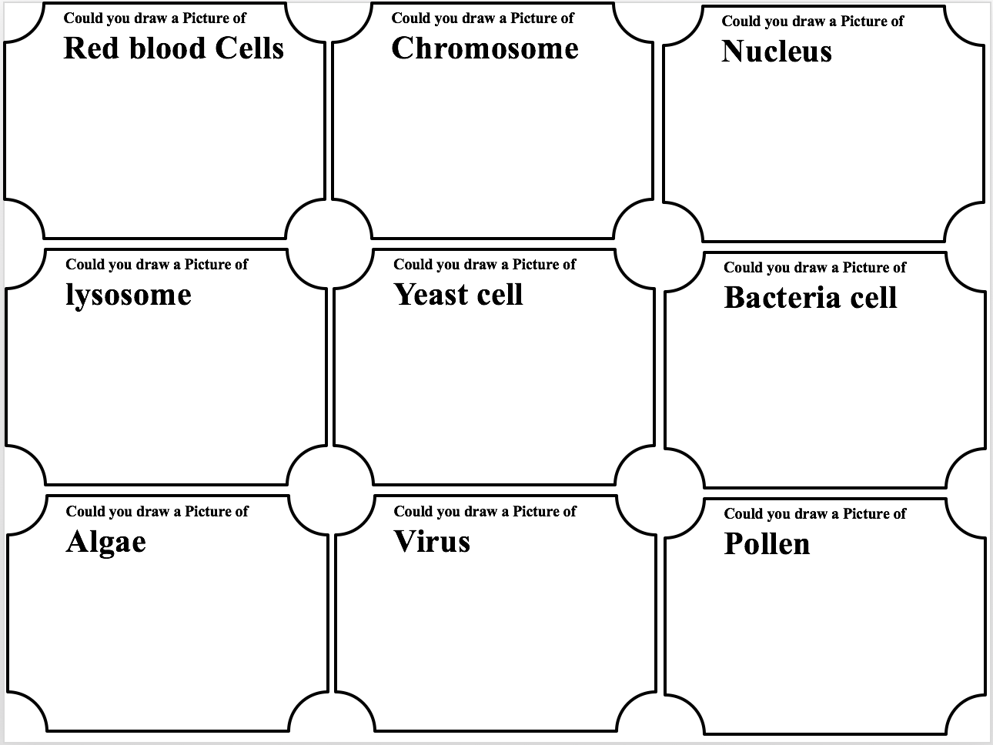
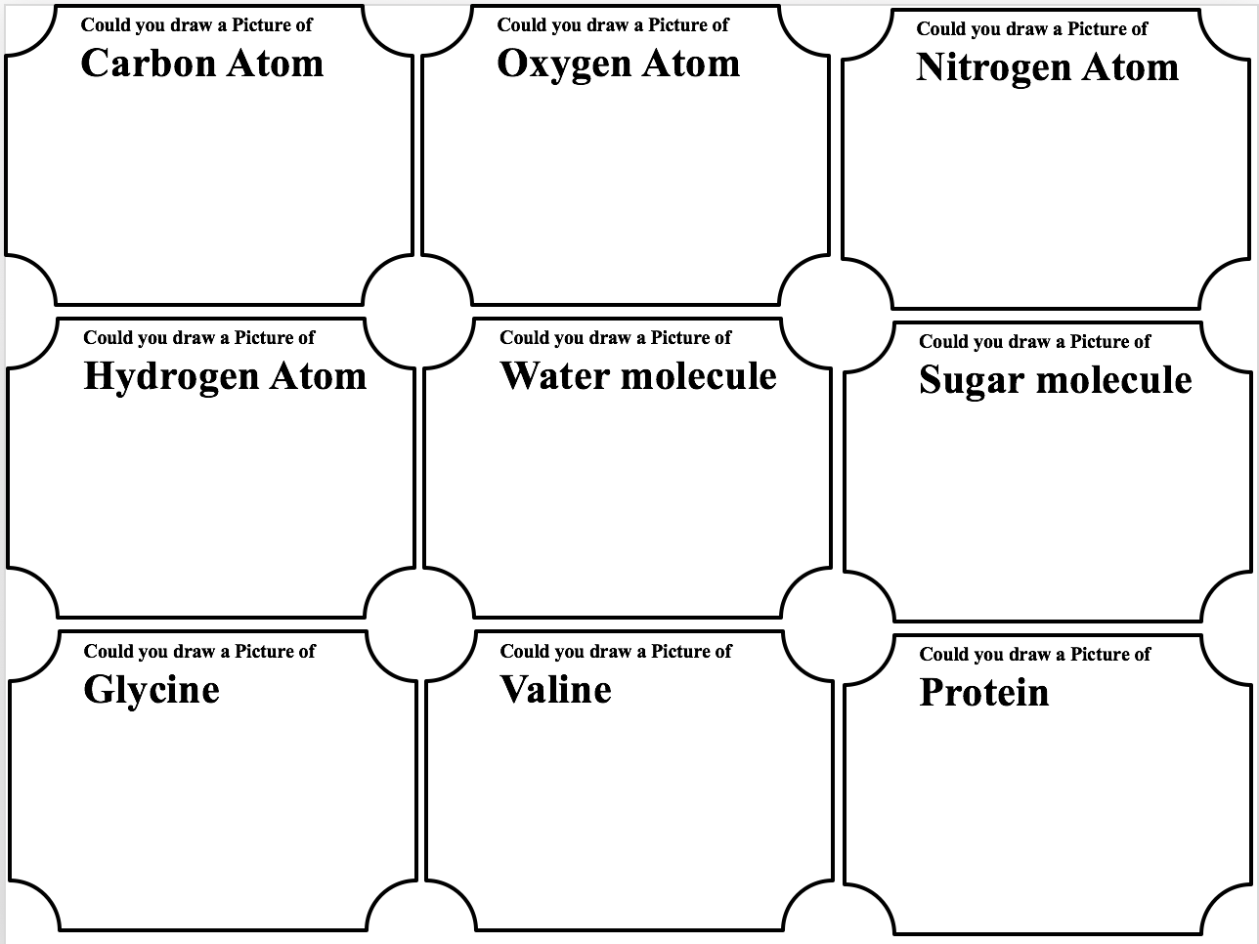
See below for students’ handout.
H) References
http://faculty.ccbcmd.edu/courses/bio141/lecguide/unit4/viruses/ssvir.html

Lesson plan Day 5: Protein, Viral Capsid and Vaccines
A) Learning Objectives
a. Students will know a virus has an inner core of nucleic acid and outer protein coat called a capsid. b. Students will know viral capsid is composed of multiple identical protein chains and viral capsids are in different shapes.
c. Students will know how vaccines are made and how they work.

B) Materials
Protein Model Building: pictures of 3D model of 20 amino acids. Toothpicks and play dough (divided to 7 groups so every group will have same amount of play dough, this need to be done before class begin), 7 trays
3D printed viral capsids
Pictures of 3D model of viral capsids in different shapes.
Computer with internet connection.
D) Teacher Content Knowledge
C) Teacher Content Knowledge
See day 4 for content about protein. Protein shell and genetic materials are common feature of all types of virus. Protein shell is used to protect genetic materials. Protein is metastable. It need to be stable enough to allow virus enter cell, but it should not be too stable so the genetic materials can release in the body. Protein is also the key to make vaccines. Vaccines trigger immune system to generate antibody (Y-shaped molecule made of protein). Antibody protects our body from future infection.
D) Tentative Timeline
Before class begin: (9:15-9:40) When students arrived, we will give them play dough and toothpicks to build glycine and practice building long protein chain.
9:40-9:45: Review amino acids and protein chain.
9:45-9:50: Explain the rule for protein building competition.
9:50-10:00: Give students 10 minutes to prepare for the competition. Come up with a strategy as a group, plan how to use materials effectively.
10:00-10:20: Protein building competition.
10:20-10:30: Students self-grade their models and explain their strategy to build their model
10:30-10:40: Snack break + Winners pick their prize.
10:40-11:20: Virus structure and shape activity.
11:20-11:45: Vaccine activity.

E) Lesson Description
ENGAGE
When students arrive, we will give them play dough and toothpicks to build glycine and practice building long protein chain. We will provide them with pictures of 3D printed glycine, and how they could be connected. Instructors and volunteers will visit each group to make sure they know how to make a long chain
EXPLORE
Explain the rules for protein building competition: they win 5 points for adding one more amino acid, they win 5 points for adding one different type of amino acid. 1 point is deducted for every incorrect connection. Students will be given 10 minutes to prepare for the competition. Instructors and volunteers will help each group to come up with a strategy. Each group will have same amount of play dough, so they need to determine how many types of amino acids they want to use. Using different types of amino acids will have more scores, however, some amino acids may consume more play dough.
Students will be given 20 minutes to build protein chain. Every group need to start at the same time, instructors and volunteers will make sure students have assembled their previous products. Their products must be build on a tray.
EXPLAIN
After 20 minutes, each group will be provided with one worksheet to self-grade their model with the help of instructor and volunteers. Then, they well explain to the entire class to address (1) How many protein amino acids are there in their protein chain? (2) How many types of amino acids did they use? (3) How did they distribute the working in their group? (4) What is their final score? Instructor will draw a chart on the whiteboard to organize their results. We have 20 3D printed viral capsid 2 types) as their rewards. Winners has higher priority to pick one. Every student is guaranteed to have one.
Play the video to show amino acids form protein chain (up to 4:45): https://www.youtube.com/watch?v=d_Oas5k4StI. Then, instructor will draw a concept map on the whiteboard to show the relationship between atom, molecule, amino acids and protein.
REENGAGE
Ask students “our theme is microorganisms. We have explored yeast, mold, bacteria, and the topic for this week is virus. Have you ever had this question, why did we spend so much time on protein?” “Now let’s look at some examples of virus”. Provide students with pictures of viruses in different shapes with each components labeled. They will answer the question “what do they share in common?”
EXPLORE
Students will look at pictures to identify common features of viruses in different shapes. Then, they will observe their rewards to identify where could their reward fit in. Identify similarities between their rewards and each picture. Then, students will be provided with physical manipulatives (model clay, cloth, yarn, toothpicks, scissors, glue). “How could we change your reward to other types of virus?” They could pick their favorite shape and change. Then students will think about the function protein capsids. What do they think virus need a protein shell?
EXPLAIN
Start the discussion with sharing common features of viruses in different shapes. Students may answer they all have protein and DNA or RNA. From the picture, they may not recognize DNA and RNA are both genetic materials. Then ask them what does DNA or RNA do. What do they think virus need a protein shell? They may answer protein shell is used to contain DNA or RNA, may protect genetic materials. The main ideas we want students to know is a virus need to have a protein shell and genetic materials. Finally, instructor will add viral capsid the the concept map (protein is the building block of viral capsids).
REENGAGE
How do virus infect cell? Ask Kyle (this students was knowledgeable about virus) to explain to the entire class and ask others to add on. Then, display a video https://www.youtube.com/watch?v=Rpj0emEGShQ This video shows there are keys on virus that match locks on the surface of cells. They have to match in order to allow virus enter cell.
EXPLORE/EXPLAIN
Ask students, how can we interrupt this process? Provide students with handouts. Ask them to work with a partner to propose a solution to interfere this process. One way is to use a fake lock.
Ask students to explain their thought. Then display another video: https://www.youtube.com/watch?v=lrYlZJiuf18 This video only have animation, no explanation. Instructor need to stop to make explanation. There is one type of cell that has similar lock, virus can land on them. Once they have identified the key on the lock, this cell will generate “Y” shaped molecules. This “Y” shaped molecule is like a fake lock, that could occupy the keys on virus. This molecule will also help the “eater” (T cell) to identify virus. Instructor can play this video twice, stop in the middle to explain. The “Y” shaped molecule is called antibody. Virus trigger the immune system to generate antibody. On a slide, instructor will share some examples of vaccines.
ELABORATE/EVALUATE
Work on concept map. Students will add virus, vaccine, and any other items they know to their own concept map.

F) Gearing up/Gearing down
Protein building activity:
Gearing down: For those who are struggling with protein building, one instructor or volunteer will work with them together to build their molecules. Instructor could let them focus on glycine, do not include valine.
Gearing up: For advanced students, encourage them to challenge different types of amino acids. The side chains can be very complicated.
Virus and vaccine:
Gearing down: Students may have difficulty to find the common feature, instructor may help them focus on one pair of virus at once. When discussing about vaccine, let students focus on the mechanism instead of terminology. We can play the video twice, let students make observations.
Gearing up: This lesson only introduced one infection mechanism. We can introduce other ways virus to infect cell, e.g., bacteriophage. We could also introduce them with virus-like-particle based, subunit-based, and nanoparticle based vaccine.
G) Handout and Worksheet
See below.
I) References
YouTube video: https://www.youtube.com/watch?v=Rpj0emEGShQ
https://www.youtube.com/watch?v=lrYlZJiuf18

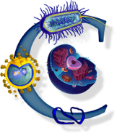 | The “Tiny” World Around You | 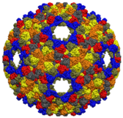
Lesson plan Day 1: Is Yeast Alive?
Pre-activity:
- Write or draw five things you know about yeast. How do you know they are alive?

Materials: 3 teaspoons of dry yeast
3 plastic zip lock bags
1 Magnifying glass
2 teaspoons sugar
Construction paper (black)

Investigation Part I: Observation.
Place a piece of construction paper on the table. Pour 1 teaspoon of dry yeast on the paper and observe. You can look, smell, touch (do not eat), and use magnifying glasses. Record your observation in the table below.
 | Draw a picture of what you have seen | Describe what you have seen, smell, and how does it feel
Dry yeast

Based on your observation, can you tell if yeast is alive?

Part II: Experiment
Obtain three plastic zip lock bags.
  - For the first bag, add one teaspoon of dry yeast and ¼ cup of water.
  - For the second bag, add one teaspoon of dry yeast and 1 teaspoon of sugar.
  - For the third bag, add one teaspoon of dry yeast, ¼ cup of water, and 1 teaspoon of warm water.
You can look, smell, touch (do not eat), and use magnifying glasses. Record your observation in the table below every five minutes.

 | Time (min) | Describe what you have seen, smell, and how does it feel | Draw a picture of what you have seen
The first bag | 0 |  | 0 minutes:  20 minutes later:
The first bag | 5 |  | 0 minutes:  20 minutes later:
The first bag | 15 |  | 0 minutes:  20 minutes later:
The first bag | 20 |  | 0 minutes:  20 minutes later:
The second bag | 0 |  | 0 minutes:  20 minutes later:
The second bag | 5 |  | 0 minutes:  20 minutes later:
The second bag | 15 |  | 0 minutes:  20 minutes later:
The second bag | 20 |  | 0 minutes:  20 minutes later:
The third bag | 0 |  | 0 minutes:  20 minutes later
The third bag | 5 |  | 0 minutes:  20 minutes later
The third bag | 15 |  | 0 minutes:  20 minutes later
The third bag | 20 |  | 0 minutes:  20 minutes later

Briefly summarize your observation. Explain what do you think happened in these bags.

Based on these observations, do you think yeast is alive or not? Briefly explain your thought.

Part III: Investigation
We all notice the third bag inflated. This indicates some gas(as) is/are formed. How could we know what gases is/are formed? Think about one way to test it. Share your strategies with your instructors. Your instructor will help you to set up the test.

Additional investigation questions:
- How does temperature affect yeast growth?
- Why water is needed to active yeast? How does amount of water affect yeast growth?
- Both baking soda and yeast are used to make bread (allow bread to rise). How could we know yeast is alive but baking soda is not?

The “Tiny” World Around You
Day 3: Investigating Bacterias
Name: ___________________________________________
Prokaryote Coloring
Prokaryotes cells are the simplest of all the cells. Bacteria are prokaryotes and they fall into two major categories: The Kingdom Eubacteria and the Kingdom Archaebacteria. Eubacteria are common types that occur all around us, usually they are on surfaces and in the soil. You can only find Archaebacterial in extreme environments, like hot sulfur springs. Archaebacterial are thought to be some of the oldest life forms on earth. Most bacteria don't make their own food. That means they have to rely on other organisms to provide them with food. These bacteria have to break down, or decompose, other living things to obtain energy.
When most people hear the word bacteria, they think of something that is bad for you. In fact, very few bacteria cause illness. Some bacteria actually help you! Bacteria are used to make food, such as cheese and yogurt, and they can also help us break down harmful substances in the environment. Scientists created a type of bacteria that could gobble up oil from oil spills. Some bacteria live inside the guts of animals and help them to digest food.
Unfortunately, there are many types of bacteria that can make us ill. Salmonella bacteria can cause food poisoning, and certain types of bacteria are responsible for other infections. You might have had some experience with Streptococcus, the bacteria that causes strep throat.
Bacteria have a very simple cell design. Most of them have a thick outer covering called the cell wall.
1. Color the cell wall purple (it’s the outermost layer).
2. Just within the cell wall is the cell membrane. Color the cell membrane pink.
3. Along the surface of the bacteria cell, you might encounter structures called pilus, whose job is to help the bacteria stick to surfaces. Color all the pilus light green.
4. Bacteria might also need to move around in their environment, so they can have structures called flagella, which resemble tails. Find the two flagella pictured and color them dark green.
5. The watery interior of the cell is called cytoplasm, and it has the texture of jello. Color the cytoplasm light blue.
6. Sprinkled throughout the cell are small roundish structures called ribosomes. Ribosomes make proteins for the cell. Color all of the ribosomes red.
7. Every prokaryote cell has DNA floating within the cytoplasm, which usually looks like a twisted strand of spaghetti. DNA contains the instructions for the cell, basically it is the control center. Find the DNA and color it yellow.
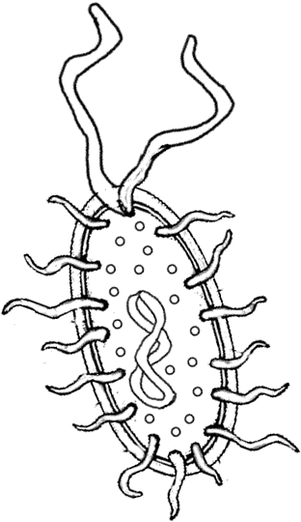
Questions:
1. What bacteria causes strep throat? 2. What are the oldest life forms on earth? 3. What type of bacteria causes food poisoning? 4. What part of the bacteria cell helps it stick to surfaces? 5. Name two foods that bacteria help make: 6. What does “decompose” mean? 7. What is the control center of the bacteria cell? 8. What part of the bacteria cell helps it move? 9. Where do Archaebacteria live?
- To what kingdom do common bacteria belong?
- Label the bacteria cell:
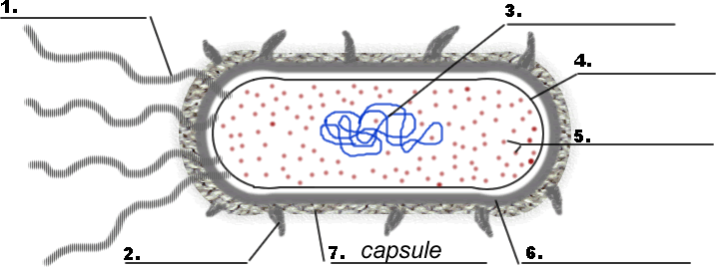
12. Note in the image above, the capsule is labeled. Not all bacteria have capsules, but many bacteria that make people sick do have this extra structure. What do you think the function of the capsule is?

The “Tiny” World Around You
Lesson plan Day 4: Protein and Virus
Observing Models:
There are four models on each table. Please walk around, observe each model. What do you think these model could be?
Picture | What have you observed? | This is a model of …
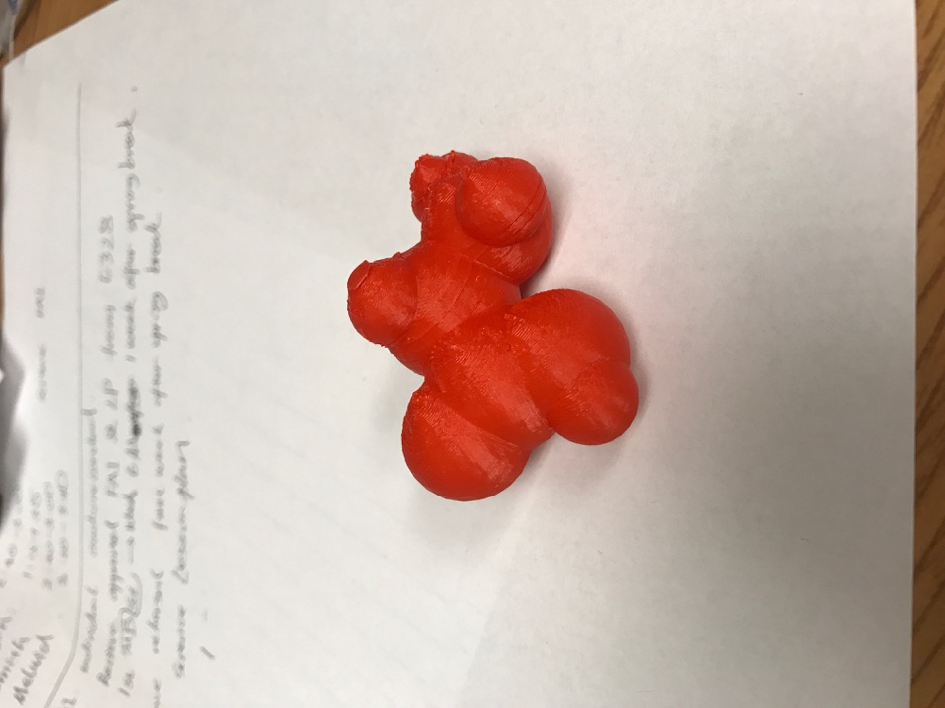

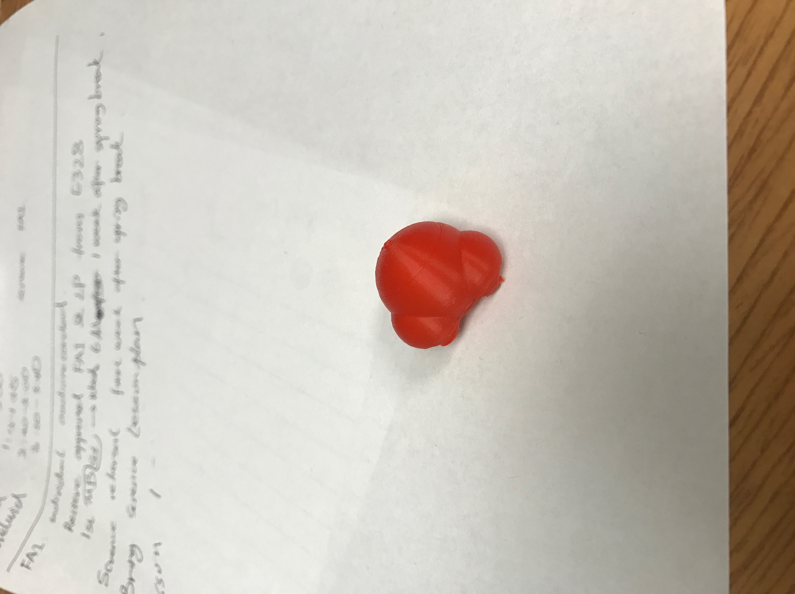

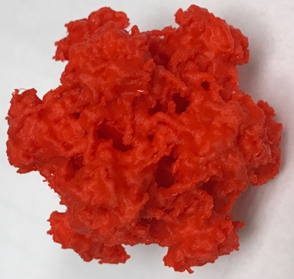

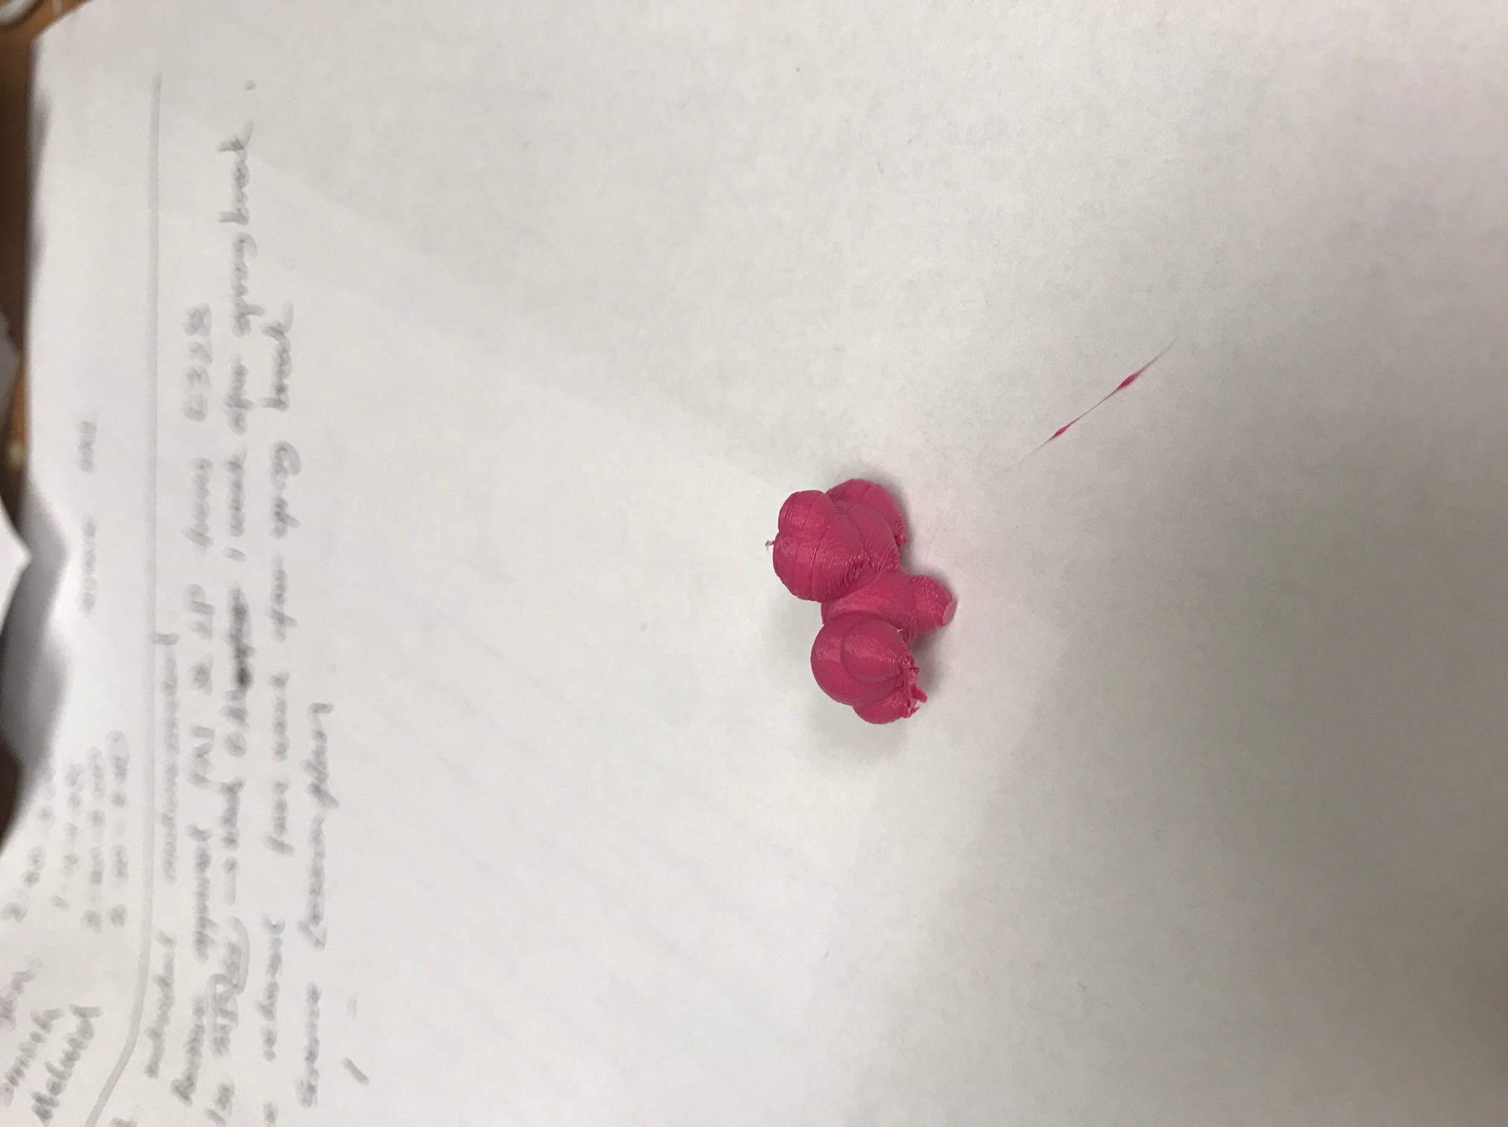

Clay model activity:
Activity 1: Build simple molecules with model clay
- Water molecule b. Carbon dioxide
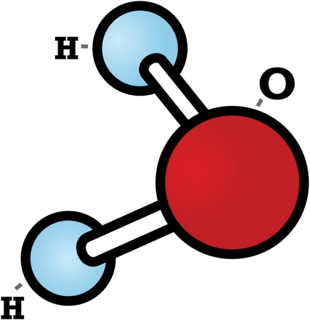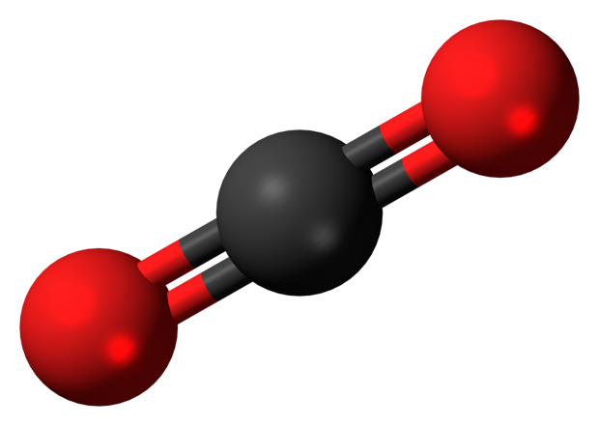

Activity 2: Build glycine (the simplest amino acid) with model clay
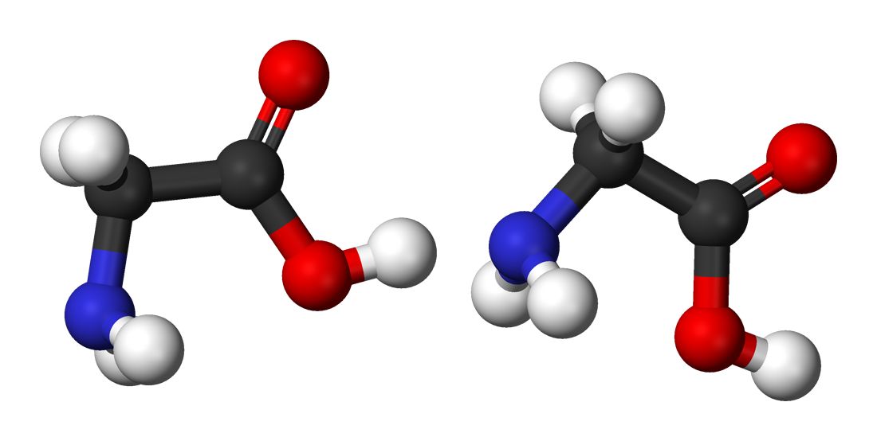
Activity 3: from amino acids to protein chain. Work with your partners, can you combine the amino acids you have created into one chain?
Glycine
Glycine

Protein building competition model activity:
Goal: Build a long protein chain using glycine
- Work in group of 2 or 3 and build a protein chain in 30 minutes.
- Your model will be graded according to the following rubric.
- Winners can take home any one of the 3D models we explored today.

Rubric:
- 5 points for every amino acid added to the model.
- 1 point is deducted for every incorrect connection.

The “Tiny” World Around You
Lesson plan Day 5: Protein, Viral Capsid and Vaccine
Pre-activity:
Let’s build glycine molecules using model clay. A ball represents an atom and a toothpick represent a bond connecting two atoms.

Glycine
Glycine

Question: How can you add another glycine to this chain?

Activity 1: Now, let’s make it more complicated.
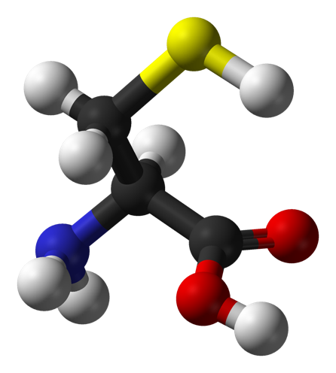
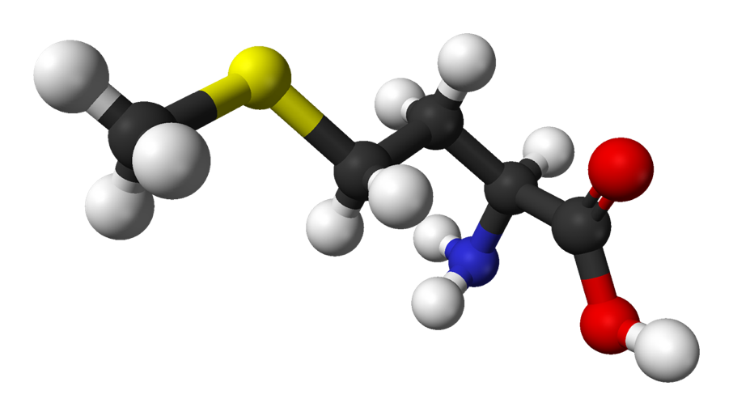
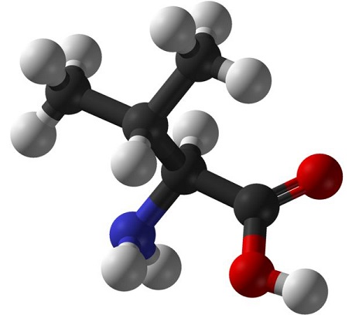
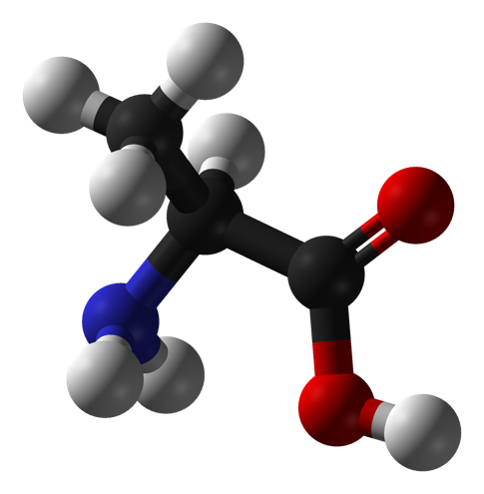
Instead of using glycine, there are other molecules like glycine:
Cysteine
Alanine
Valine
Methionine
Glycine

Protein building competition model activity:
- Work in group of 2 or 3 and build a protein chain in 20 minutes.
- When you build your protein, hydrogen can be neglected.
- Your model will be graded according to the following rubric.
- Winners can choose 3D models first.

Rubric:
- 5 points for every amino acid added to the model.
- 5 points for every different type of amino acids
- 1 point is deducted for every incorrect connection.

Example: A group build the following chain:
Glycine-Alanine-Glycine-Valine-Glycine-Glycine
This chain contains 6 amino acids, and 3 types of different amino acids. This group gain 45 points. However, they have 2 incorrect connections, their final score is 43points.

Please write down what protein chain you have build (use three letters to represent one amino acid):

- - - - - - -
Activity 2: Viral Structures

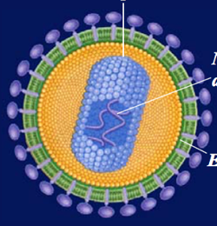
- 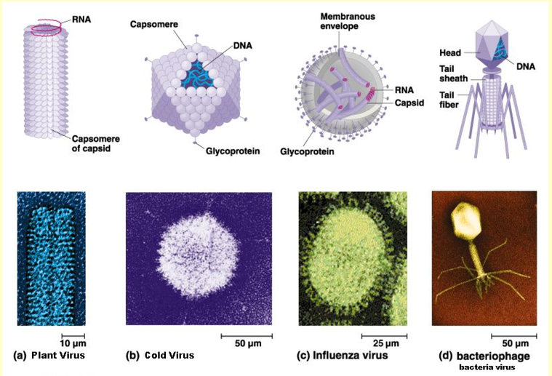Look at pictures below, can you identify common features of these viruses? Can you tell the differences among these viruses?
Protein Shell
Protein Shell
Protein Shell
Head (Protein shell)
Protein Shell
RNA
DNA
DNA
RNA

Membranous envelop
Protein Shell
Protein Shell

Similarity | Differences

- Look at your 3D printed model, which category does it belong to? How can you make it into another type with materials on your table? If not, can you build a model of another type?

Activity 3: Vaccine activity

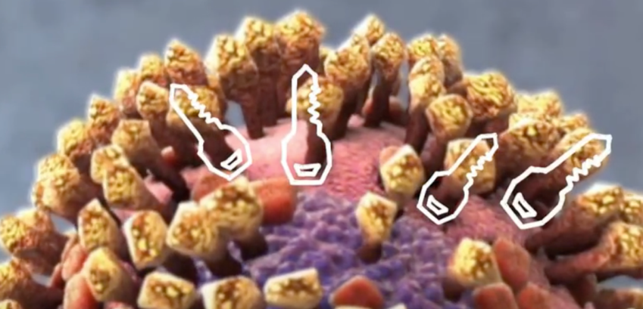 There are keys on the surface of virus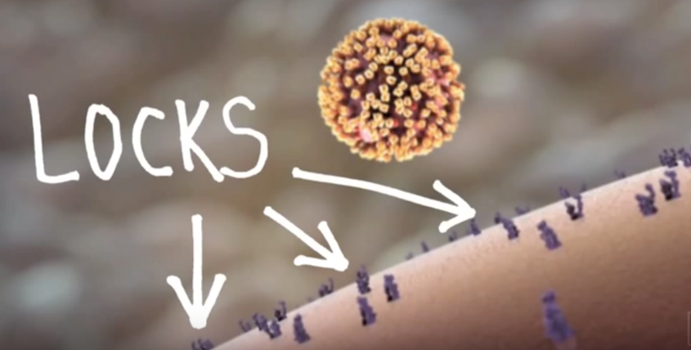 There are locks on the cell

If there is a match, the virus sticks on the surface of the cell.

Discuss with your partner.
Can you think of a way our body could prevent this process?

