INDIANA UNIVERSITY

School of Education

Spring Faculty Meeting
Friday, March 29, 2019

Agenda

INDIANA UNIVERSITY SCHOOL OF EDUCATION
Welcome Dean Watson Dean’s Update Dean Watson Other Updates Faculty
Lunch Atrium Balcony

All-School Meeting • Friday, April 26 • 10am - Noon

Assumptions

INDIANA UNIVERSITY SCHOOL OF EDUCATION
- I don’t have a set of preconceived outcomes of how or what needs to be done other than what has been shared with me as a dean.

- My role is to ask questions, facilitate, lead, and coordinate groups and resources to make sure the work gets done.

Assumptions

INDIANA UNIVERSITY SCHOOL OF EDUCATION
- I am responsible to make sure we are accountable for our resources.

- I believe that each person is an adult and will act accordingly, so I am not “making” anyone do anything.

Assumptions

INDIANA UNIVERSITY SCHOOL OF EDUCATION
- To make sure you understand the short and long term consequences of our decisions.

- To make sure that I am legally and authoritatively honoring the terms of my contract with Indiana University, Board of Trustees, and the State of Indiana as I serve the School of Education.

Mission Statement and Values

The mission of the Indiana University School of Education is to improve teaching, learning, and human development in a global, diverse, rapidly changing, and increasingly technological society.

We:
- Prepare reflective, caring, and highly skilled educational practitioners and scholars who lead in their chosen professions;
- Inform educational theory and practice through research; and
- Work in partnership with a range of constituents to effect change from the local to national levels and throughout the world.

Core Values

As a leader in anticipating and serving the educational and research needs of our communities, the state, the nation, and the world, the Indiana University School of Education pursues cutting-edge research, scholarship, and creative activity.

In this work, the School promotes:

  - Excellence
  - Integrity
  - Diversity
- Accountability
- Usefulness
- Respect

Goals

- Prepare excellent teachers and offer high quality undergraduate and graduate education more broadly as the essential priority in the School of Education.
- Engage in collaborative partnerships with P-12 schools and student- centered agencies.
- Illuminate and improve educational theory and practice, and prepare tomorrow’s leaders in the field through rigorous, innovative research and professional education.
- Exemplify and provide leadership in the appropriate use of technologies to enhance teaching, research, and learning experiences.
- Create a diverse and inclusive environment for learning, research, and service by honoring, respecting, and embracing diversity within the School of Education and the surrounding communities.

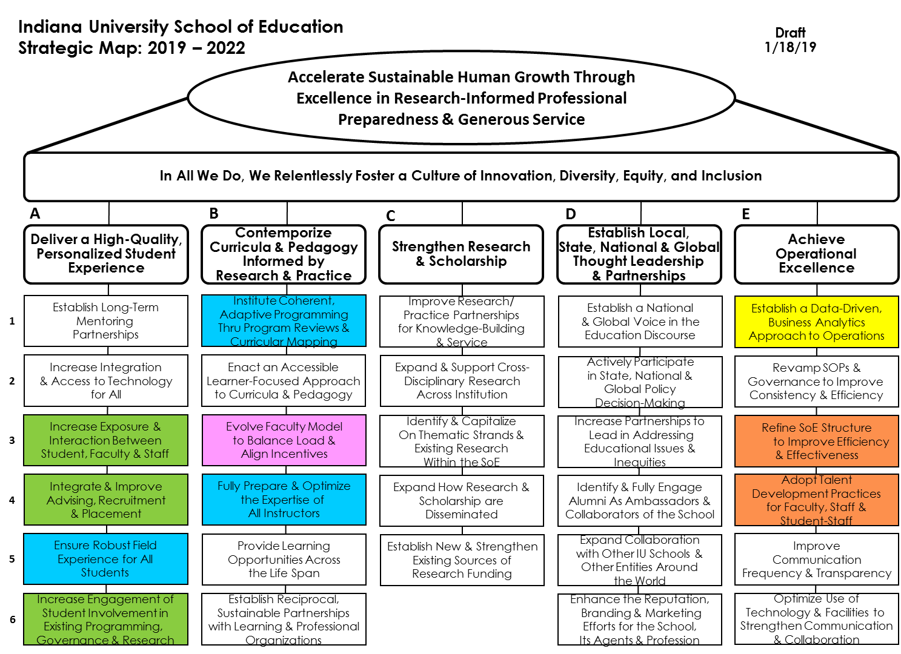
Strategic Initiatives and Priorities (short-term)

INDIANA UNIVERSITY SCHOOL OF EDUCATION

Indiana University School of Education Strategic Map: 2019 – 2022
Accelerate Sustainable Human Growth Through Excellence in Research-Informed Professional Preparedness & Generous Service

Draft 1/18/19

In All We Do, We Relentlessly Foster a Culture of Innovation, Diversity, Equity, and Inclusion

A

Deliver a High-Quality,
B C

Contemporize
D

Establish Local,
E

Achieve

Personalized Student Experience

Establish Long-Term
- Mentoring
Partnerships

Increase Integration
- & Access to Technology
for All

Increase Exposure &
- Interaction Between Student, Faculty & Staff

Integrate & Improve
- Advising, Recruitment & Placement

Ensure Robust Field
- Experience for All Students
Increase Engagement of Student Involvement in
- Existing Programming,
Governance & Research

Curricula & Pedagogy Informed by
Research & Practice
Institute Coherent, Adaptive Programming Thru Program Reviews & Curricular Mapping
Enact an Accessible Learner-Focused Approach to Curricula & Pedagogy

Evolve Faculty Model to Balance Load & Align Incentives

Fully Prepare & Optimize the Expertise of
All Instructors

Provide Learning Opportunities Across the Life Span
Establish Reciprocal, Sustainable Partnerships with Learning & Professional Organizations

Strengthen Research & Scholarship

Improve Research/ Practice Partnerships for Knowledge-Building & Service
Presenter Notes
2024-03-26 16:37:24
--------------------------------------------
The fifth track of work – highlighted in orange – is Enhance Talent Management. It includes Strategic Objectives E-3 and E-4. As we move forward with implementing the strategic map, these five areas will receive priority for the first twelve months.
Expand & Support Cross- Disciplinary Research Across Institution
Identify & Capitalize On Thematic Strands & Existing Research Within the SoE
Expand How Research & Scholarship are Disseminated

Establish New & Strengthen Existing Sources of Research Funding

State, National & Global Thought Leadership
& Partnerships

Establish a National & Global Voice in the Education Discourse
Actively Participate in State, National & Global Policy Decision-Making
Increase Partnerships to Lead in Addressing Educational Issues & Inequities
Identify & Fully Engage Alumni As Ambassadors & Collaborators of the School
Expand Collaboration with Other IU Schools & Other Entities Around the World
Enhance the Reputation, Branding & Marketing Efforts for the School,
Its Agents & Profession

Operational Excellence

Establish a Data-Driven, Business Analytics Approach to Operations

Revamp SOPs & Governance to Improve Consistency & Efficiency

Refine SoE Structure
to Improve Efficiency & Effectiveness
Adopt Talent Development Practices for Faculty, Staff & Student-Staff
Improve Communication
Frequency & Transparency
Optimize Use of Technology & Facilities to Strengthen Communication & Collaboration

Dean’s Job Announcement

Opportunities & Challenges
- Define a distinctive identity for the School, one which incorporates scholarly excellence, service, and global presence into a cohesive vision for the future.

- Innovate to grow enrollment, attract top undergraduate and graduate students, and ensure long-term sustainability.

INDIANA UNIVERSITY SCHOOL OF EDUCATION

Dean’s Job Announcement

Opportunities & Challenges
- Assess and refine the School’s infrastructure to enhance support for students, cultivate faculty, and encourage collaboration across departments and programs.

- Forge strong relationships with partners across campus and the educational community in Indiana and beyond.

INDIANA UNIVERSITY SCHOOL OF EDUCATION

Dean’s Job Announcement

Opportunities & Challenges
- Manage a complex enterprise and grow the financial resources of the School.

- Advance commitment to diversity, inclusion, and social justice of the School.

INDIANA UNIVERSITY SCHOOL OF EDUCATION

Getting There

- I have already begun to move on those things for which the Dean’s Office has direct responsibility.

- Retreat scheduled for May - in conjunction with Long-Range Planning Committee – to identify the scope of work and who will be responsible for what.

- We will be working over the summer to get ready for the SoE Faculty Retreat (Date TBD) to share work to be done.

Updates to Dean’s Office Suite

- Reporting roles

- Permanent terms for current interims

- Closed search for Associate Dean for Diversity, Equity, and Inclusion and re-evaluating role at IU and scope of work to be done in the SoE

- Hiring

- Center (Research Centers, Service Centers, and Institutes)

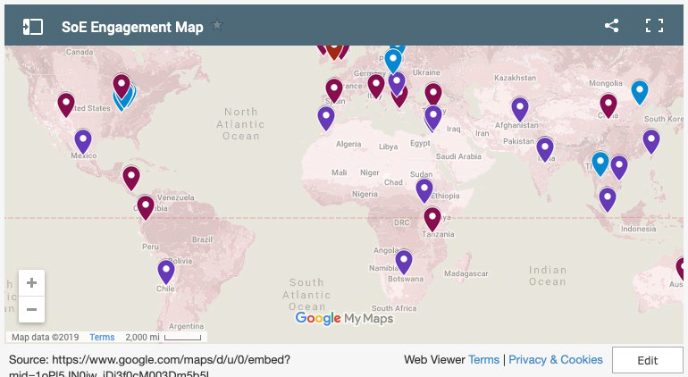

INDIANA UNIVERSITY SCHOOL OF EDUCATION

Update on International Visits from the Year
  - Turkey
  - Thailand
  - Kosovo
  - Ethiopia

INDIANA UNIVERSITY SCHOOL OF EDUCATION

Themes for requests
  - Special education
  - Science and technology
  - Leadership and management
  - Enhancement of teacher education and systemic changes for P-20 education
  - Experienced practitioners who also have research and policy knowledge to help with transformation . . . .

INDIANA UNIVERSITY SCHOOL OF EDUCATION

In Memoriam


David Estell
Associate Professor
Department of Counseling and Educational Psychology Human Development, School Psychology

June 29, 1973 – February 19, 2019

Where our funding goes

General Fund Expenses FY19 - Provost Presentation

General 2.72%
Travel & Other

1.00%
Transfers 2.84%
Operating Loss (Cash)
-2.63%

Financial Aid 11.86%

Compensation 84.22%

Compensation Financial Aid General Travel & Other Transfers Operating Loss (Cash)

Where our funding comes from

General Fund Revenue Net of Assessments FY19 - Provost Presentation

Other
Assessments

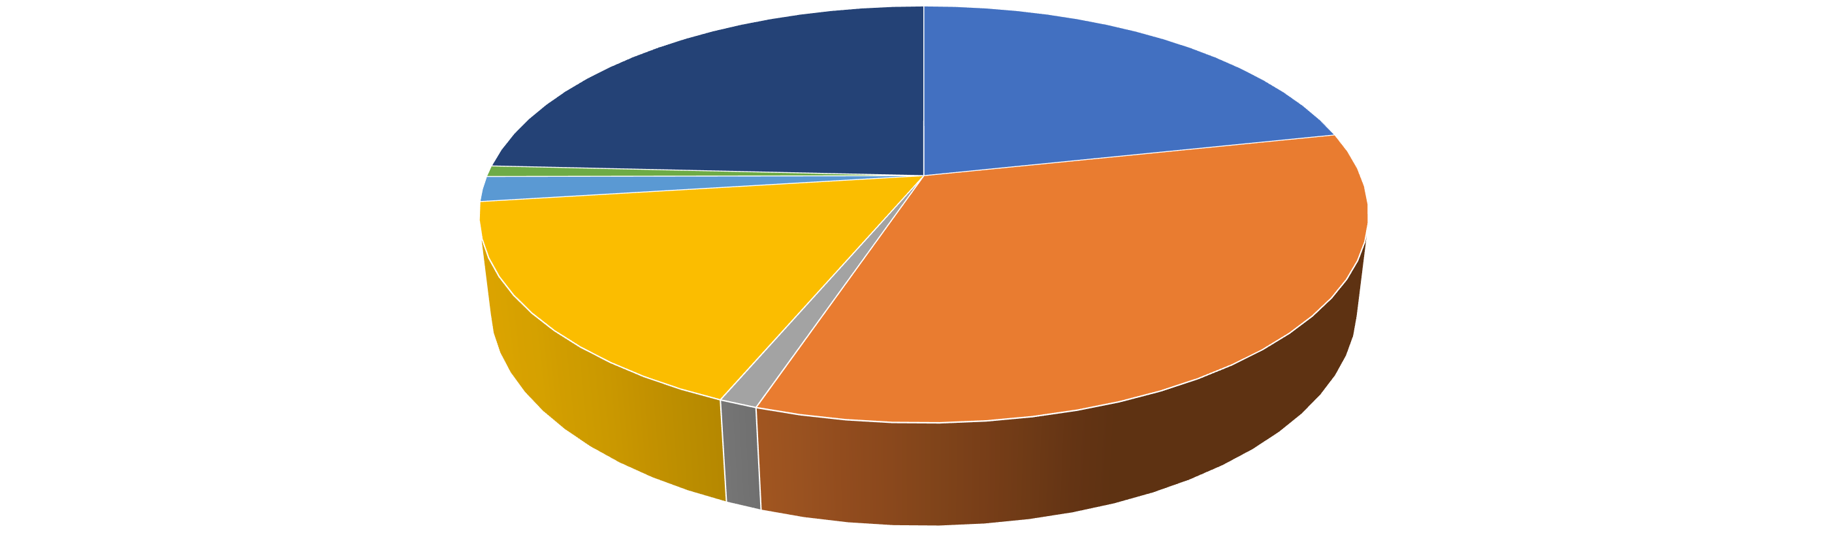
1.64%
-46.98%
GRAD Tuition Income
41.94%
ICR
3.77%
State Appropriation
32.38%
UGRAD Tuition Income
64.97%
Other Student Fees 2.29%
GRAD Tuition Income UGRAD Tuition Income Other Student Fees State Appropriation ICR Other Assessments

General Fund Trends

32,000,000

Base Funded Net Revenue by Fiscal Year - Loss of $3.94M Over Eight Years


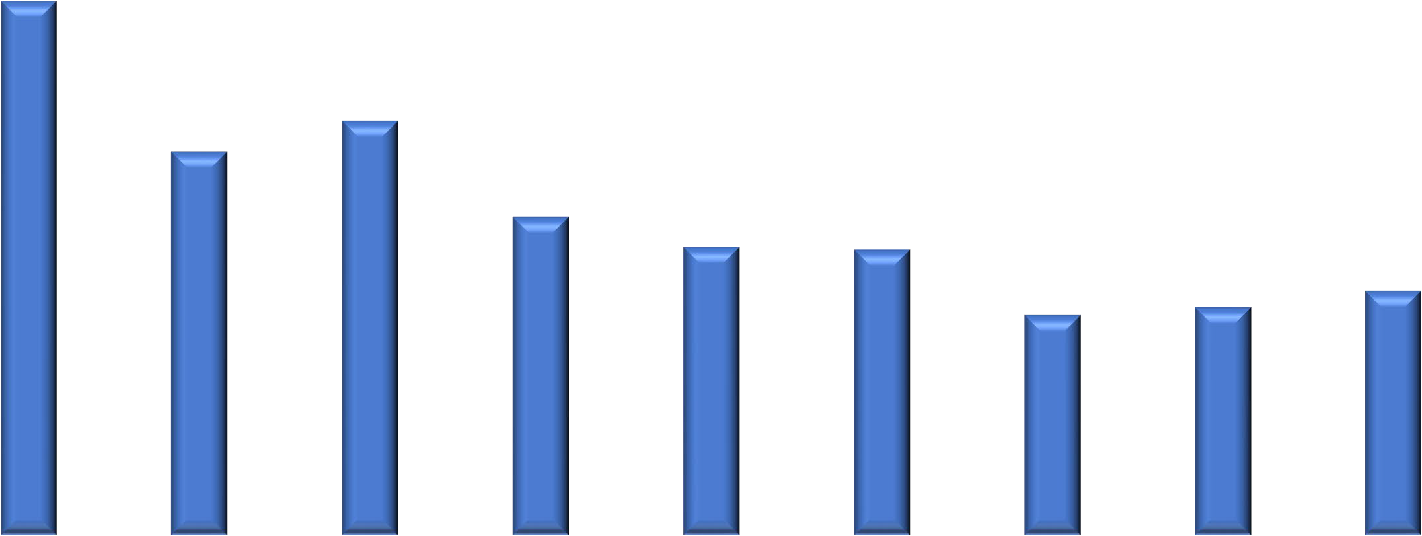
31,000,000
1.4%
-6.5%
-4.4%
-1.4%
-0.1%
0.8%
-3.2%
0.4%

30,000,000

29,000,000

28,000,000

27,000,000

26,000,000

25,000,000

24,000,000
FY14 FY15 FY16 FY17 FY18 FY19 FY20 FY21 FY22

Spring 2019 Course Enrollment Table

Department | Undergrad Sections Offered | Undergrad Sections Under  Enrolled | %  Under enrolled | Graduate Sections Offered | Graduate Sections Under  Enrolled | %  Under enrolled
C&I | 109 | 38 | 35% | 51 | 26 | 51%
CEP | 41 | 7 | 17% | 78 | 19 | 24%
ELPS | 43 | 2 | 5% | 52 | 8 | 15%
IST | 12 | 5 | 42% | 28 | 10 | 36%
LCLE | 21 | 12 | 57% | 35 | 8 | 23%
School-wide totals | 226 | 64 | 29% | 244 | 71 | 29%
- Co-taught sections are counted as one
- Sections with 0 Spring enrollment are not counted
- Sections that do not count toward teaching load
(e.g., independent studies) are included in the number of sections offered but not as under-enrolled

Who Teaches Under Enrolled Sections?

 | Faculty |  | AI |  | Other
Department | # | % | # | % | # | %
C&I | 35 | 55% | 19 | 30% | 10 | 15%
CEP | 18 | 69% | 7 | 27% | 1 | 4%
ELPS | 8 | 80% | 1 | 10% | 1 | 10%
IST | 11 | 73% | 3 | 20% | 1 | 7%
LCLE | 11 | 52% | 6 | 29% | 4 | 19%
School-wide totals | 83 | 61% | 36 | 27% | 17 | 12%

Sponsored Research Trends

 | FY 2014 | FY 2015 | FY 2016 | FY 2017 | FY 2018 | FY 2019  (July - February)
Proposal Numbers | 121 | 112 | 116 | 150 | 132 | 46
Proposal Dollars | $41,318,410 | $50,600,487 | $46,813,653 | $65,209,506 | $62,524,113 | $23,118,353
Award Numbers | 63 | 62 | 67 | 76 | 56 | 35
Award Dollars | $8,322,828 | $10,542,550 | $11,087,241 | $7,013,361 | $9,821,041 | $5,913,867
Indirect Dollars | $1,496,746 | $1,404,003 | $1,316,966 | $1,141,643 | $1,217,689 | $1,594,135

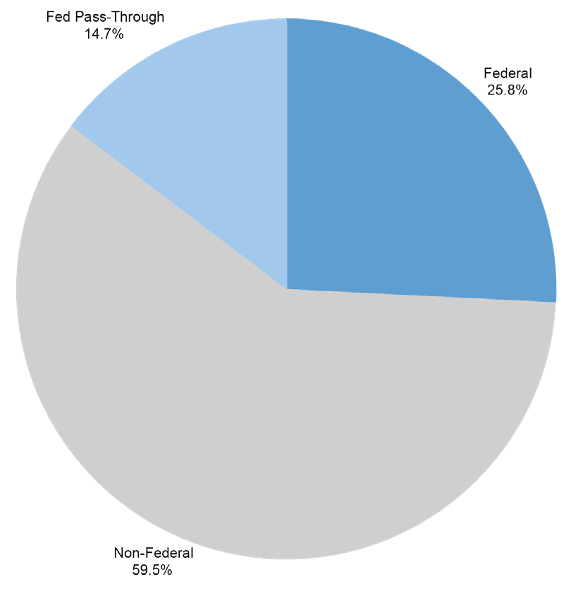
Awards by Source, Federal vs. Non-Federal

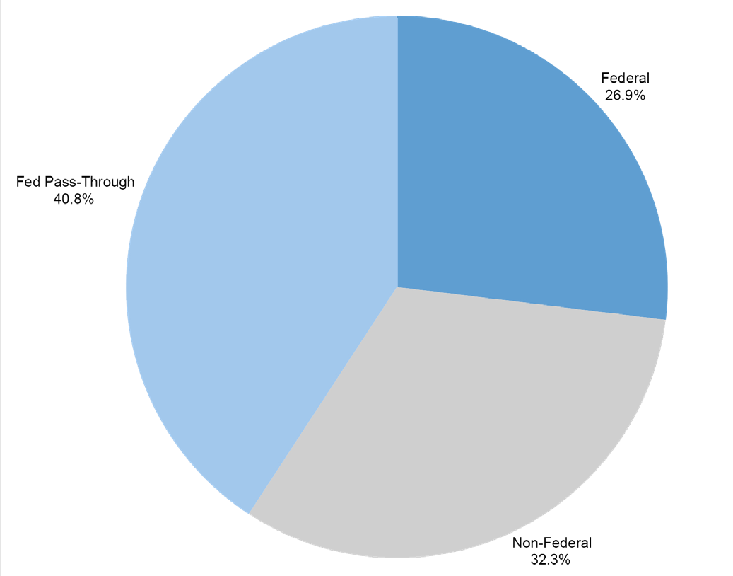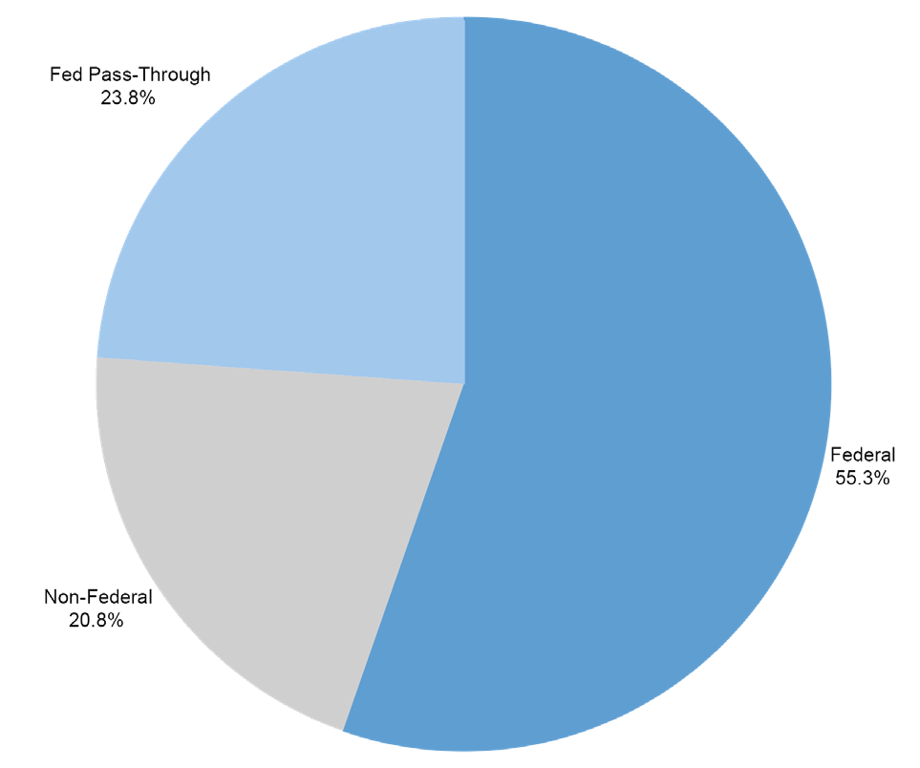
2014 2016 2018

Source of Non-Federal Awards
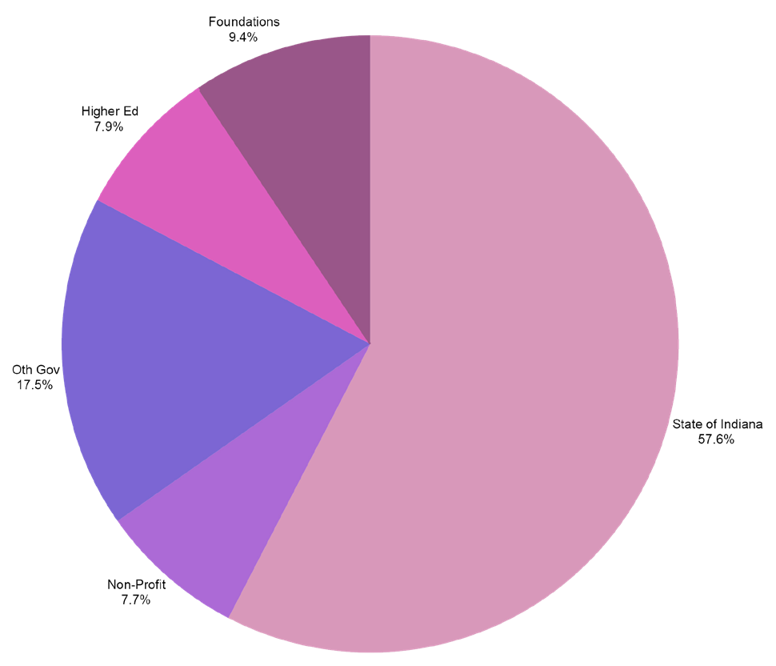
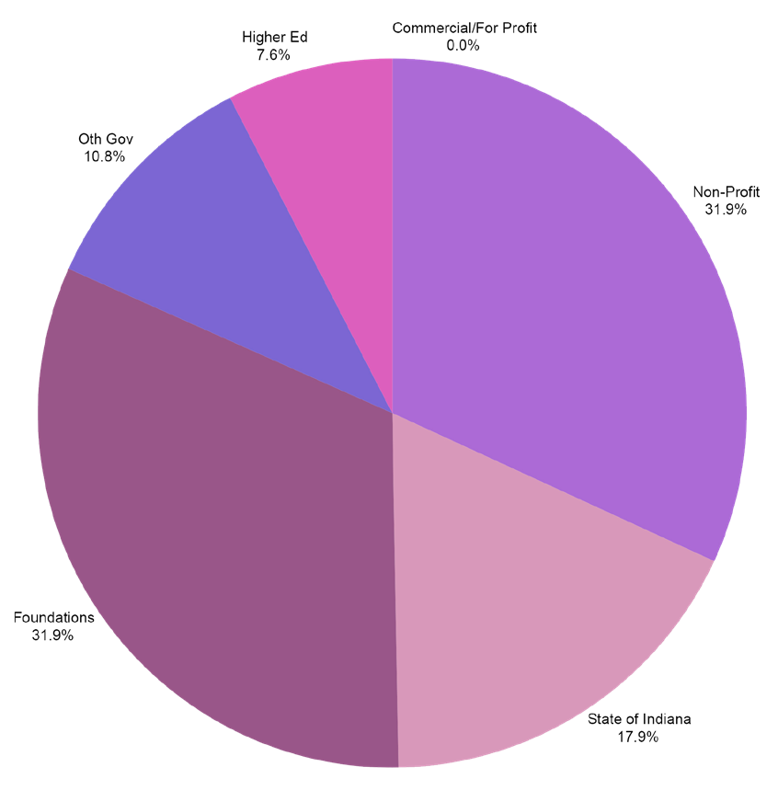
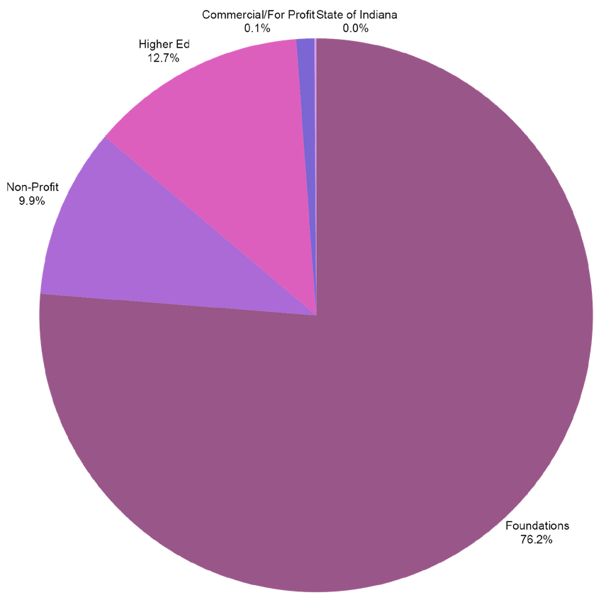
2014 2016 2018

Creative Paths to Peace

Suzanne Eckes
International Collaboration on Human Rights and Marginalized Population in Schools

Kempf

Valarie Akerson
Assessment of K-12 Students' Science and Literacy Knowledge

Proffitt

Ana Maria Brannan
Improving edTPA Inter-Rater Reliability and Training

Daniel Castner
Experiencing Quality Early Education: A Multi-Case Phenomenological Study

Christopher Lubienski
Using Geo-Spatial Analyses to Map the Arrangement of School Options in Indiana

Proffitt Summer Faculty Fellowship

Erik Jacobson
Examining the Role of Teacher Gesture When Making Sense of Student Mathematical Work

Tina O’Neal
The Effects of Professional Development Workshops and Module-Based Guided Reflections on Pre-Service Teachers Self-Efficacy on the Usability and Implementation of Assistive Technology

Gustave Weltsek
Arts and Youths' Sense of Political Agency: An Arts Inquiry Partnership

2018-19 R&D Events

Date | Presenter | Topic
April 2019 | Faculty Panel (TBD) | Graduate Student Publishing: Managing Research Expectations and Collaborations
March 2019 | Panel Discussion: Sara Lubienski, Dubravka Sventina, Kevin Fosnacht, Gayle Buck | Navigating Graduate School and Beyond
February 2019 | Esen Gokpinar-Shelton , AJ Asomani-Adem | GradGrants Center
January 2019 | Adam Mills | FERPA and Human Subjects Research, Parental/ Guardian Consent and Child Assent in Research
November 2018 | All R&D Centers | Poster Session: Fostering Discussions with the R&D Research Centers and the projects they support
October 2018 | R&D Office | Internal Grants Poster Session
October 2018 | Mary Dwyer & Cory Rutz | Foundation Grants
September 2018 | Adam Mills | IU Human Subjects

Ed.D. Program Revisions
Background: We award the Ed.D. — not UGS

New Policies Approved by GSC and Policy Council:
- Merger of program and research committees
- Residency requirements set by programs
- Programs no longer need to require a minor
#1 and #2 effective immediately.
#3: Programs must change requirements and go through approvals to eliminate minor.

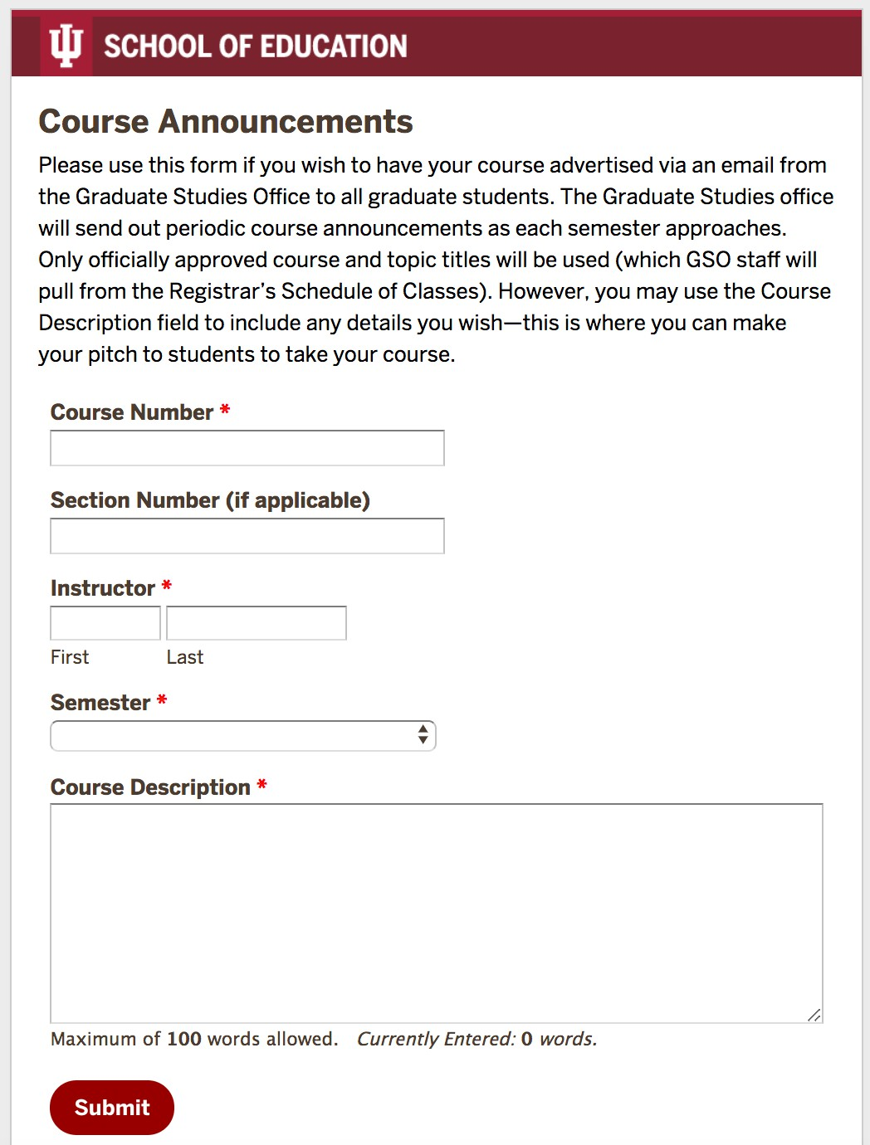

Other News
Graduate Student Convocation with Hooding
Friday, May 3 at 6 pm
Course announcements now go to GSO (see your email).

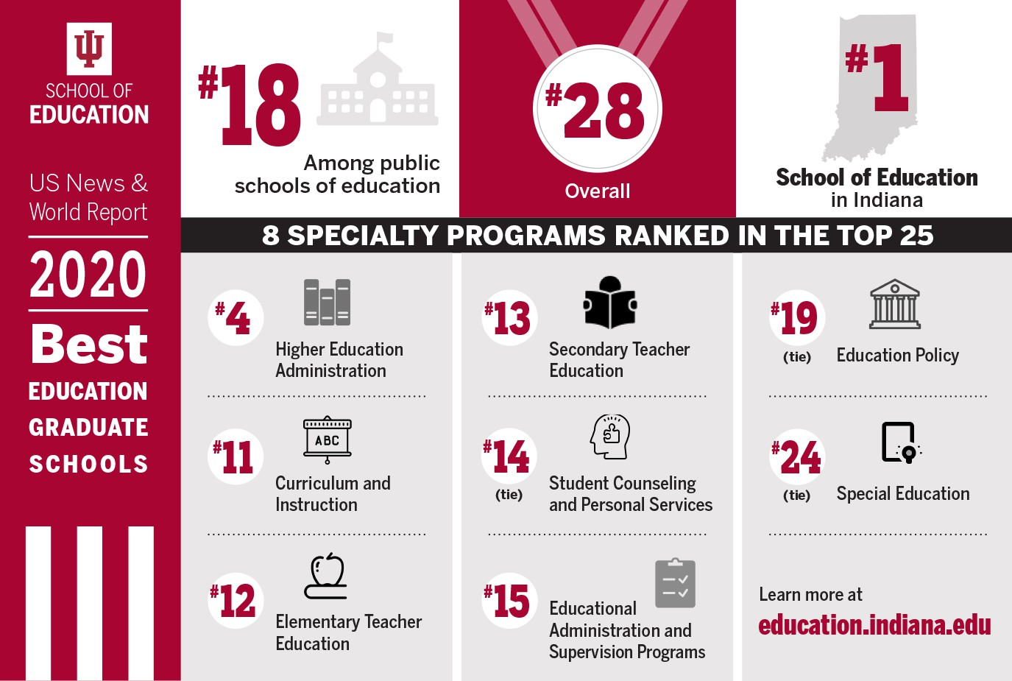

Q&A - Discussion

Other faculty updates



Lunch on atrium balcony

