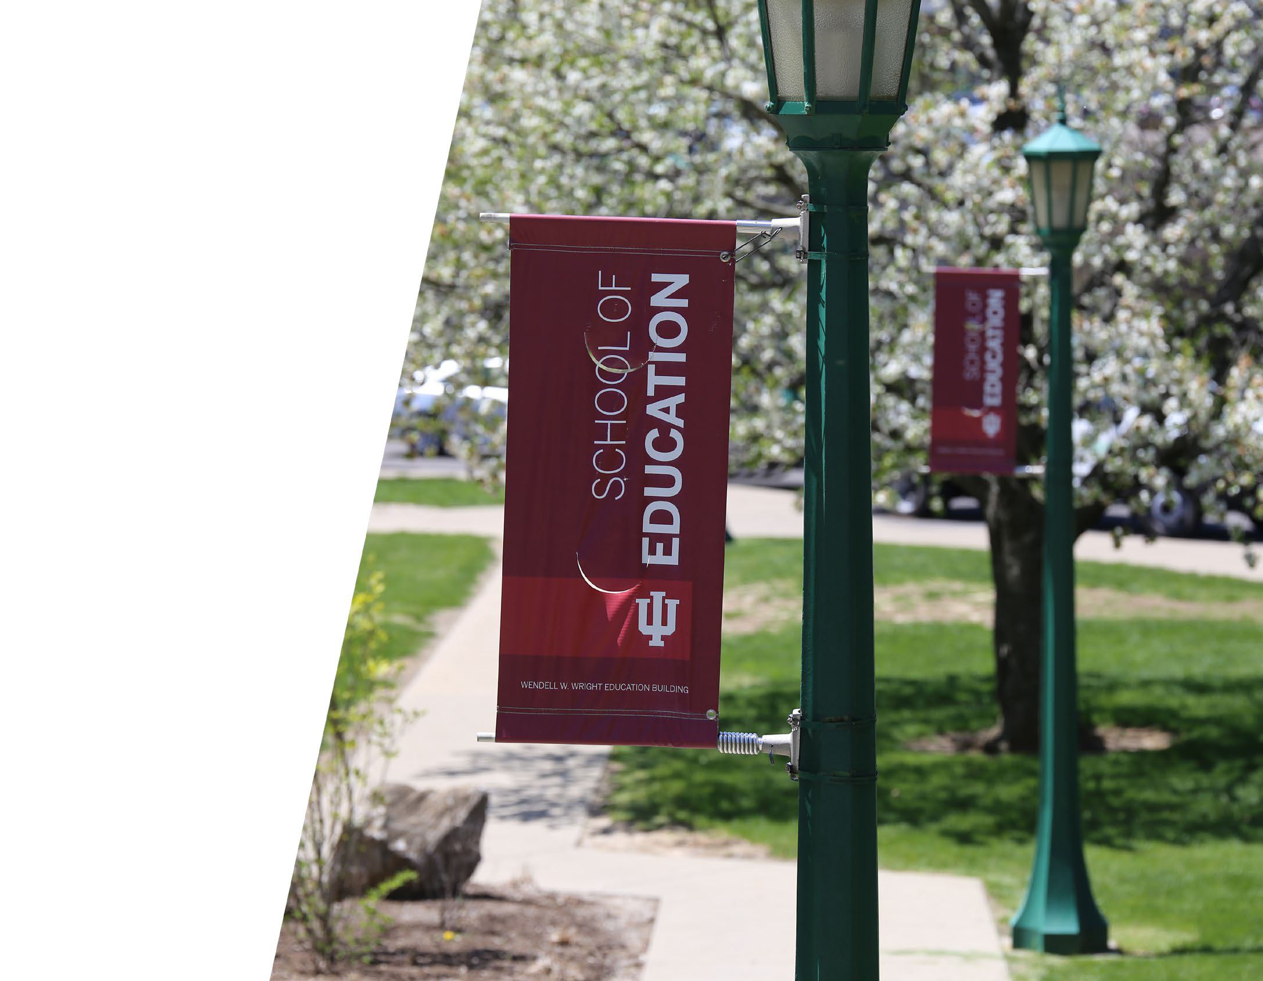

School of Education

Fall Faculty Meeting
Friday, November 1, 2019

Welcome
Jessica Lester, Faculty Policy Council Chair

Counseling and Educational Psychology
Joel Wong, Chair

Programs

- Counseling/Counseling Psychology
- Human Development
- Inquiry Methodology
- Learning Sciences
- School Psychology

CEP’s Distinctiveness
Presenter Notes
2024-03-27 14:49:28
--------------------------------------------
Context in which we operate.

Mission of the IUB School of Education:

- Our mission is to improve teaching, learning, and human development in a global, diverse, rapidly changing, and increasingly technological society.

CEP’s Distinctiveness
Learning and Human Development Context

Learning

Teaching

Human Development
  - Families
  - Culture
  - Race
  - Mental Health
  - School environments
  - Media


Presenter Notes
2024-03-27 14:49:28
--------------------------------------------
Not all forms of learning takes place within the context of teaching. Students go to a book or Youtube to learn (but there is no teacher). Human development is an even broader concept – here’s we’re no longer talking about acquiring knowledge and skills – we’re talking about how people change and grow over time. For example, someone who is become Context – learning, teaching,

SCHOOL OF EDUCATION

CEP by the Numbers

- 26 – number of full-time faculty members in CEP.
- 2,344 – number of undergraduate credit hours in spring 2018.
- 2,257 – number of graduate credit hours in spring 2018.
- 8 – number of CEP faculty members who are editors or associate editors of peer-reviewed journals.
- $13,906,751 – total amount of external grant money obtained by CEP faculty members over the past 5 years.

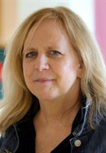

Lucinda Carspecken

Lucinda Carspecken received an Honorable Mention
from AERA’s Qualitative Research Special Interest Group's Outstanding Book Award Committee for 2019.


Joshua Danish
Joshua Danish and colleagues received a
$1.25 million grant from the NSF to explore how elementary students can use embodiment as a way to create and systematically revise scientific models.

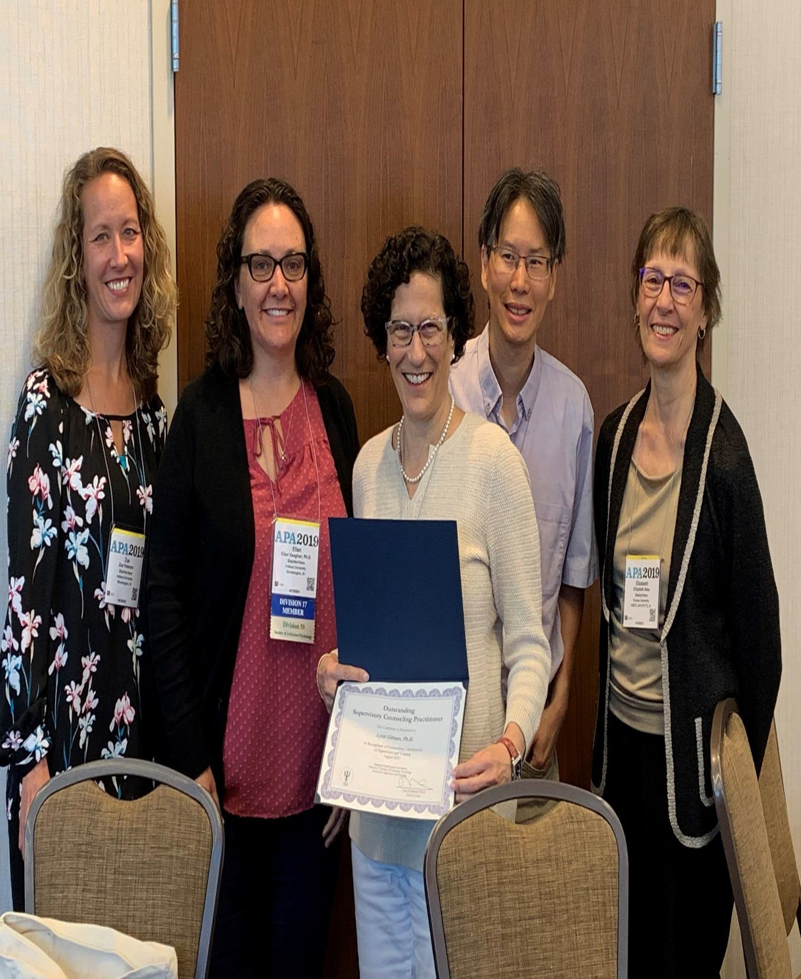
Lynn Gilman
Lynn Gilman received the Outstanding Counseling Supervisor Award for 2019 from the Supervision & Training Section (STS) of the Society for Counseling Psychology



Jessica Lester
Jessica Lester had two books published in 2019 — one with Sage focused on applied conversation analysis for studying social interactions and the other with Springer focused on using naturally occurring data for health research.



Heather Ormiston
Heather Ormiston received a 5- year, $2.5 million Department of Education grant to develop a trauma-informed support framework within the Richland Bean Blossom Community School Corporation.

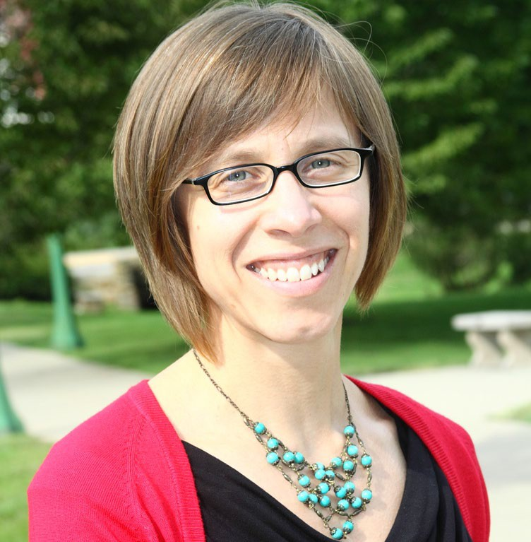

Leslie Rutkowski

Leslie Rutkowski and David Rutkowski are co-authors of a World Bank-commissioned report on appropriately using international
educational achievement data.



Jesse Steinfeldt
Jesse Steinfeldt became a Fellow of the American Psychological Association through two divisions -- Divisions 51 (Men and Masculinities) and 17 (Counseling Psychology).



Rex Stockton
Rex Stockton received the IU Bicentennial Medal in recognition of distinguished and distinctive service in support of the mission of Indiana University on the occasion of his 50th year at IU.


Dubravka Svetina
Dubravka Svetina was selected as the program chair of Division D (Measurement and Research Methodologies) in AERA; in this role, she organizes the division’s program for the AERA conference in 2020.

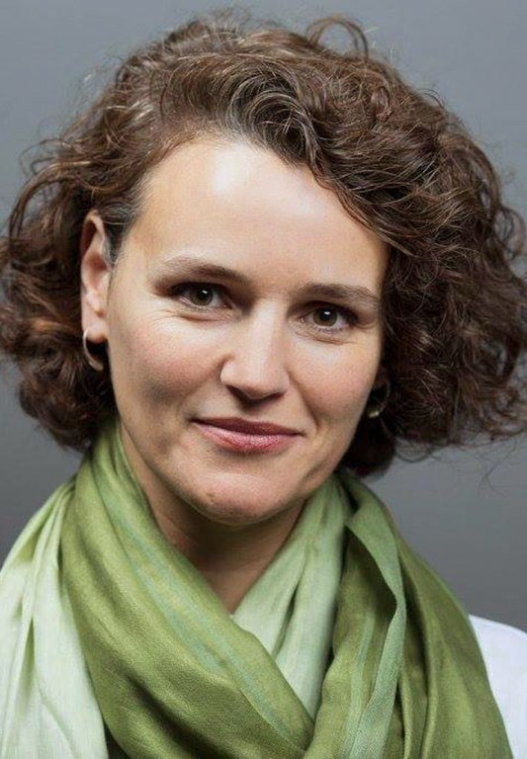
Mary Waldron

Mary Waldron was elected Chair of the IU (all-campus) Graduate Faculty Council (GFC), the representative body of the Graduate Faculty. The GFC provides instruction and guidance on all matters related to graduate education.

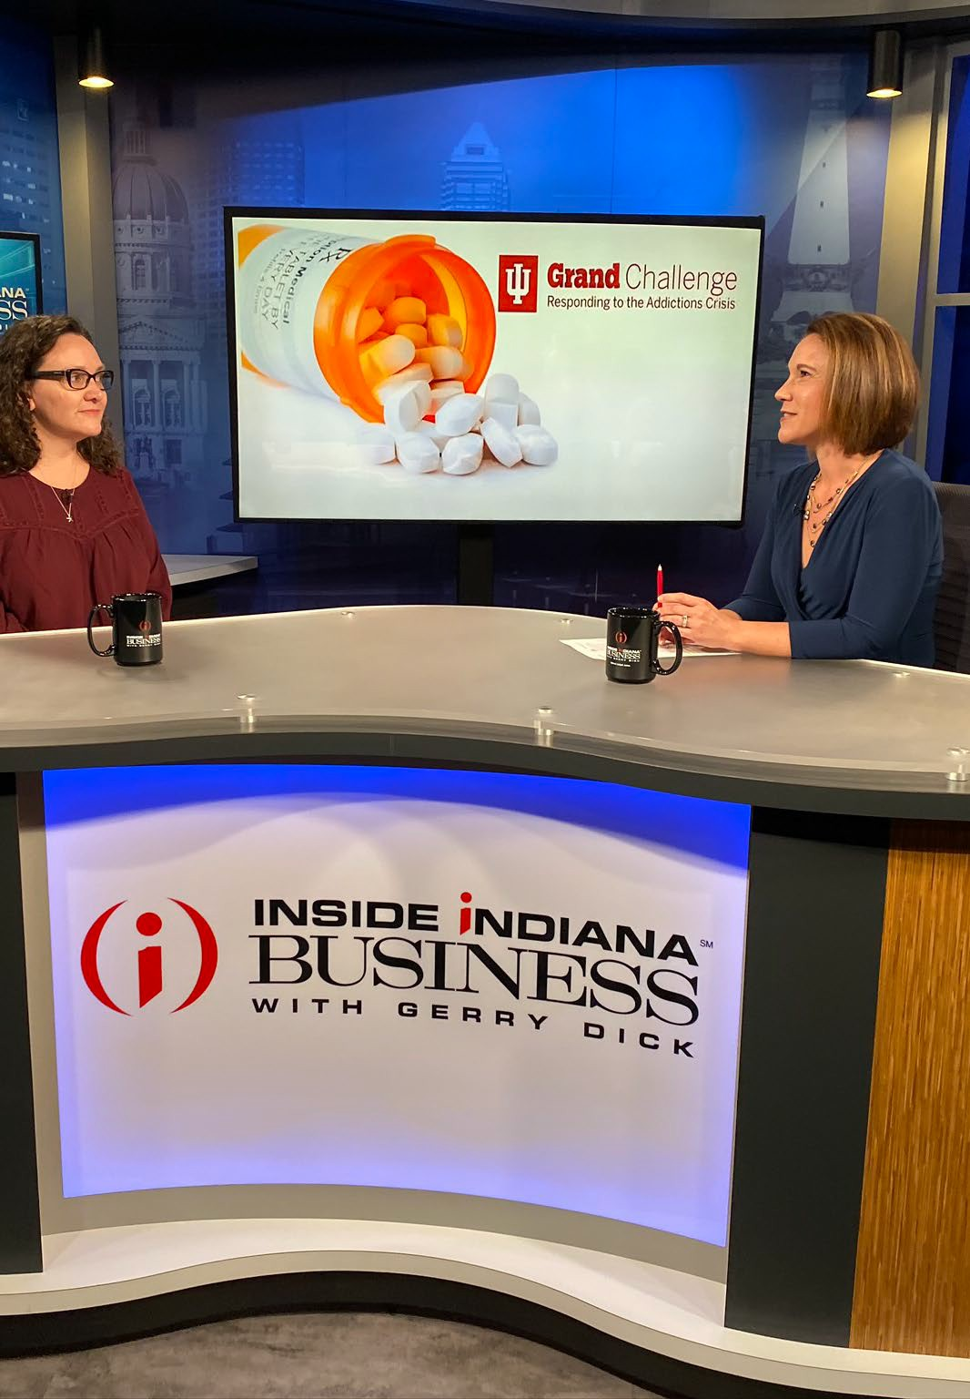

Ellen Vaughan

Ellen Vaughan was on WFYI and WISH-TV to discuss the 2- year anniversary of IU’s Responding to the Addictions Crisis Grand Challenge and the new Addictions Counseling track.

CEP’s Challenges and Needs

Need for greater racial diversity in our faculty
- Out of 26 faculty members, only 4 are faculty of color (no African Americans). We need more racially diverse faculty members, especially African Americans.

Future Directions
- New undergraduate major in Counseling and Student Services (CASS).
- New online graduate certificate in qualitative research.
- Proposal for a Social Justice in Education conference organized by the School Psychology Program.
- Proposal for a new master’s degree in Learning Analytics (interdisciplinary collaboration with Informatics, IST, and CEP).

Curriculum and Instruction
Jeff Anderson, Chair

Curriculum & Instruction

- We provide the majority of curricular experiences for School of Education’s teacher candidates.

- Our graduates are working in private, public, and charter schools, as well as daycare centers, after-school programs, colleges and universities (domestic and abroad), online programs, museums, community agencies and centers, and in a host of professional settings.

- Our faculty combine a deep commitment to quality instruction with impressive scholarly activity and impact on policy and practice throughout Indiana and across the globe.

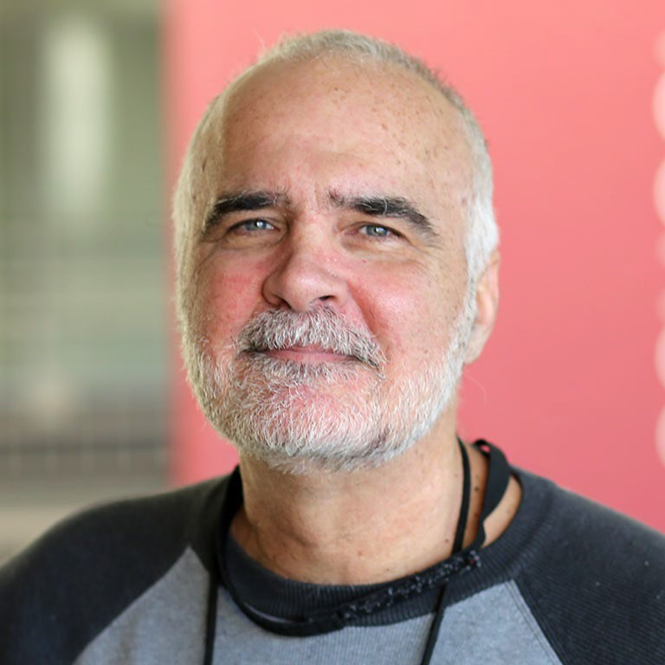


Jeff Anderson & Mary McMullen

SCHOOL OF EDUCATION


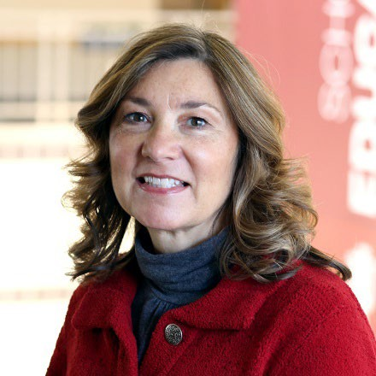  Laura Robinson – Department Administrator | 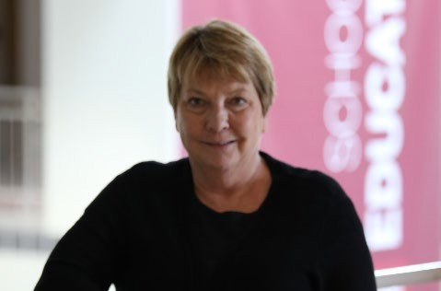  Sara White – Administrative Secretary
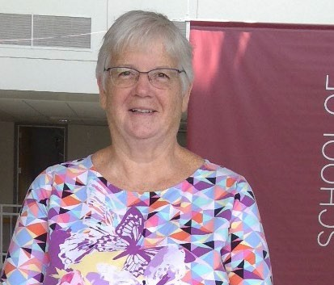  Sara Sturgeon –  Sara Sturgeon - Administrative Secretary and Travel Representative | 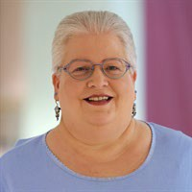  Brenda Helms – Support Staff










Gabriele Abowd Damico |  |  | Gus Weltsek
Lara Lackey |  | 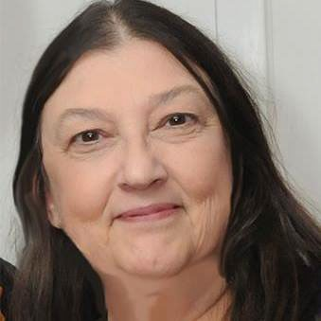 | Marjorie Manifold


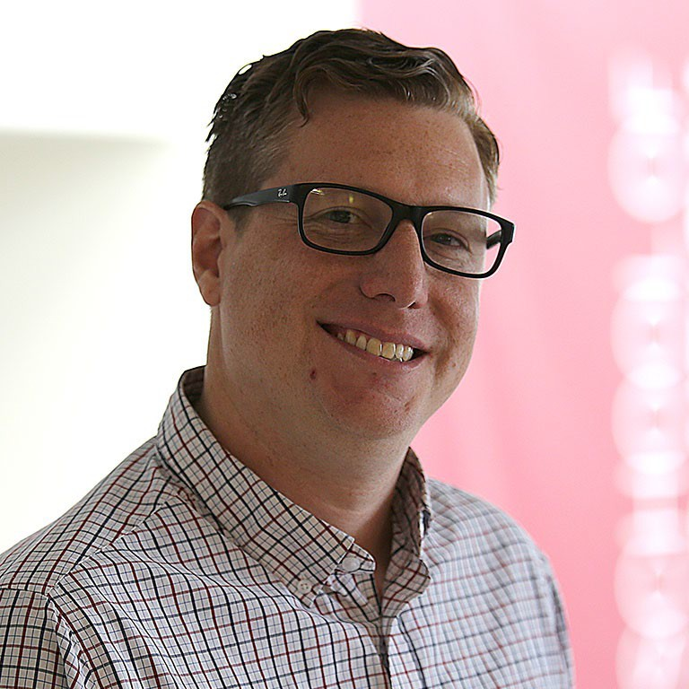


Dan Castner Mary McMullen


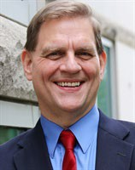  Keith Barton | 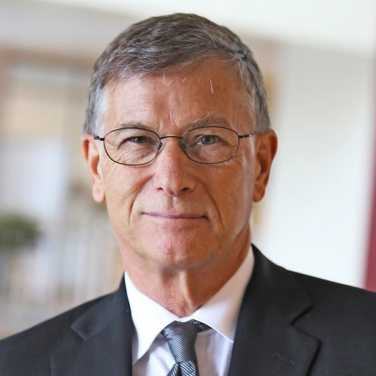  Terry Mason |   Rob Kunzman | 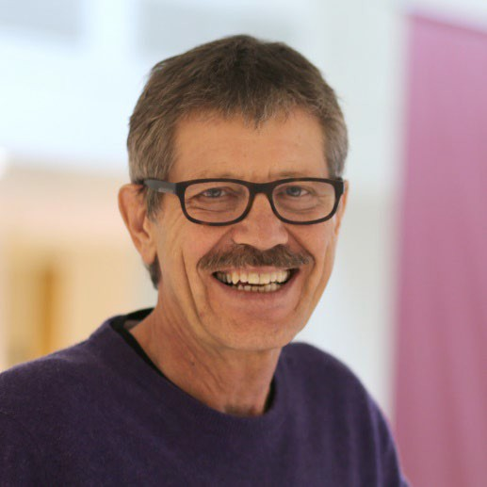  David Flinders
  Alex Cuenca | 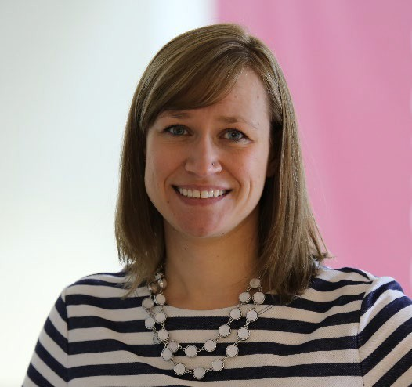  Kathryn Engebretson |   Patty Kubow

  Amy Hackenberg | 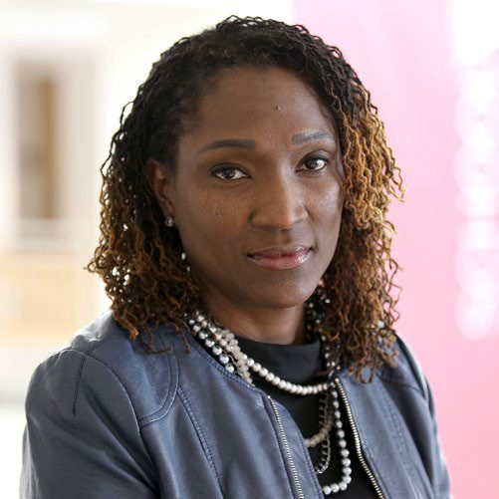  Dionne Cross Francis | 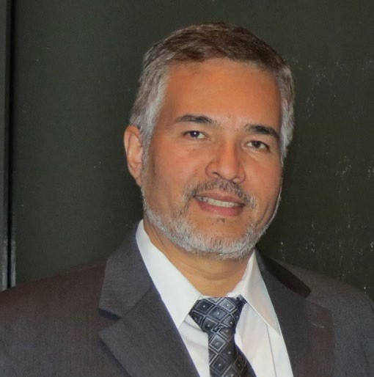  Enrique Galindo
  Erik Jacobson |   Erik Tillema |   Sarah Lubienski


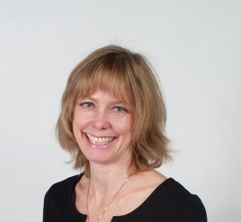  Valarie Akerson | 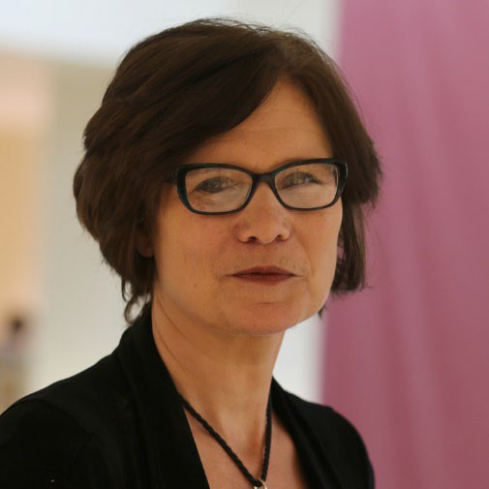  Gayle Buck
  Adam Maltese | 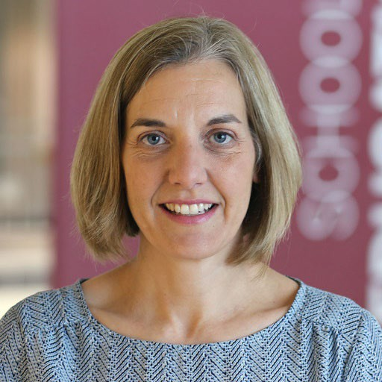  Meredith Park Rogers


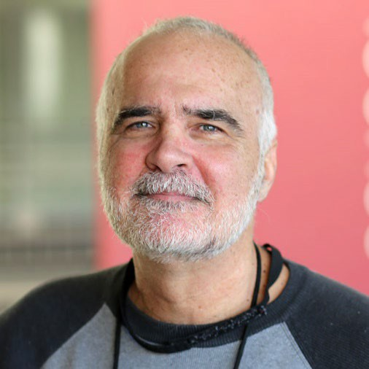  Jeff Anderson | 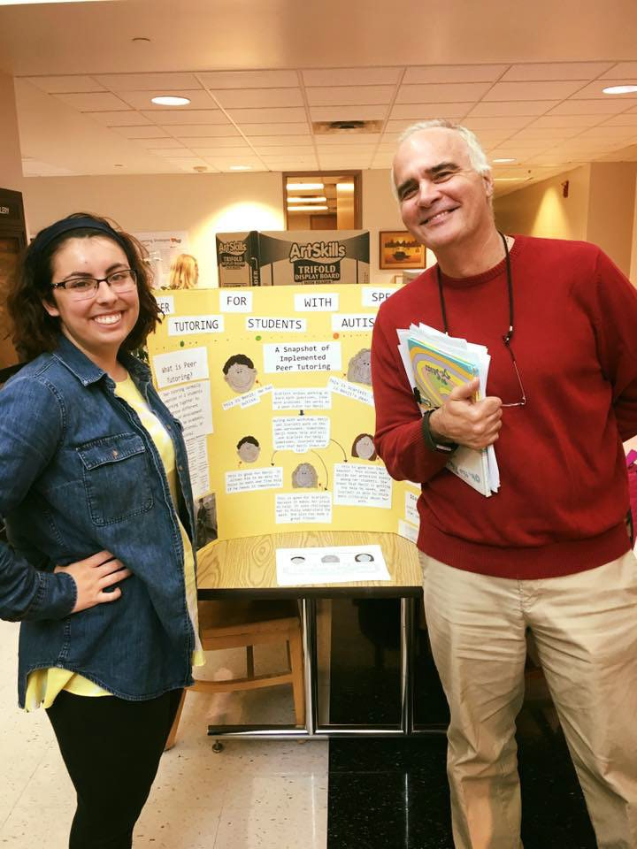    Ana Maria Brannan |   Gretchen Butera
Sarah Hurwitz | 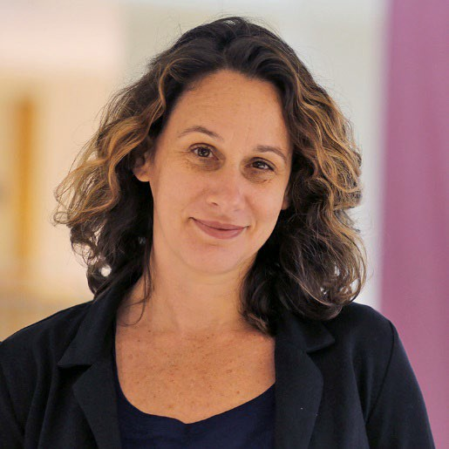 | Derek Nord | 


Theresa Ochoa | 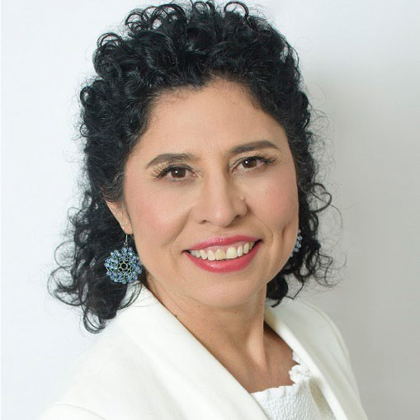 | 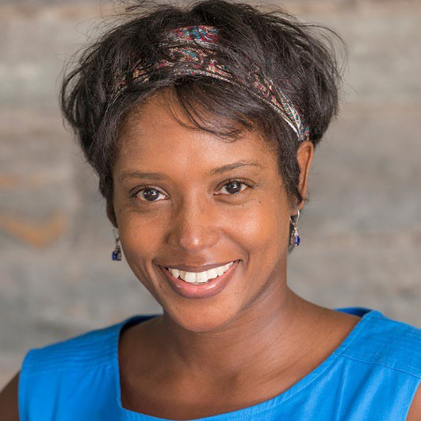 | Tina O’Neal
Hannah Schertz |  |  | Kelly Williams



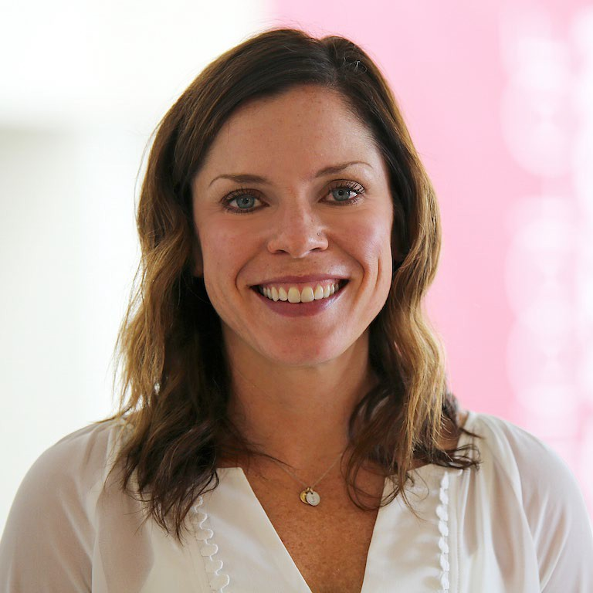

Aly Elfreich

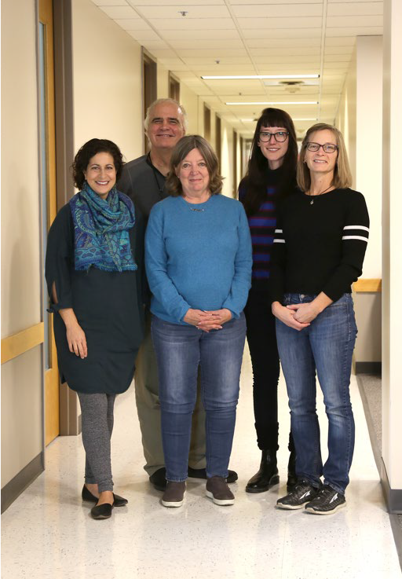
A Community of Teachers
- Created more than 25 years ago to offer a program based on democratic principles
- Core mentorship
- Student-oriented seminar pedagogy courses
- Performance- and field-based teaching portfolio
- Undergraduate and graduate options, as well as face-to-face and distance formats

Our faculty and students are active.

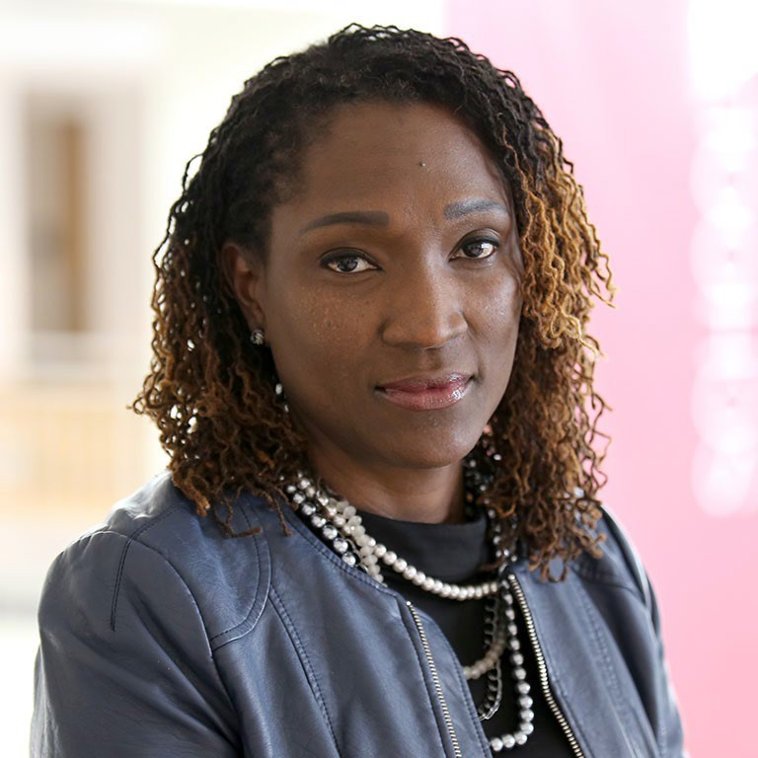
News from the C&I Department
Dionne Cross Francis was awarded a grant to investigate the experiences of Ghanaian teachers within the context of mathematics curricular reform.

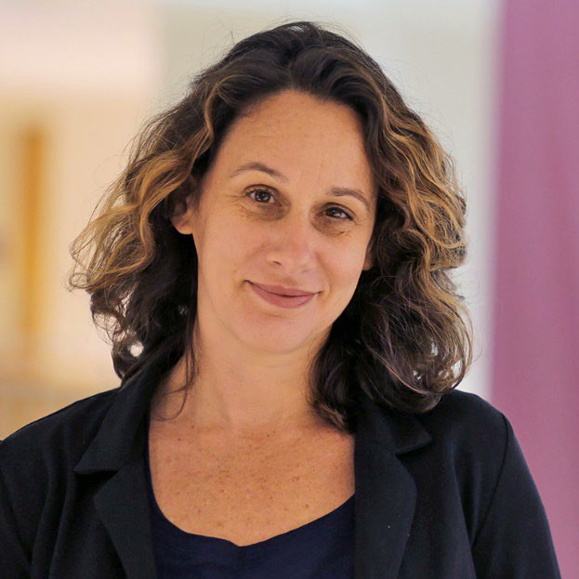
News from the C&I Department
Presenter Notes
2024-03-27 14:49:31
--------------------------------------------
Student portal walk through. This is where you’ll find information about some of the milestones and forms that you need to complete. You have two places to look - the section for what degree you’re working towards, or there are the Program Specific pages.

Sarah Hurwitz and Derek Nord
Derek Nord received state appropriation funding to study technology-based interventions for students with autism.
Along with Sarah Hurwitz, this research team will study the implementation, utilization, and outcomes of a robot technology embedded in elementary school programs. This innovative new project will be conducted in public school districts across the state.

News from the C&I Department
Presenter Notes
2024-03-27 14:49:31
--------------------------------------------
The program of studies needs to be completed with your advisor, and it outlines what courses you will be taking to complete your degree. Many of the programs have pre-filled out POS forms on the Student Portal based on the degree requirements. If not, use the bulletin to fill out your program of study. This is the contract between you and IU to determine what needs to be done for you to graduate.
Erik Tillema, Associate Professor, Mathematics Education
“Generalization Across Multiple Mathematical Areas: Studies of Classrooms and Teaching”
Co-Principal Investigator National Science Foundation

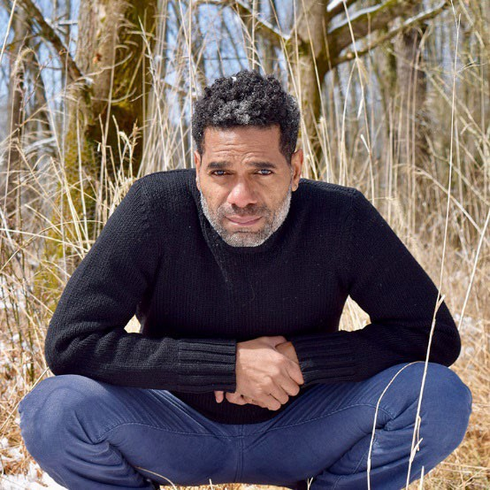
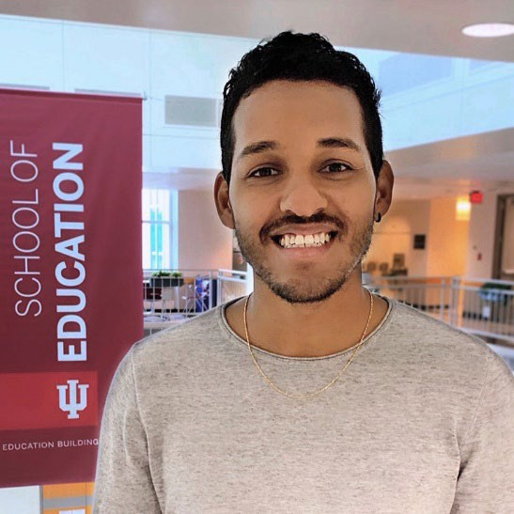

News from the C&I Department

An arts-based research project by Javier Cardona Otero, a second-year Ph.D. student in Arts Education, has been awarded a Sustainability Research Development Grant from the Indiana University Office of Sustainability.
Weverton Ataide Pinheiro, a Ph.D. student in Mathematics Education, has been awarded a research grant to study why graduate mathematics continues to be a male- dominated field.
John Andresen, Ph.D. student in Special Education was appointed as the 2019/20 student intern to the Higher Education Consortium for Special Education (HECSE).


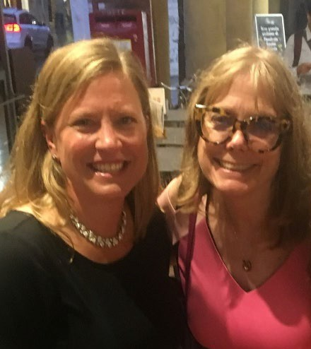

News from the C&I Department

Qiu Zhong was awarded the 2019- 2020 P.E.O. International Peace Scholarship. Financial support to woman who are studying in the United States or Canada and who desire to return to their home countries to be advocates of education, especially for woman, towards the goal of world peace.
Claire Cesljarev and Valarie Akerson (faculty) presented their work that was funded through the Kempf program at the European Science Education Research Association in Italy. Their current work comprises interviewing 100 Indiana fourth graders for their conceptions of scientific inquiry.
Meredith Park Rogers received a Collaboration Fellowship Award from The Institute for Advanced Study (IAS). She is working with colleagues on a study of how beginning teachers’ plan for and teach in ways that provide opportunities for students’ to display their mathematical and scientific thinking.


Presenter Notes
2024-03-27 14:49:32
--------------------------------------------
Please make sure to review the information in the handouts. I’ll touch on a few highlights right now, but I urge you to review the information on your own time.

Courses offered (Undergraduate and Graduate)
- Fall: 120 courses
- Spring: 100 courses
- Summer: 50 courses




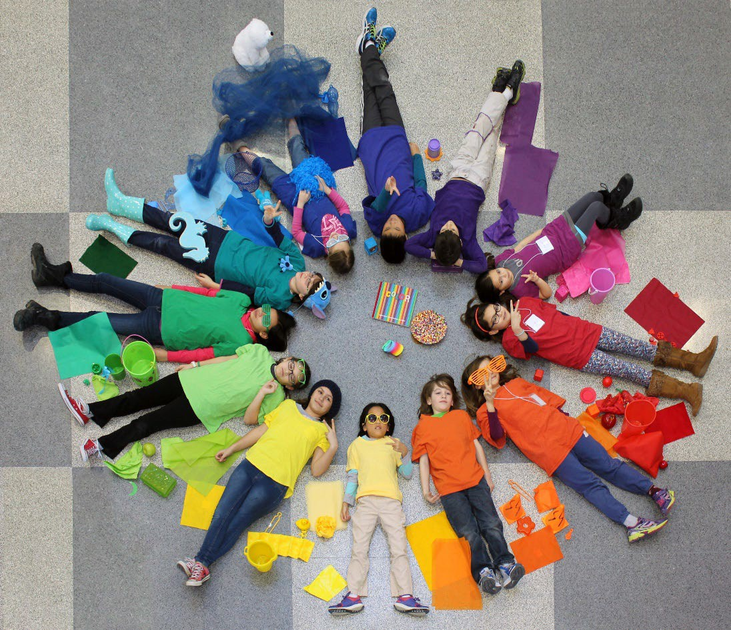
IU Saturday Art School
provides opportunities for children to experience visual arts instruction in supportive, small group settings with new themes each term.

9/3/2019 C&I Department 2019


Saturday Science Quest

  - Provides K-8 children opportunities to formulate questions, conduct hands-on science experiments, and emulate scientists/engineers

  - Serves as an authentic teaching experience for elementary education majors with science concentrations, including planning and teaching each week

New Ventures and Opportunities…
- Innovation committee
- Collaboration committee
- Partnerships
- Reimagining the PhD
- AI Certificate
- Online MA program
- Hybrid T2T

New Ventures and Opportunities…

- Enhanced field experiences for teacher candidates
- Development of additional online opportunities
- Realigning degree requirements to maximize course enrollment

Educational Leadership and Policy Studies
Vic Borden

Department Organization

Policy Studies
Foundations
Educational Leadership
Higher Education & Student Affairs
Educational Leadership and Policy Studies

Program Coordinators
- HESA – Gary Pike
- Foundations – Bradley Levinson
- Educational Leadership – Chad Lochmiller
- Policy Studies – David Rutowkski and Christopher Lubienski

Degrees Offered

Graduate Degrees offered in Educational Leadership and Policy Studies

History, Philosophy, and Policy Studies
Higher Education and Student Affairs
PhD, Ed.D.
Education Leadership
Ed.D.

PhD in History
PhD in Philosophy
PhD in Policy Studies

Concentration in International and Comparative Education
Concentration in Educational Leadership

Concentration in Higher Education

Educational Law Concentration

Individualized Concentration

Master's Degrees

- Educational Leadership (online)
- Higher Education and Student Affairs (HESA)
- History and Philosophy of Education
- International and Comparative Education (ICE)
- New online ICE

Certificates

- Certificate in Institutional Research
- Graduate and Undergraduate Certificate in Higher Education and Student Affairs
- Certificate in College Pedagogy
- Certificate in Education Law
- Recently approved Certificate in Improvement Science

Higher Education and Student Affairs



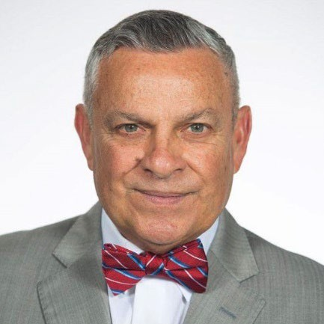


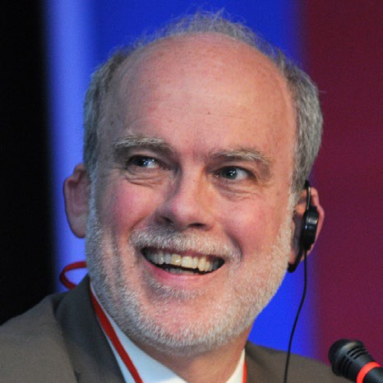
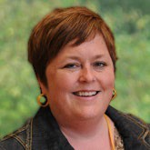
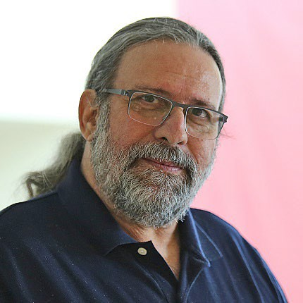
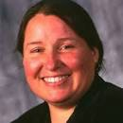
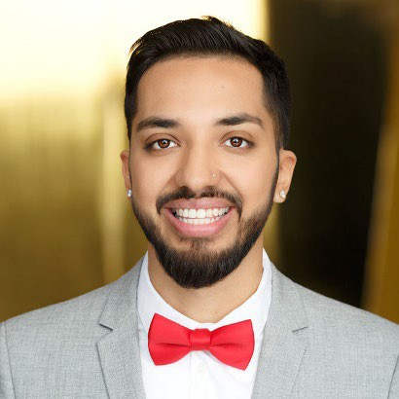

Educational Leadership

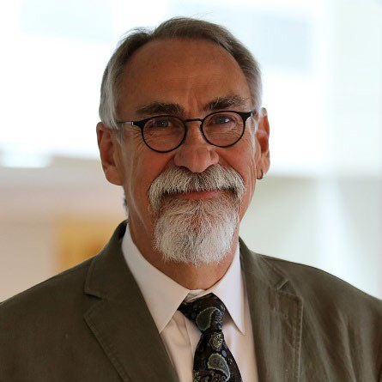

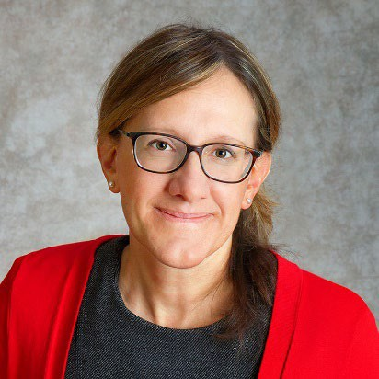
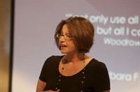




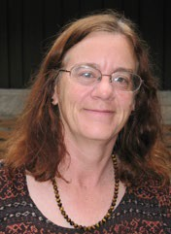
Foundations

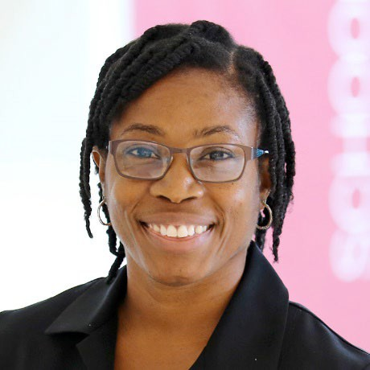


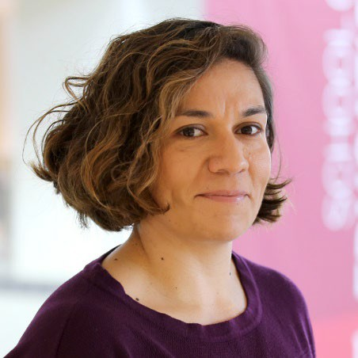

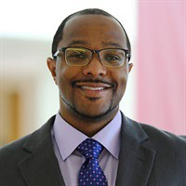


News
- Gerardo Gonzalez is one of Amazon’s top 100 Best Sellers in Latino and Hispanic Biographies (54)
- Chris Lubienski’s research was tweeted by a presidential candidate and the Indiana State Superintendent
- Bullock: https://twitter.com/GovernorBullock/status/11678 37450573467648?s=20
- McCormick: https://twitter.com/suptdrmccormick/status/11 67606964693737474

Leadership
  - Thomas Nelson Laird was named the editor of Review of Higher Education. He is also the director of the Center for Postsecondary Research.
  - Alex McCormick is the director of NSSE
  - Lucy LePeau is the Associate Director for the National Institute for Transformation and Equity
  - Victor Borden is the director of the Carnegie Classification of Institutions of Higher Education (a national project)

Leadership
  - Andrea Walton is the IUB Campus Historian, working to bring IUB’s history to life for the Bicentennial
  - Sylvia Martinez just completed a 4.5 year tenure as director of the Latino Studies Program
  - Margaret (Peg) Sutton is the director of the Southeastern Asian Studies Center
  - Dionne Danns is the Associate Vice Provost for Institutional Diversity

Instructional Systems Technology
Krista Glazewski, Chair

Who is IST?
    - We are a professional field composed of educators, instructional designers, developers, and researchers

    - We prepare individuals for the practice and research in the field to include designing and building tools, processes, and systems for use in various instructional settings to improve human learning and performance

    - We inform local, state, and national adult education, programs, and literacy

By the numbers
- 2 Graduate Programs
(Instructional Systems Technology and Adult Education)

- 5 Degree Programs

- 10 Faculty

- 250 Degree Seeking Students

- 18 students in our undergraduate licensure program

Examples

- Computer Science education and outreach in K-12
- Problem-solving and educational gaming designs to support teacher orchestration in elementary and middle school
- Systematic, comprehensive review of all MOOC research
- Learning in organizations
- Women in leadership
- The role of adult literacy in democratic participation
- Studio teaching: practice and
scholarship
- Instructional design in online environments
- Wise practice videocase database


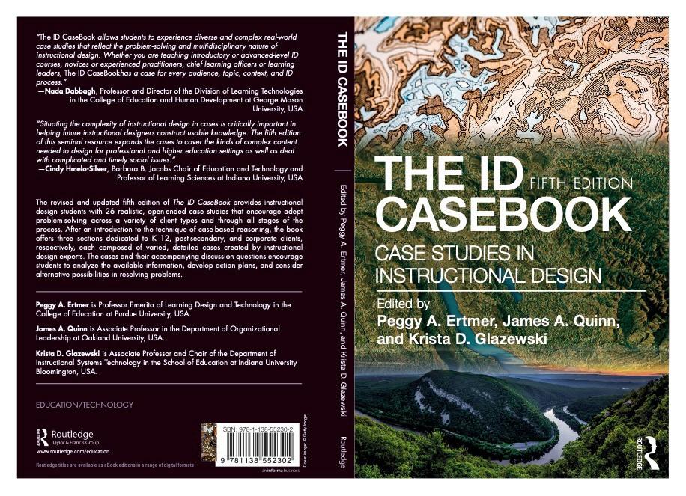
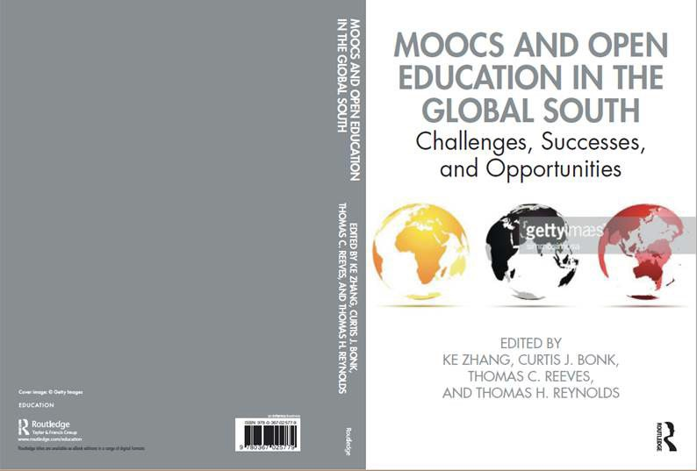
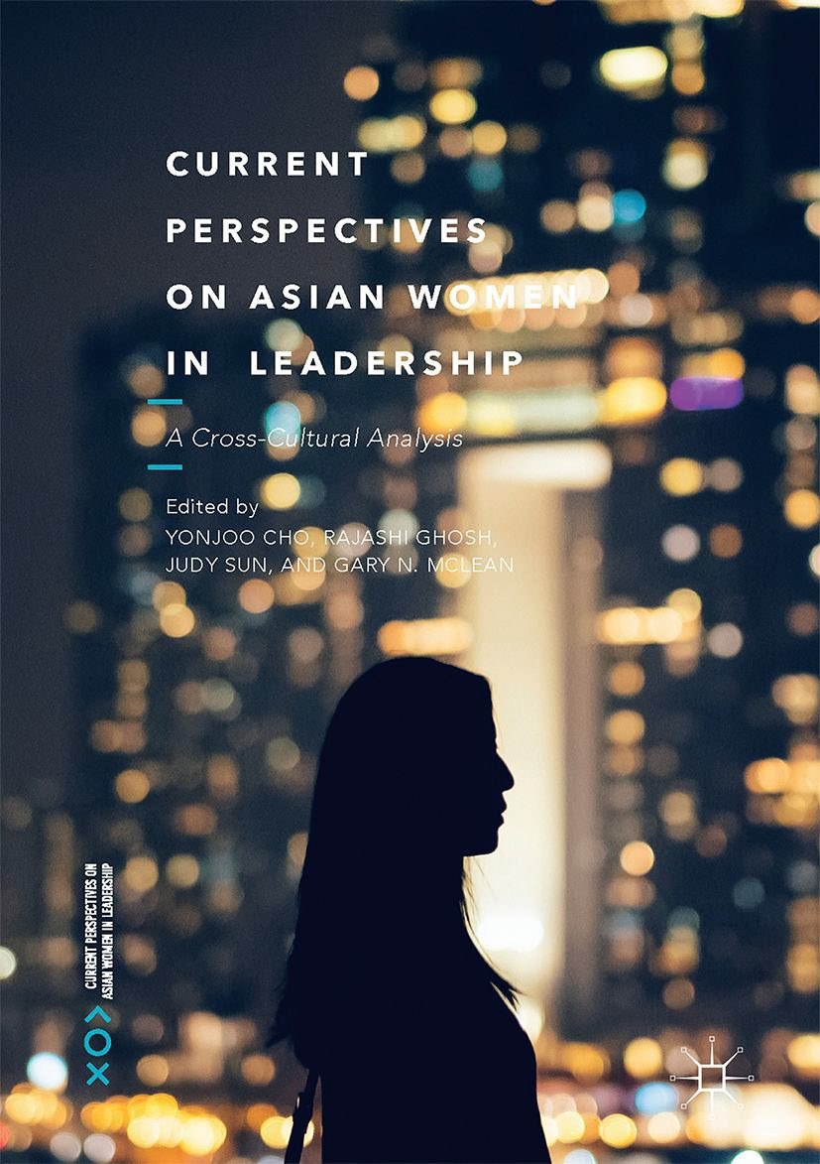
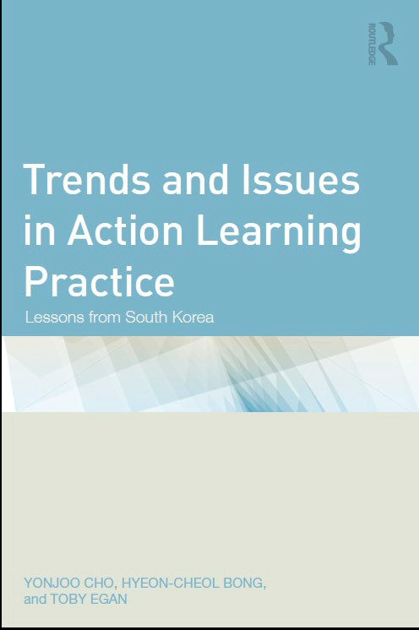

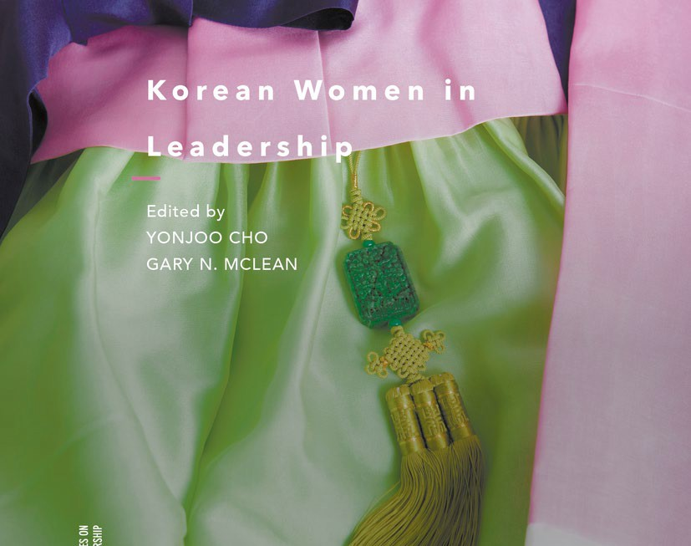
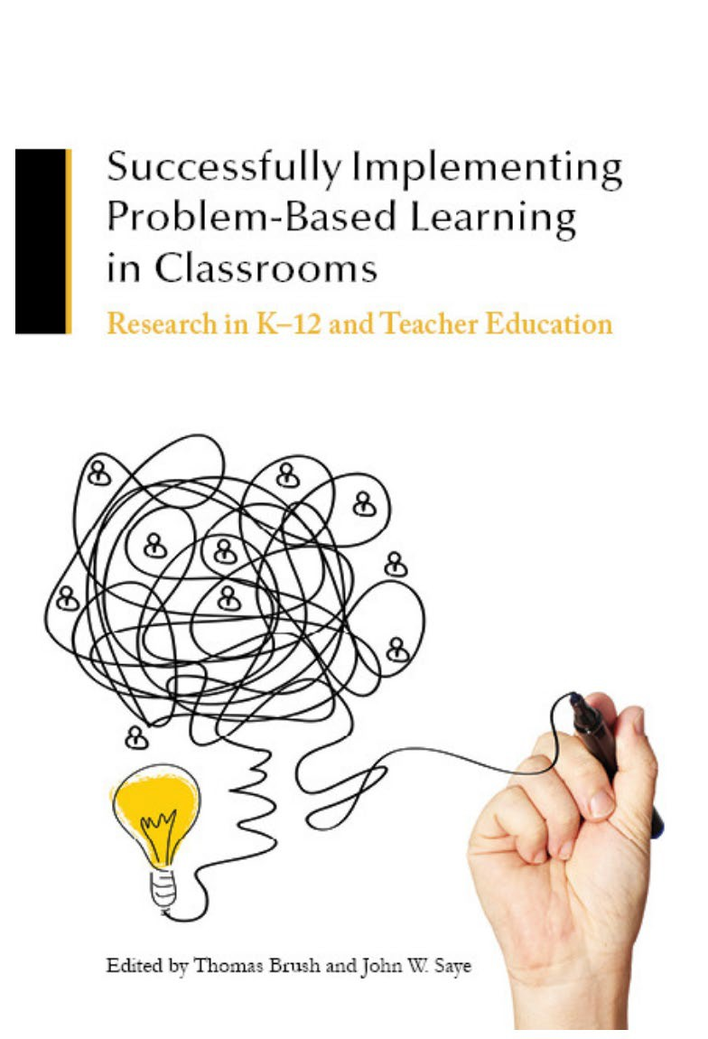

INDIANA UNIVERSITY BLOOMINGTON

M.S.ED. IST
Residential
M.S.ED. Adult Ed Online

19
Ed.D. IST Online
106
43
Enrollments

M.S.ED. IST Online
46
Ph.D. IST Residential

36

Online Ed.D. – Our Largest Program
  - 106 students

  - 60-credits above the master’s degree

  - Fully online (3 residency requirements)

  - Mid-career working professionals drawn from a wide range of professional career areas: military, publishing, health sciences, higher education, K12 and engineering

Residential Studio Masters Program: rigorous preparation
CORE COURSES
Entry level skill in the field Stacks to the Masters certificate
STUDIO COURSES
Three sequential semesters Capstone project
PORTFOLIO
Record of professional work Matched to goals in the field
- Rapid changes in technology, beliefs about learning, and organization structures are resulting in a growing demand for instructional designers and human performance technologists.
- The program provides a base of skill and knowledge, paired with a sustained experience in challenging design—for example, current capstone projects include:
  - professional development in computer science for rural Indiana teachers
  - safety training for workers in small manufacturing plants in China
  - performance support for caregivers assisting the elderly in Dehli, India
  - online course structure for holistic self-care of gastro-intestinal diseases
- Full cycle of design from problem framing through production and testing.

INDIANA UNIVERSITY BLOOMINGTON

Problem Solving, Computing, and Gaming in Elementary and Middle School Grades

- Recent Funding from the National Science Foundation across 3 faculty in IST and in collaboration with CEP faculty
  - PrimaryAI ($670,000)
  - Big Data From Small Groups ($974,000)
  - Intelligent Augemented Cognitive Assistants ($1.5 million)
- Support complex problem solving, computing, and computer science education in game-based learning environments
- Support teacher classroom orchestration
- Involve extensive outreach to elementary and middle school across southern Indiana.

Computer Science Ed Outreach
Presenter Notes
2024-03-27 14:49:35
--------------------------------------------
Expanding Computing Education Pathways (ECEP) Alliance Pathways 2.0 (2018). Proposal submitted to the National Science Foundation, ECEP. Fletcher, C., Ottenbreit-Leftwich, A., Richardson, D., Biggers, M., & DeLyser, L. $2,492,815. ECEP Indiana Case Studies of BPC (2017). Proposal funded by the National Science Foundation, ECEP. Ottenbreit-Leftwich, A., & Biggers, M. $12,369.
Expanding Computing Education Pathways in Indiana: BPC Summits and CS Education Landscape Report (2016). Proposal funded by the National Science Foundation, ECEP. Ottenbreit-Leftwich, A., & Biggers, M. $25,000.

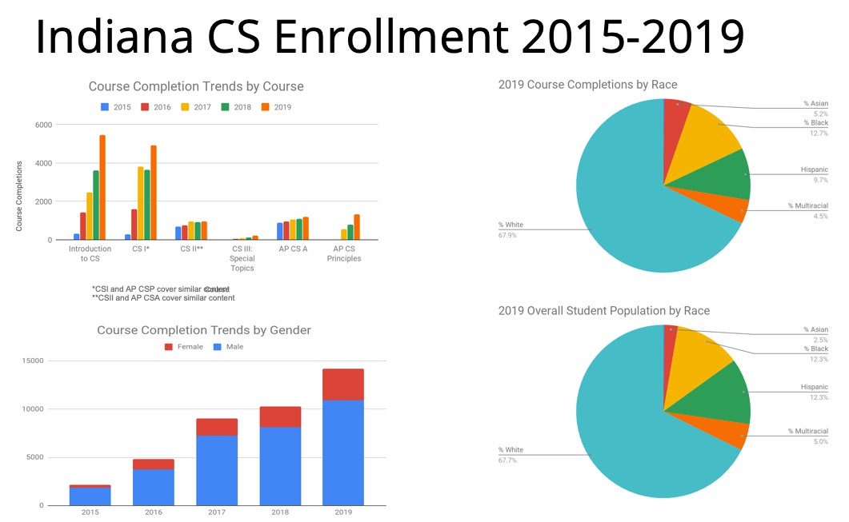
- Trained over 300 IN K-8 teachers
- Worked with 23 districts to create and establish CS plan
  - Collaborated with MCCSC to co-design surveys and CS+STEM plan
- Landscape report (2017 & 2019 – in progress)
- Collaborated with IN DOE, NexTech, Code on CS courses, policies, and strategic plans

Google Grant 2018 – MCCSC PBL CS
Presenter Notes
2024-03-27 14:49:35
--------------------------------------------
Examining the impact of socially relevant problem-based learning curriculum at the elementary level: Students’ CS interest/knowledge and teachers’ implementation needs (2018). Proposal funded by Google Computer Science Education Research Grant. Ottenbreit-Leftwich, A., Brush, T., Kwon, K., Dalkilic, M., & Roberts, M. $101,678.

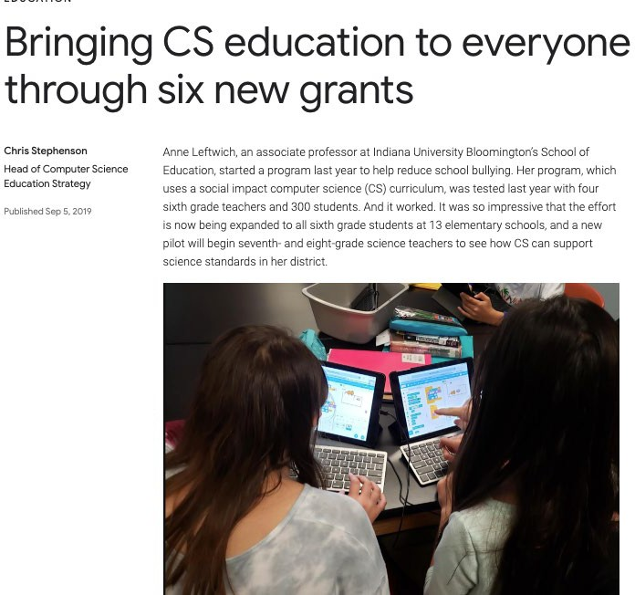

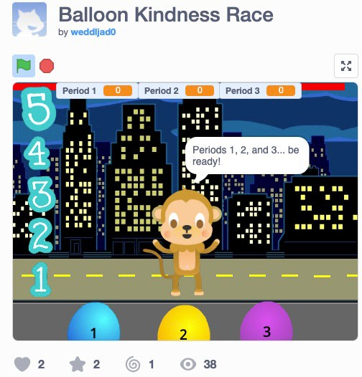
- 2018 - Trained and implemented 6th grade CS pilot (300 students, 4 teachers)

  - 2019 - Fully implementation (all 13 elementary schools)

- 2019 – Trained and pilot 7th grade CS (4 science teachers)

Google Grant #2
Presenter Notes
2024-03-27 14:49:35
--------------------------------------------
National Computer Science Education Preservice Case Studies (2019). Proposal funded by Google Computer Science Education Research Grant. Ottenbreit-Leftwich, A., Brush, T., DeLyser, L., Yadav, A., Simon, B., & Childs, J. $134,447.

National Preservice CS Landscape

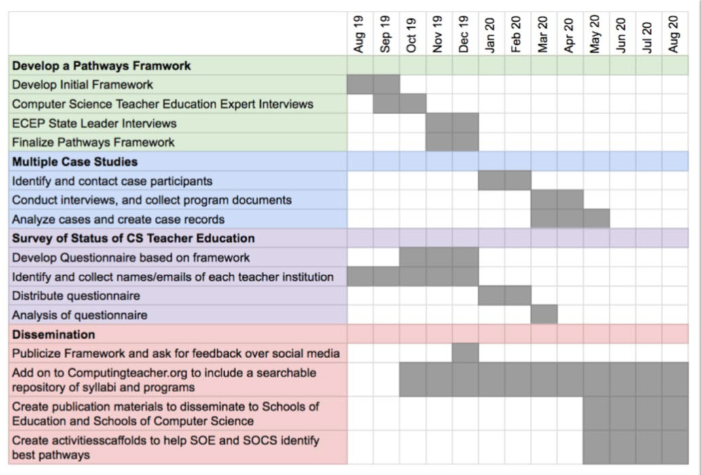
- Provided input on Code.org’s Micro- credentialing Report
- Contributed to NSF’s funded CSforALL Priming the Computer Science Pump Report
- National case study and survey of the current status of CS preservice teacher programs


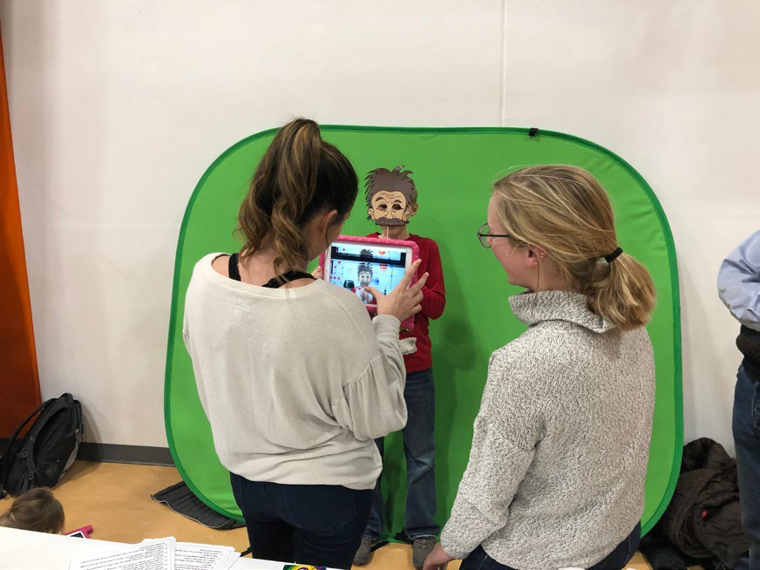

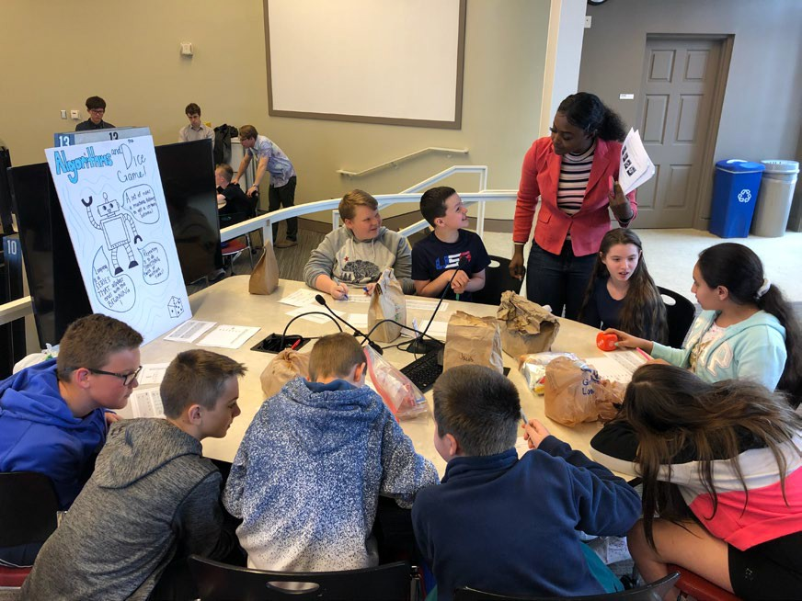
Computer Education License
Program
Presenter Notes
2024-03-27 14:49:36
--------------------------------------------
Ozogul, G., Karlin, M., & Ottenbreit-Leftwich, A. (2018). Evaluation of computer science preservice teacher program. Journal of Technology and Teacher Education, 26(3), 375-409.
Sadik, O., Ottenbreit-Leftwich, A., & Nadiruzzaman, H. (2017). Computational thinking conceptions and misconceptions: Progression of preservice teacher thinking during computer science lesson planning. Rich, P. J., & Hodges, C. (Eds) (pp. 221-238). Computational Thinking: Research and Practice. Springer.

  - 4-10 graduates per year (elementary and secondary)
    - Google recognized this as one of the largest programs in the nation
  - Field experiences in every class, assisting in local classrooms
  - Two articles published (2017 & 2018) based on our curriculum in peer reviewed journals

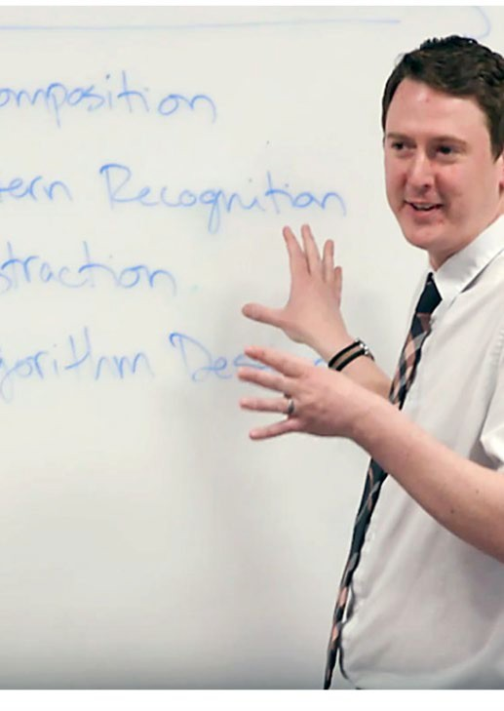
Recognition

Mike Karlin
IST Doctoral Student

Indiana University
Lieber Memorial Teaching Associate Award (2019)

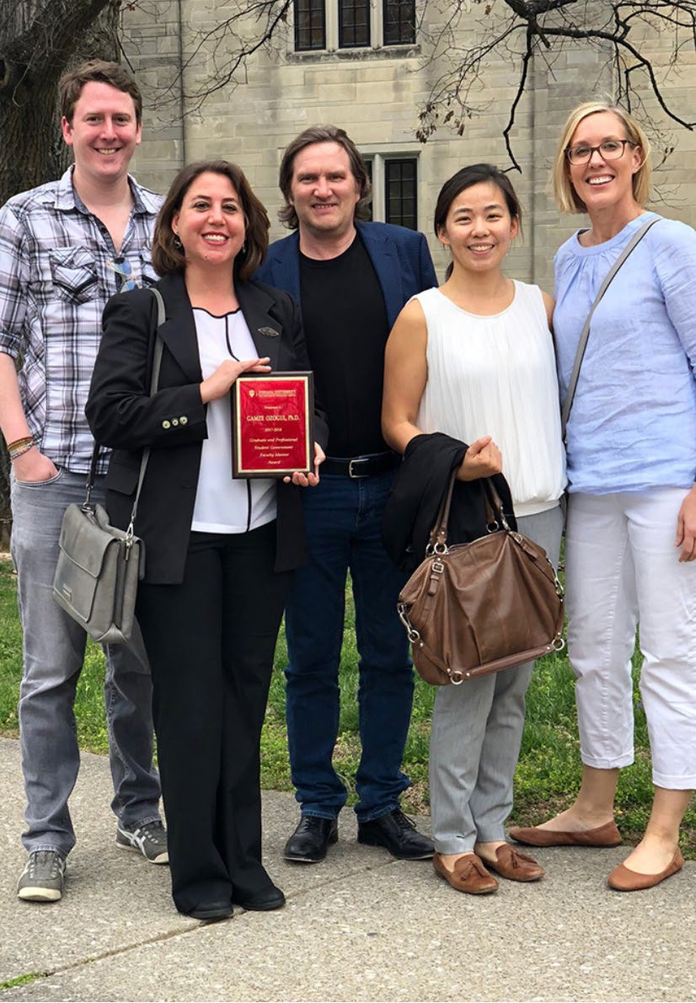

Recognition

Gamze Ozogul
Associate Professor of IST

IU Graduate School and IU Graduate and Professional Student Government (IUGPSG)_2018

Outstanding Faculty Mentor Award

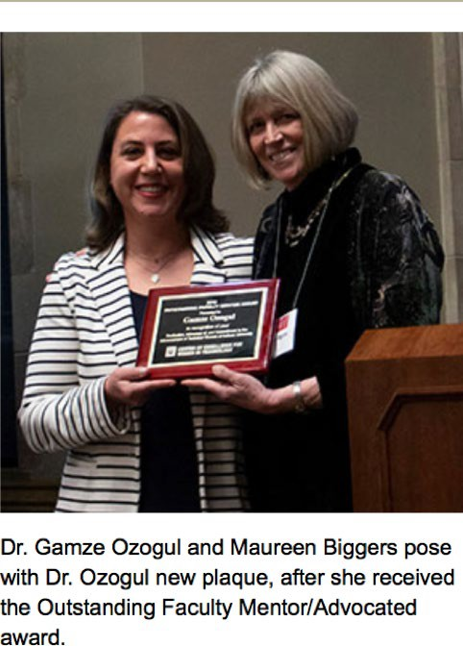

Recognition

Gamze Ozogul
Associate Professor of IST

IU Center of Excellence for Women in Technology Award_2019

Outstanding Faculty Mentor Award

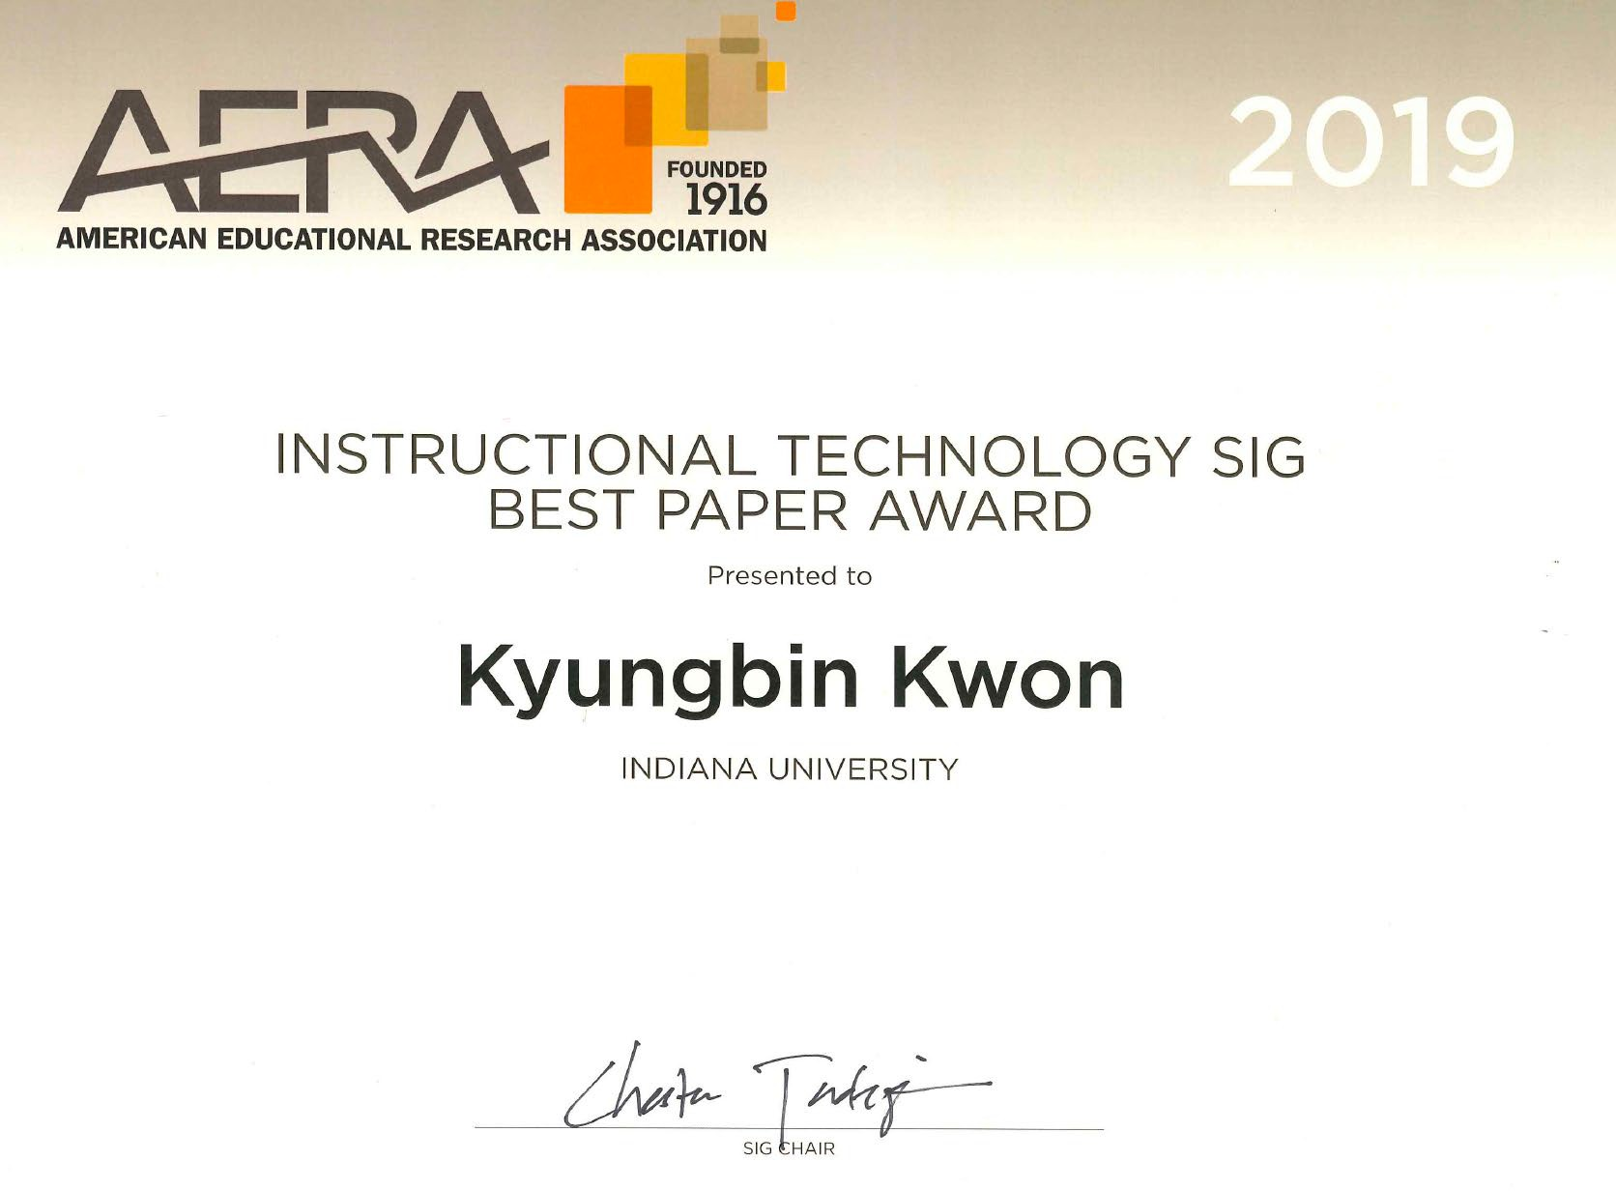
Recognition

Kyungbin Kwon
Assistant Professor of IST

AERA_ Instructional Technology SIG

Best Paper Award_2019

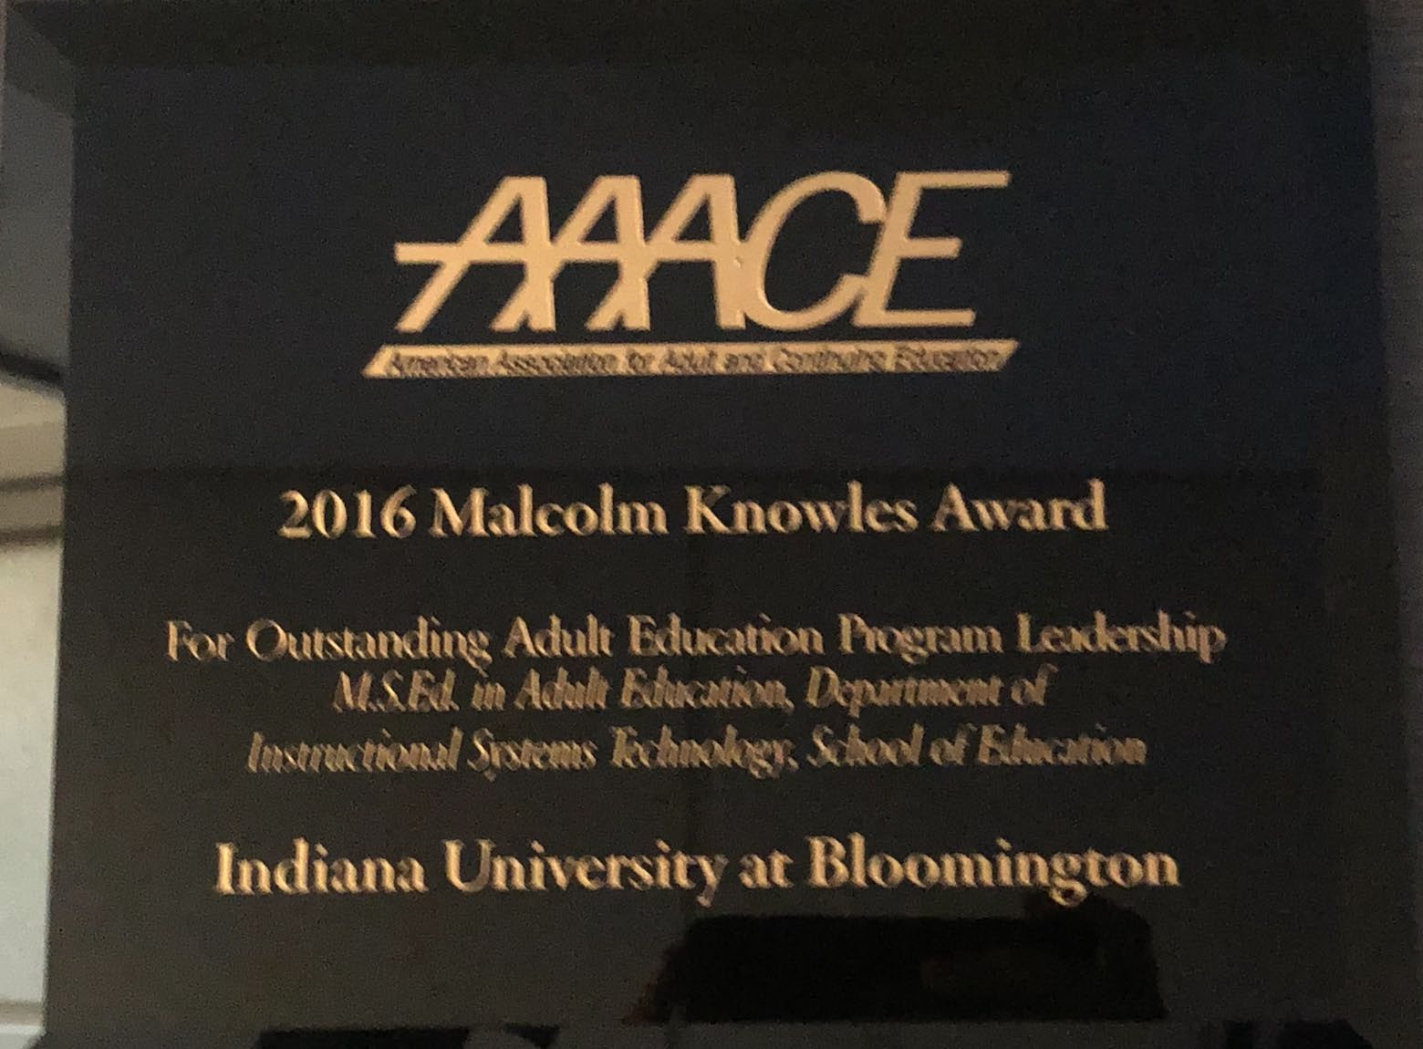
Recognition

Frank Di’Silvestro & Marjorie Treff
Adult Education Faculty Members AAACE Malcolm Knowles_2016
Outstanding Adult Education Program Leadership Award

Literacy, Culture, and Language Education
Mary Beth Hines, Chair

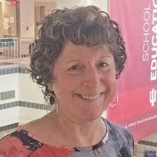
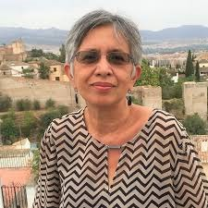
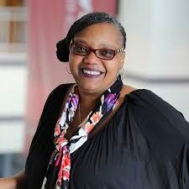


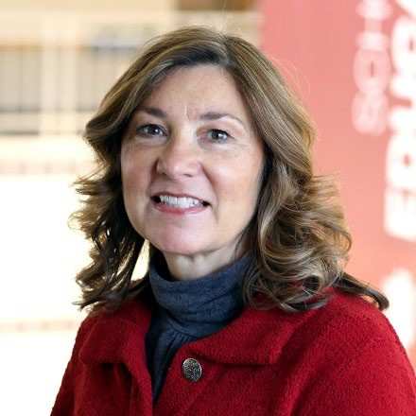
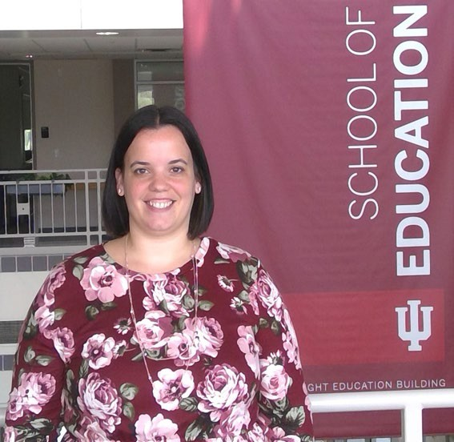
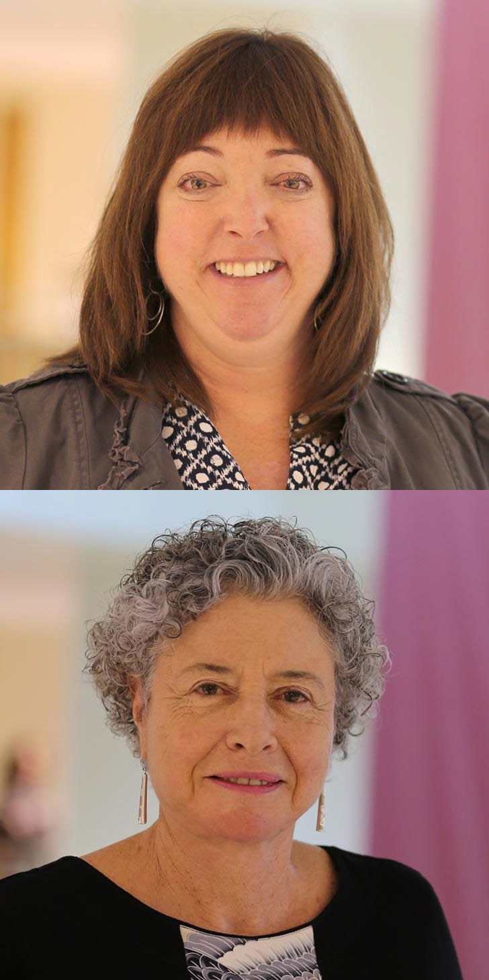
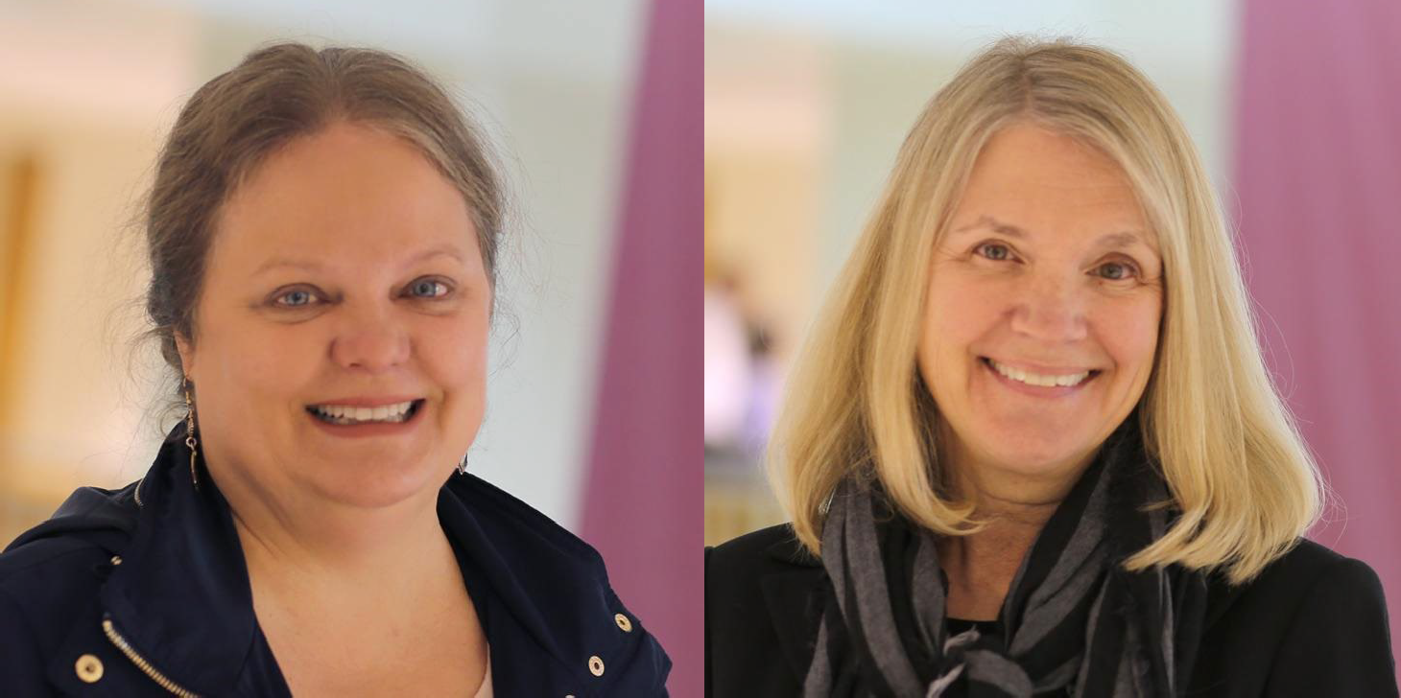
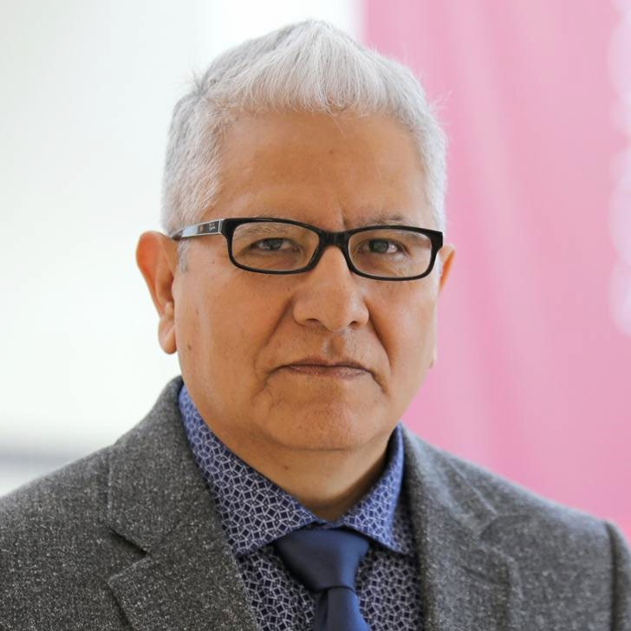


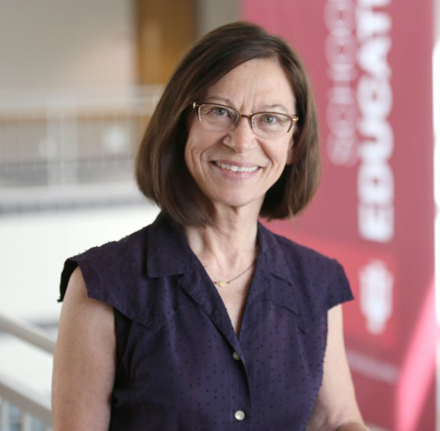

A Small Faculty with Large Ambitions

- Preservice Teacher Education
- Inservice Teacher Education
- Outreach to Schools
- Involvement locally, nationally, globally
- Teaching F2F and online programs

Conceptual Frameworks Guiding Our Work
  - Research, teaching and service dedicated to diversity, equity, and inclusion in classrooms and in the larger culture, working on local, state, and global levels.
  - Strength-based approaches, tapping “funds of knowledge, “in our approaches to issues of difference: affirming diverse languages, cultures, gender identities/sexual orientations, physical and mental abilities
  - Culturally relevant and humanizing pedagogies and research
  - Critical perspectives on language and literacies: What counts as “good” language practices? What counts as “English”? What counts as literacy (-ies): To whom and under what conditions?

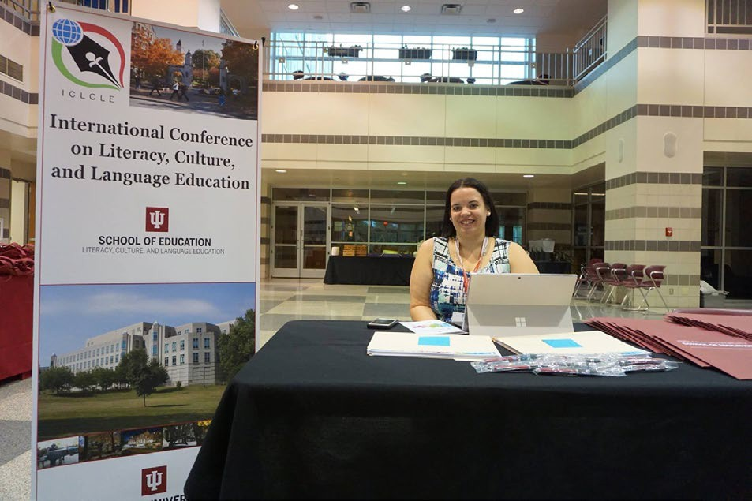
Awards & Distinctions

STAFF

Chanel Stickles, (2019) Staff Recognition Award

FACULTY
Sharon Daley, Faculty, 2016 Recipient of Trustees’ Teaching Award & Student Choice Award for Excellence in Teaching
Martha Nyikos, Faculty Teaching Award, 2019

Sharon Daley, Faculty, 2016 Recipient of Trustees’ Teaching Award & Student Choice Award for Excellence in Teaching

Ray Smith, Faculty Teaching Award, 2015

Beth Samuelson, Faculty Excellence in Mentoring award, 2019

Faculty Awards and Distinctions (cont)
Serafin Coronel-Molina, Helen C. Bailey Alumni Award, Graduate School of Education at University of Pennsylvania, Philadelphia, 2019

Stephanie Power-Carter, AAADS William H. Wiggins Mentoring & Teaching Faculty Award, 2018

Ray Smith, Graduate and Professional Student Government (GPSG) and University Graduate School Faculty Mentor award, 2019

Serafin Coronel-Molina, Indiana University Bicentennial Professor, 2018

Martha Nyikos, Purdue University, Distinguished Alumni Award, 2019

Programs We Offer

Teacher Education Programs
Elementary Literacy: The only SOE elementary program with nine hours of concentrated study beyond that required for all elementary teachers.
English/Language Arts: The only secondary program with intensive subject area coursework required beyond the TEP requirements: 12 additional hours

World Languages: Teachers of other languages earning all-grades certification to teach any of seven languages in U.S classrooms.
English as a New Language: A license addition that all certification areas can add in order to teach biliteracy to students from multilingual backgrounds.

Reading Addition: A license addition to teach reading at elementary or secondary levels.

LCLE
Undergraduate Programs

Licensing
License Additions
Concentrations

World Languages
Reading Addition
Elementary Language Arts concentration

English/Language Arts
English as a New Language Addition

LCLE Graduate Programs

Doctoral
Masters
Licensing
License Additions
Concentrations
Certificates

PhD

EdD

Online

World Languages
English as a New Language Addition
Elementary Language Arts concentration
EFL/ESL Teacher Preparation certificate

Residential
Online
Residential
English/Language Arts
Reading Addition
EFL/ESL Teaching certificate

Residential

Selected Faculty Research & Initiatives
Facilitating Student Engagement: Literacy Learning through Young Adult Literature (Stephanie Power-Carter)

A Multi-institution Study of Elementary Teacher Candidates' Self-Efficacy: Analysis of Participant Characteristics and Implications for Teacher Education (Sharon Daley)

"Time for Your Checkup": Tracking Embodied Literacies and STEM Concepts in Doc McStuffins’ Museum Play (Karen Wohlwend and A. Maltese)

Teacher training and professional development of Chinese English language teachers: Changing from fish to dragon, (Faridah Pawan, Fan, W., & Pei, M)

Selected Faculty Research & Projects (cont)
Civic media literacy and climate change (James Damico, Baildon, M. & Panos, A.)

Latinx popular culture imaginaries: Examining Puerto Rican children social discourses in telenovelas interpretations (Carmen Medina, C., Costa, M del R., & Soto, N.)

Incremental drivers of transformative learning among world language pre-service teachers (Martha Nyikos)

Empathetic communication: Bridging differences in a global context (Erna Alant, Beth Samuelson)

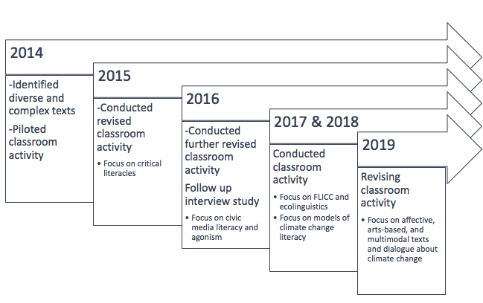
Our Research Projects

Climate change/justice literacy (J. Damico)
Project Overview & Guiding Question

What does it mean to be literate about climate change?


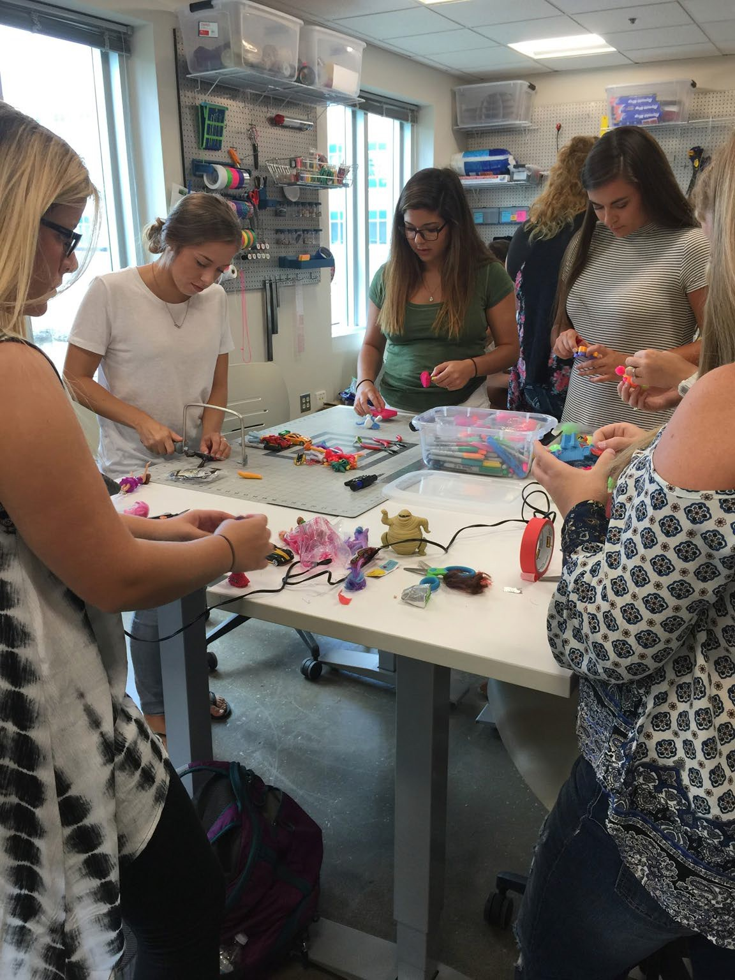
Our Research Projects

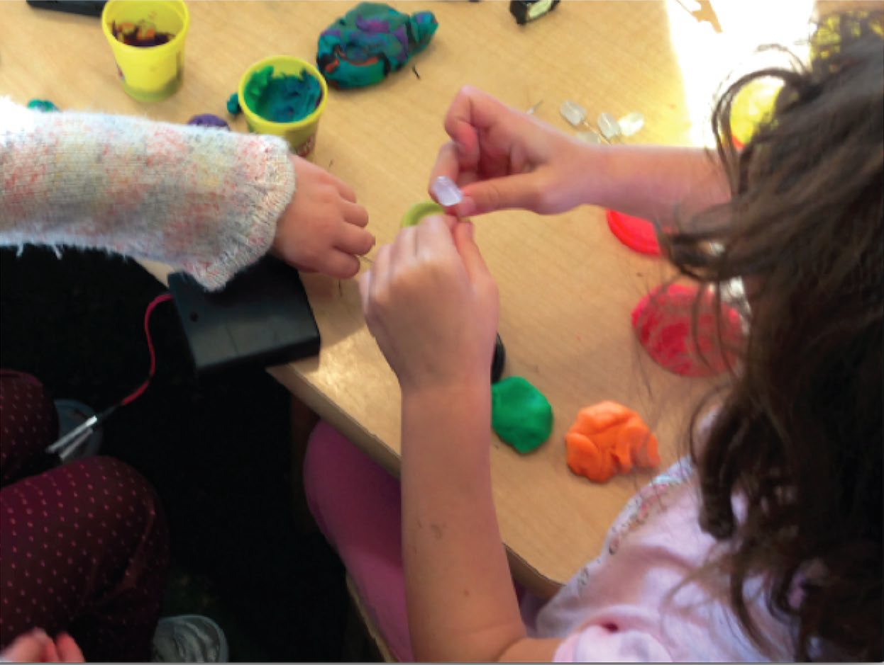
Literacy Playshop: Producing Toy Stories in P-16 Makerspaces (Karen Wohlwend)

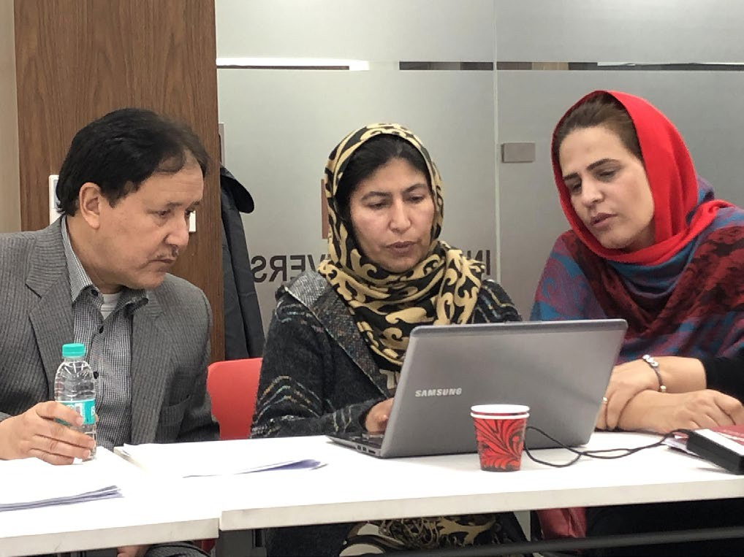
Our Research Projects

Research in India and Afghanistan (Mitzi Lewison)
January 2019
- $34,000 Grant from US Embassy Kabul for Curriculum Revision:
- IU/Kabul Education University English Master’s Program

$60,000 grant from Regional English Language Office, US Embassy New Delhi:
21st Century Skills Academic Camp—Summer 2019
- 3-week intensive academic skills program for 100 underserved & underprepared freshman and sophomore university students at Ambedkar University, New Delhi
- LCLE graduate class students will create curriculum and teach camp

Selected Faculty Research & Projects (cont.)
Beyond Critical Performance: Charting New Territories for Global Imaginaries with Post-Embodiment Theories and Methodologies (Carmen Medina and Karen Wohlwend)

Examining Early Dual Language Teaching and Learning: The Impact of Teaching to Learn (TTL) Approach to Enhancing DLI Pedagogy (Martha Nyikos)

Media Literacy and Climate Change in a Post-Truth Society (James S. Damico and M. Baildon)

Empathetic communication: Bridging Differences in a Global Context
(Beth Samuelson and Erna Alant)


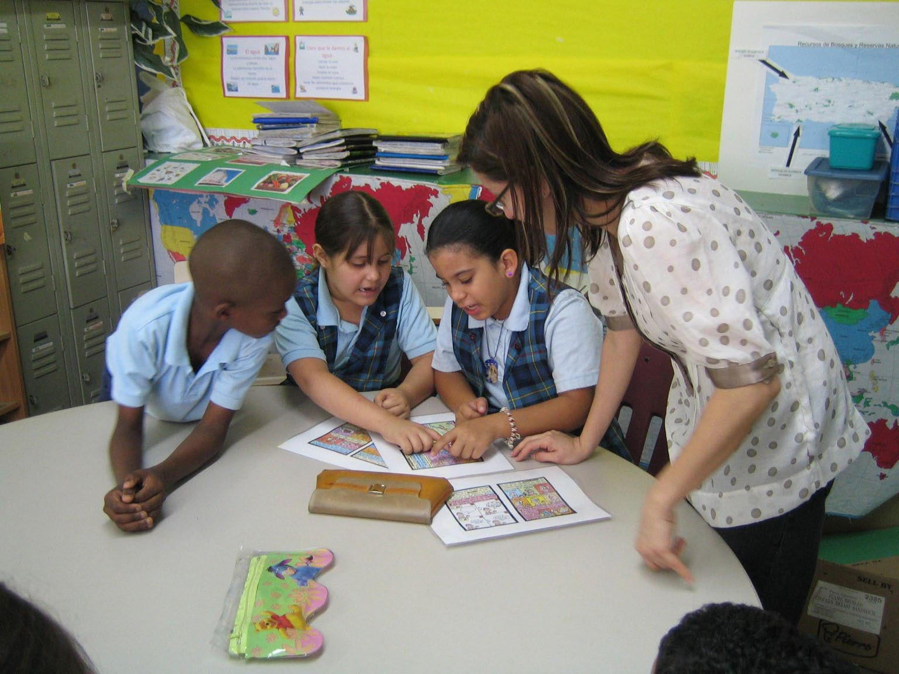

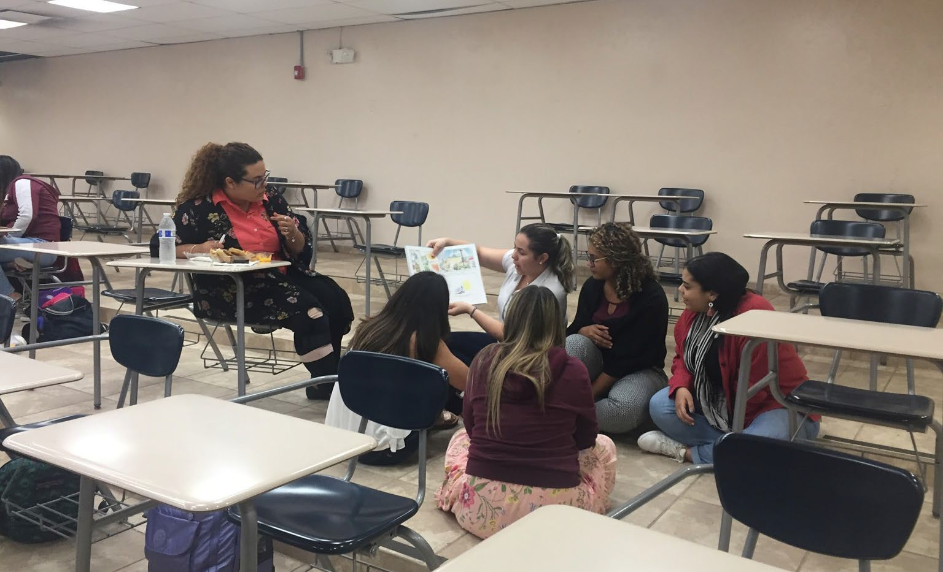

Our Research Projects
Critical Literacies in Puerto Rico
(Carmen L. Medina)

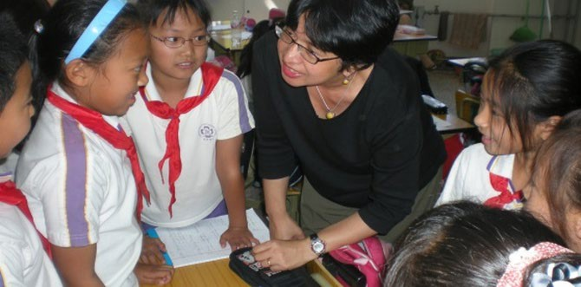

Our Research Projects
ELT’s approaches in teaching Chinese multilingual minority students
(Faridah Pawan)

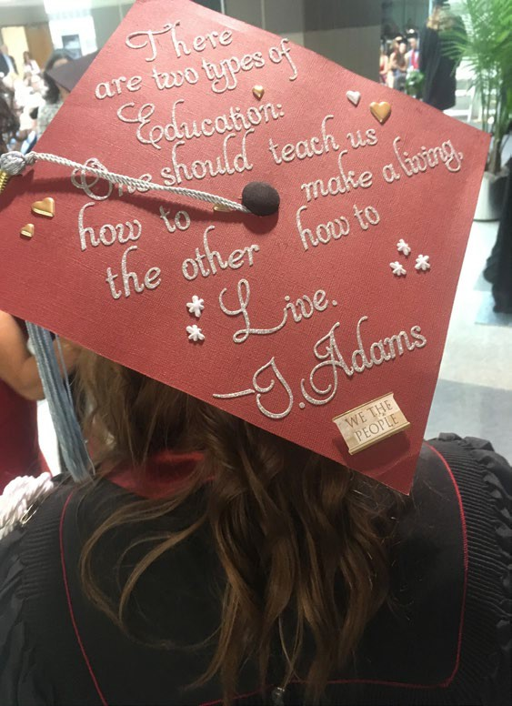
Our Service
International and National Leadership

Editorial Boards
Research in the Teaching of English (Dr. P-C, Dr. Wohlwend, Dr. Medina, F. Pawan)
English Teaching: Practice & Critique (Dr. Medina, Dr. Wohlwend)
Journal of Literacy Research (Dr. Wohlwend, Dr. Carmen Medina)
Multimodal Communication, Journal of Early Childhood Literacy, Language Arts, Contemporary Issues in Early Childhood (Dr. Wohlwend)
Journal of Adult and Adolescent Literacies (Dr. Damico) Journal of Ethnic and Cultural Studies (Dr. Coronel-Molina) Sustainable Multilingualism (Nyikos)
Board of Directors, Literacy Research Association (Dr. Medina, Dr. Wohlwend) Indiana Department of Education, Global Language Advisory Board (Nyikos)
Advisory Board of 5 National Title VI Centers (IAURC, CeLCAR, REEI, CSGC, NALRC) (M. Nyikos) Secretary, Division G, American Educational Research Association (Dr. Medina)
TESOL Accreditation Board Member (F. Pawan) TESOL Teacher Educator SIG, Chair Elect (F.Pawan)


Our Service
State Leadership
Editor Indiana State Literacy Journal (Dr. Daley)

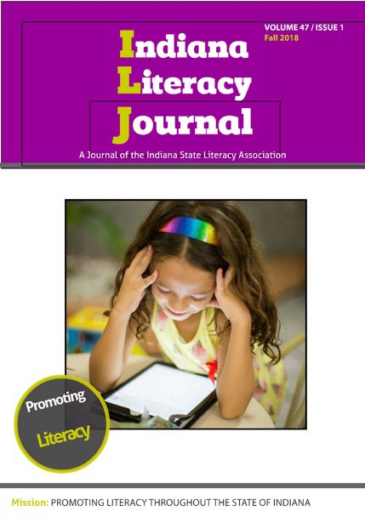
Institutional & Unit Leadership
Global Service & Peace Corps Preparation Program Advisory Board (2019 - ) (Dr. Samuelson)
IU Books & Beyond Project, Faculty Director (2019 - ) (Dr. Samuelson) IUB SoE International Programs Committee (2018- ) (Dr. Coronel-Molina) IUB SoE Policy Council Chair (2017-18) (Dr. P-C)
IU CRRES Post Doc Fellowship Committee (2017-18) (Dr. P-C) IUB Black Faculty and Staff Liason (2017-18) (Dr. P-C)
IUB Director, INSPIRE Living Learning Center (Dr. Damico)
IUB Center of Excellence for Women & Technology Faculty Advisory Board (Dr. Wohlwend)
South East Asian Executive Committee Member (Dr. Pawan) Center for Global Change Advisory Board Member (Dr. Pawan) Overseas Studies Advisory Council (2012 - ) (Dr. Samuelson)
Hutton Honors Residential Faculty Fellow (2017 - 19) (Dr. Samuelson)

Our Recent Publications

Alant, Erna, Samuelson, B. L., & Ogle, Lindsay. (2017). Empathetic communication: Bridging differences in a global context. In Santoshi Halder & Lori Czop Assaf (Eds.), Cross-cultural global perspective on individuals with special needs: Traversing abilities and challenges (pp. 153-167). New York: Springer.

Bloome, D., Power-Carter, S. Baker, D., Castanheira, M., Kim, Minjeong, and Rowe, L. (Under Contract). Discourse analysis of language and literacy in educational settings: A microethographic perspective. New York: Routledge.

Chamot, A., Harris, V., Griffiths, C., Gunning, P., Nyikos, M. & Tutünis, B. (2019). Teacher education for language learning strategy instruction: Involving teachers in participatory research. A.U. Chamot & V.Harris (Eds.) Learning Strategy Instruction in the Language Classroom: Issues and Implementation. Bristol: Multilingual Matters.

Coggin, L., Daley, S., Sydnor, J. & Davis, T.R. (2019). Imagining my ideal: Teacher candidates’ digital storytelling as reflective practice. Reflective Practice: International and Multidisciplinary Perspectives, 20(2), 143-159.

Our Recent Publications

Coronel-Molina, S. M., & Samuelson, B. L. (2017). Language contact and translingual literacies. Journal of Multilingual and Multicultural Development, 38(5), 379-389. http://dx.doi.org/10.1080/01434632.2016.1186681

Daley, S., Davis, T.R., Sydnor, J. (2019). Sites of possibility: Digital stories as a means of making reflective practice visible. Professing Education, 12(1-2), 42-64.

Damico, J.S., Baildon, M. & Panos, A. (2018). Civic media literacy and climate change. Journal of Media Literacy Education, 10(2), 11-32.

Damico, J.S., Panos, A., & Myers, M. (2018). Digital literacies and climate change: Exploring reliability and truth(s) with pre-service teacher educators. In E. Ortlieb, E. Cheek Jr., & P. Semingson (Eds.) Best Practices in Teaching Digital Literacies. West Yorkshire, UK: Emerald Publishing Ltd.

Damico, J.S., Panos, A., & Baildon, M. (2018). “I’m not in the truth business”: The Politics of Climate Change with Pre- Service Teachers. English Teaching: Practice & Critique. 17(2), 72-89.

More Recent Publications
Davis, T.R., Bolyard, C.S., Zhang, S., Livers, S.D., Sydnor, J., & Daley, S. (2019). A multi-Institution study of elementary teacher candidates' self-efficacy: Analysis of participant characteristics and implications for teacher educators. The Teacher Educator, 54(3), 313-330.

Hines, M.B. (2019). The pedagogical dilemmas of addressing blackface and white privilege in the classroom. In J. Heybach (Ed.), Making sense of race in education: Practices for change in difficult times. Gorham, ME: Myers Press.

Hines, M.B., Armbruster, K., Henze, A, Ivanova, C,. Lisak, M. Rowland, L.; Waggoner, L..(2019). Educational action research, 2nd edition. In Oxford Bibliographies in Education. Ed. Luanna Meyer. New York: Oxford University Press.

Hines, M.B., & Davis, S. (2019). English language arts curricula. Routledge Online Encyclopedia of Education.
New York: Routledge.

Hung, Y.-J., Chen, S.-C. F., & Samuelson, B. L. (2016). Elementary EFL students’ practice of peer assessment of classroom activities. TESOL Journal, 7(2), 449-468.

More Recent Publications

McNeill, E., & Hines, M.B. (2018). Canonical texts and cultural critiques with English learners (2018). In Macaluso,
M. & Macaluso, K. (Eds.), Teaching the canon in 21st century classrooms: Challenging genres
(pp.181-194) Urbana, IL: National Council of Teachers of English.

Medina, C., Costa, M del R., & Soto, N. (2017). Latinx popular culture imaginaries: Examining Puerto Rican children social discourses in telenovelas interpretations. Early Years: An International Research Journal 37(1), 77-
90. (Special issue focusing on research in the United States)

Nyikos, M. (2019). Incremental drivers of transformative learning among world language pre-service teachers. In B. L. Leaver, D.E. Davidson, & C. Campbell (Eds.) Transformative Language Learning and Teaching.
Cambridge, UK: Cambridge University Press.

Pawan, F., Fan, W., & Pei, M. (2017). Teacher training and professional development of Chinese English language teachers: Changing from fish to dragon. New York: Routledge/Taylor Francis (Book)

In Addition ...
Pawan, F. & Pu, H. (2019). Methods as interpretation and glocalization, not application: Water far away will not put out nearby fires. TESL-EJ, 22 (4).

Pawan, F.,Wiechart, K., Warren, A., & Park, J. (2016) The pedagogy & practice of online teaching: Oz behind the curtain.
Alexandria, VA: TESOL. (Book)

Power-Carter, S. Zakeri, B, Kumasi, K. (2019). Theorizing and languaging blackness: Using the African philosophy of ubuntu and the concept of sawubona . In Languaging relationships across social worlds: Re-theorizing the teaching and learning of literacy in the language arts. New York. Routledge.

Power-Carter, S. & Zakeri, B. (2018). Blind spots: Literacy, power, and personhood. In Re-theorizing literacy as social practice. New York Routledge

Samuelson, B. L., Park, G. Y., & Munyaneza, S. P. (2018). Cultural imaginaries and oral traditions as creative resources for connecting home storytelling to English learning. TESOL Journal, 9(4), 1-11.

And Finally...
Wohlwend, K. E. (2019). Child’s play: Reading and remaking gendered action texts in toys. In B. Guzzetti, T. Bean, & J. Bean (Eds.) Literacies, sexualities, and gender: Understanding identities from preschool to adulthood, (pp. 27-38). New York: Routledge.

Wohlwend, K. E. (2019). Play as the literacy of children: Imagining otherwise in contemporary early childhood education. In D. E. Alvermann, N. J. Unrau, & M. Sailors (Eds.), Theoretical models and processes of literacy (7th ed.), (pp. 301-318). New York, NY: Routledge.

Wohlwend, K. E., Keune, A., & Peppler, K. A. (2019). "We need it loud!”: Listening to preschool making from mediated and materialist perspectives. In M. Sakr & J. Osgood (Eds.), Post-developmental approaches to early childhood art, (pp. 177-189). London: Bloomsbury.

Wohlwend, K. E. (2020). P(l)aying online: Toys, apps, and young consumers on transmedia playgrounds. In O. Erstad, R. Flewitt, & B. P. Kümmerling-Meibauer, I. S. Pires (Eds.), The Routledge handbook of digital literacies in early childhood. London: Routledge.

Wohlwend, K. E., & Thiel, J. J. (2019). From cutting out to cutting with: A materialist reframing of action and multimodality in children’s play and making. In J. Rowsell, N. Kucirkova, & G. Falloon (Eds.), Handbook of literacies and technology in early childhood, (pp. 170-181). New York: Routledge.


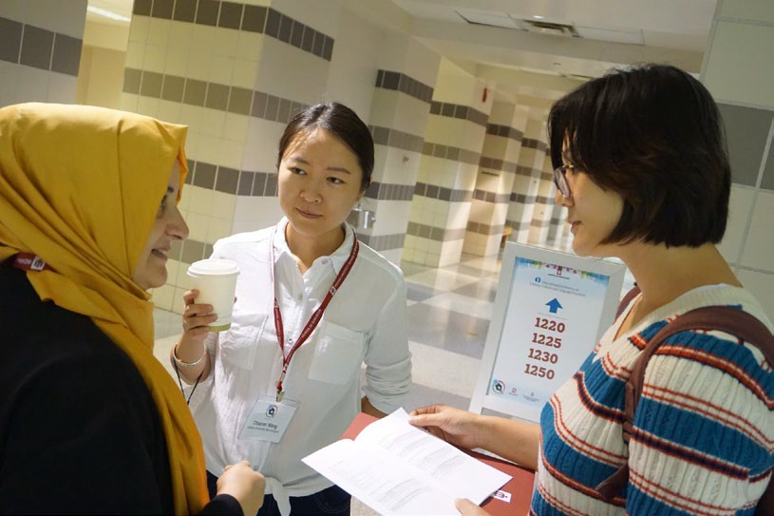
First International Conference on Literacy, Culture, and Language Education (ICLCLE)

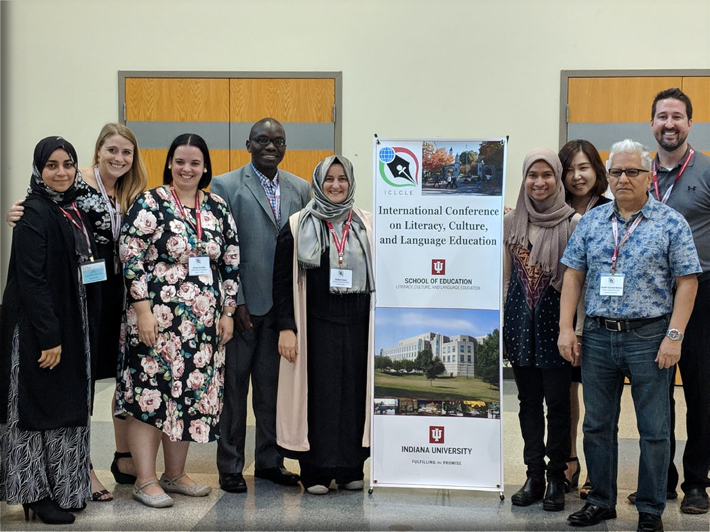
Members of the 2018 ICLCLE Committee

Participants came from 35 states and 17 countries

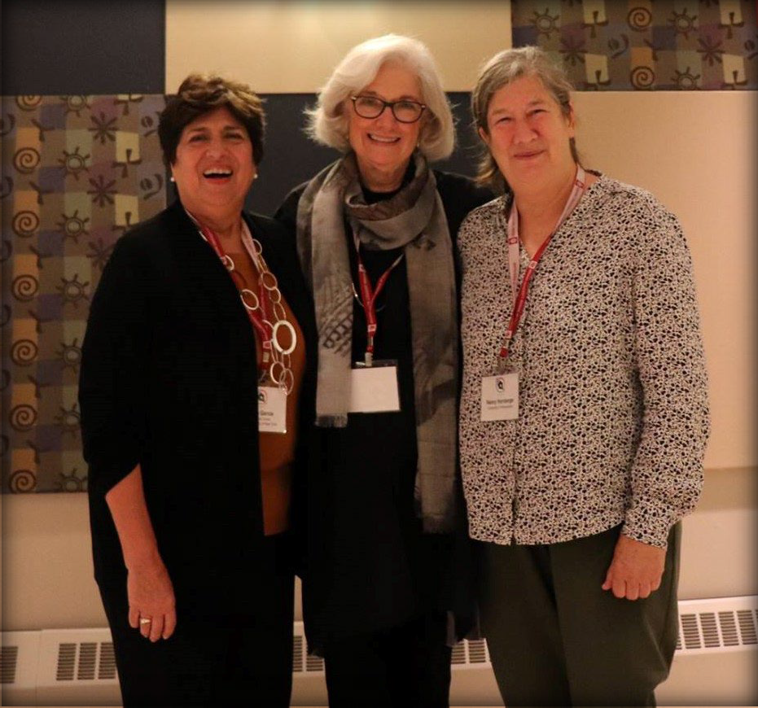

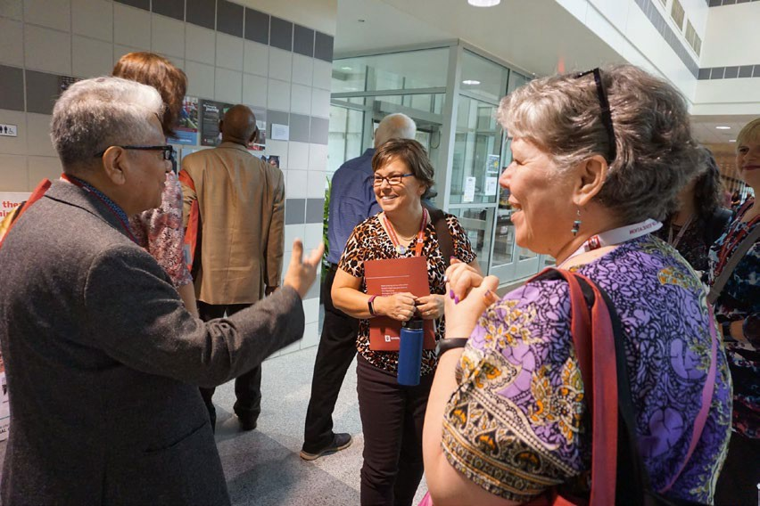

Keynote speakers
Dr. Ofelia García, Dr. Shirley Brice Heath, and Dr. Nancy H. Hornberger

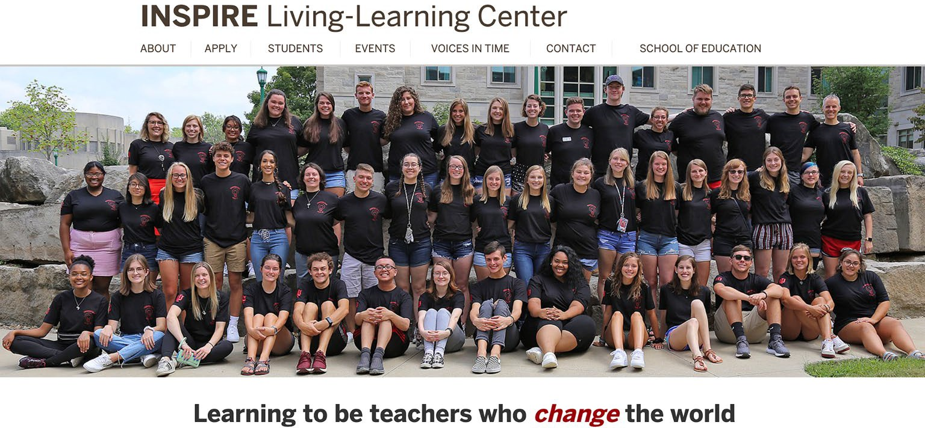

More Service: International Perspective
In partnership with the College of Arts and Sciences …

Books and Beyond (Beth L. Samuelson)

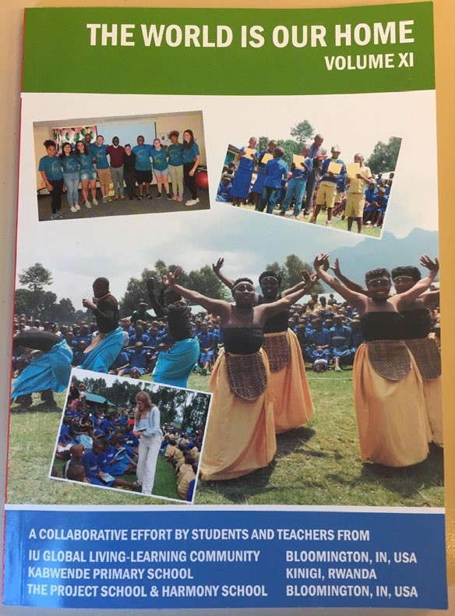


More Service—Focus on the Community
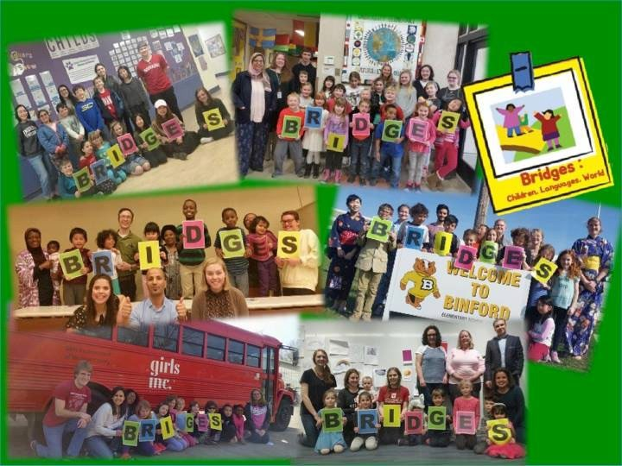
Bridges: Children, Languages, World (joint project with P-16 Center & multiple Title VI Centers) at Fairview, Binford, Childs, University Elementary Schools in Bloomington
Arabic, Chinese, Russian, Japanese, Swahili, Turkish,
Recipient: Senator Paul Simon Award


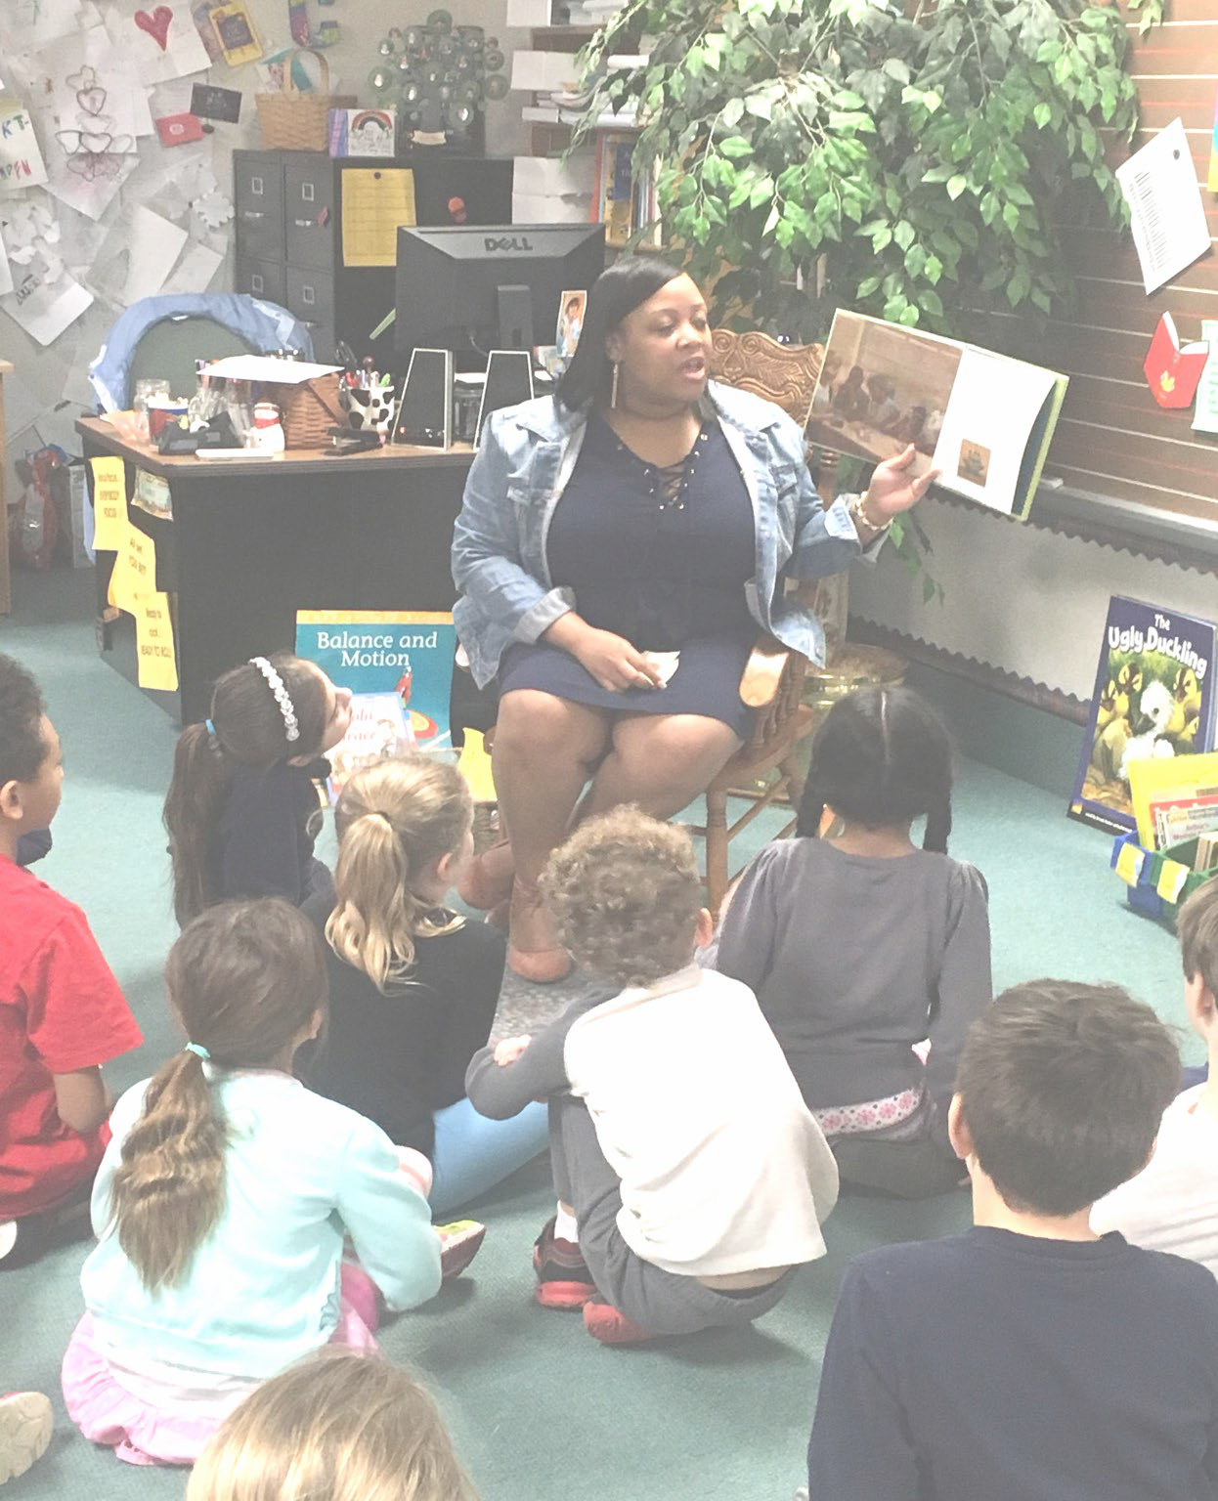
Community Service
Annual African American Read-In (2019)
Celebration of Black Literacies, Literature, & IU Recruitment

Provided over 500 books about the Black experience to local elementary & high school youth

Newest Initiative: Online Ed.D.

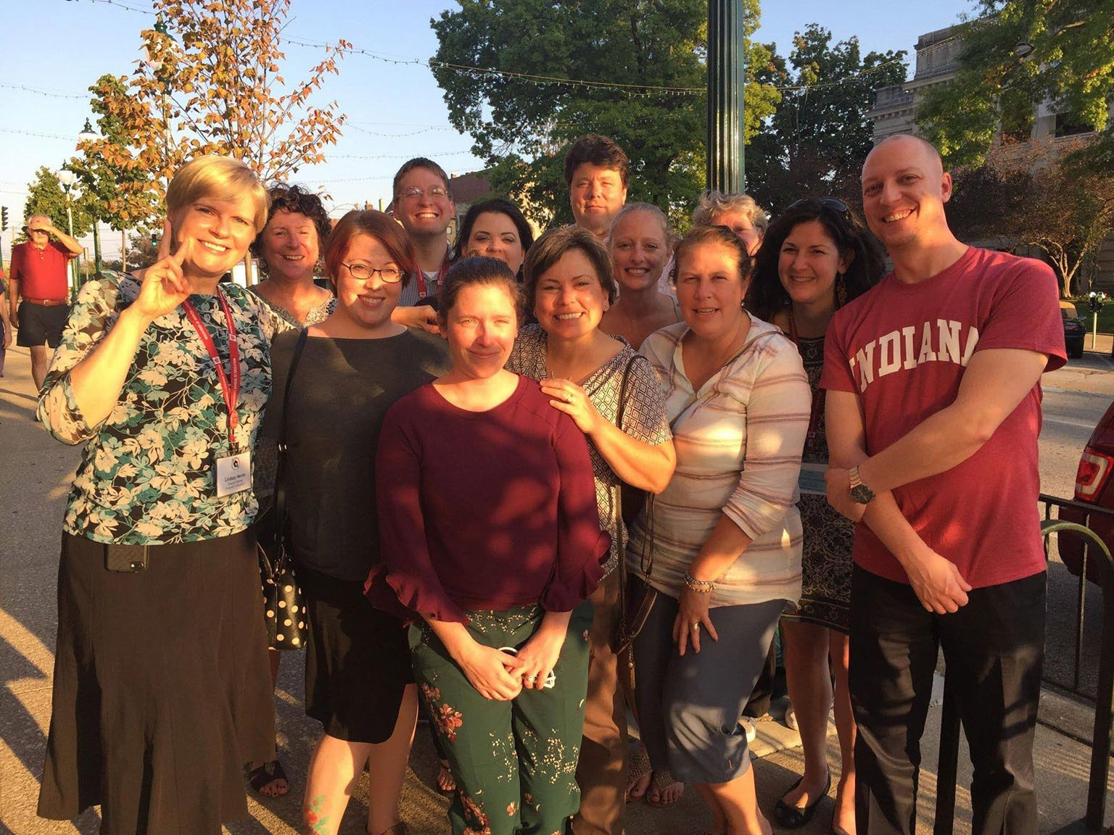
Begun in 2017
First cohort taking qualifying exams (first benchmark) in preparation for writing dissertations

LCLE Online Ed.D. Enrollment Patterns

Admitted | Enrolled in L600 | Semester 1 (Fall) |  | Semester 2 (Spring) |  | Semester 3 (Fall) |  | Semester 4 (Spring) |  | Semester 5 (Fall) |  | Semester 6 (Spring) |  | Semester 7 (Fall) |  | Semester 8 (Spring) |  | Semester 9+
Cohort 1 20 admits | 20 | L600 F16 | 17 | L601 SP17 | 16 | L599 F17 | 15 | L650 SP18 | 15 | L700 F18 | 14 | L795 SP19 | 12 | L799
Cohort 2 25 admits | 24 | L600 F17 | 20 | L601 SP18 | 15 | L599 F18 | 15 | L650 SP19 | 15 | L750 |  | L750 |  | L700 F19 | max  15 | L795 |  | L799
Cohort 3 30 admits | 23 | L600 F18 | 19 | L599 SP19 | 20 | L601 F19 | max  24 | L650 SP20 | max 24 | L750 |  | L750 |  | L700 |  | L795 |  | L799
Cohort 4 30 admits | 22 | L600 F19 |  | L599 SP20 |  | L601 F20 |  | L650 SP21 |  | L750 |  | L750 |  | L700 |  | L795 |  | L799

Teaching Collaborations
Bloomington High School North Adolescent Literature Class Partnership: IU YA-Lit class meet bi-weekly at BHSN with Ms. Cannon’s YA-Lit course . IU students work and prepare activities and engage students in YA-lit to support student learning .
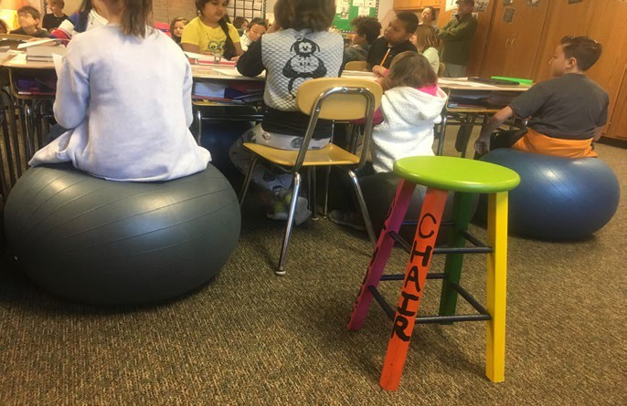
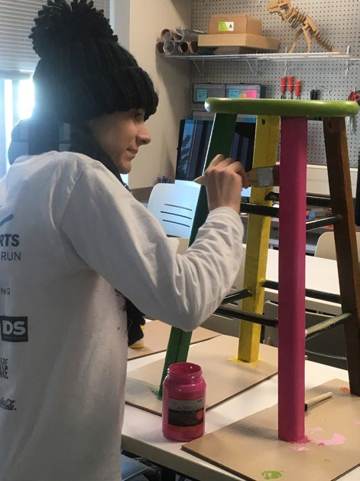
Batchelor Middle School Content Area Literacy Partnership: IU students meet bi- weekly at Batchelor Middle School. IU students prepare activities to support and scaffold students’ literacy learning.
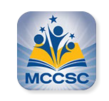


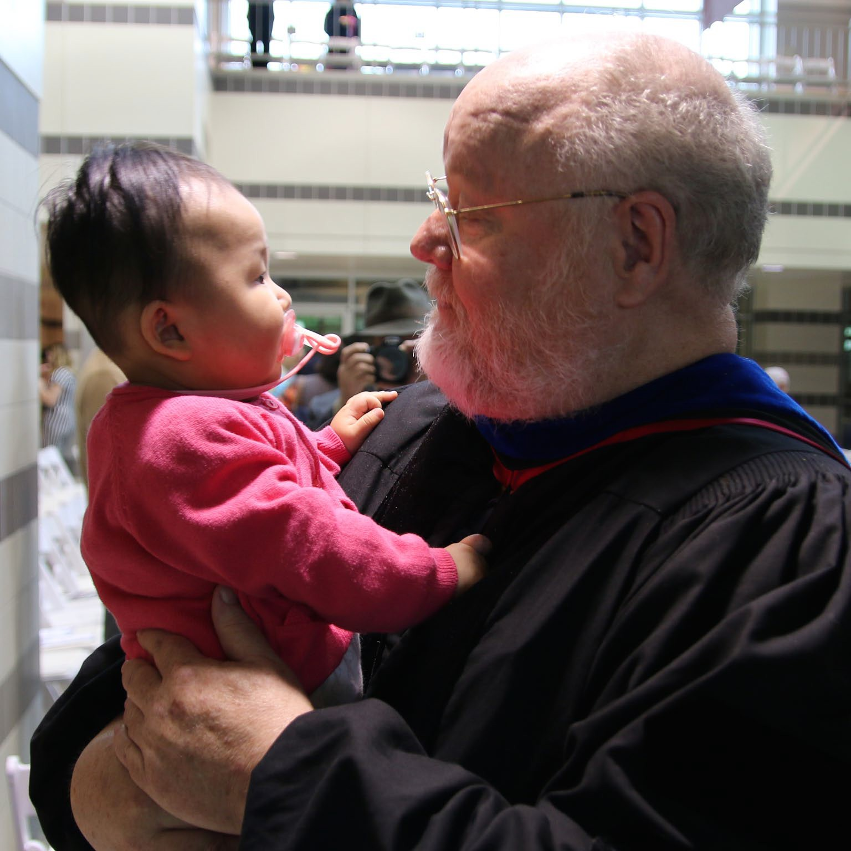
A Distinguished Graduate Program With an International Emphasis
Ai-Chu Ding, Doc Student awarded the 2019 AERA TACTL Best Paper Award

Christian Perry, Ed.D. student, 2019, Foreign Language And Area Studies Fellowship to study Japanese at Middlebury College

Casey Pennington, Ph.D. Student, 2018 Teaching Award

Yoo Young Ahn, Ph.D. Student, 2018 TIRF Award, The International Research Foundation for English Language Education for her doctoral dissertation research

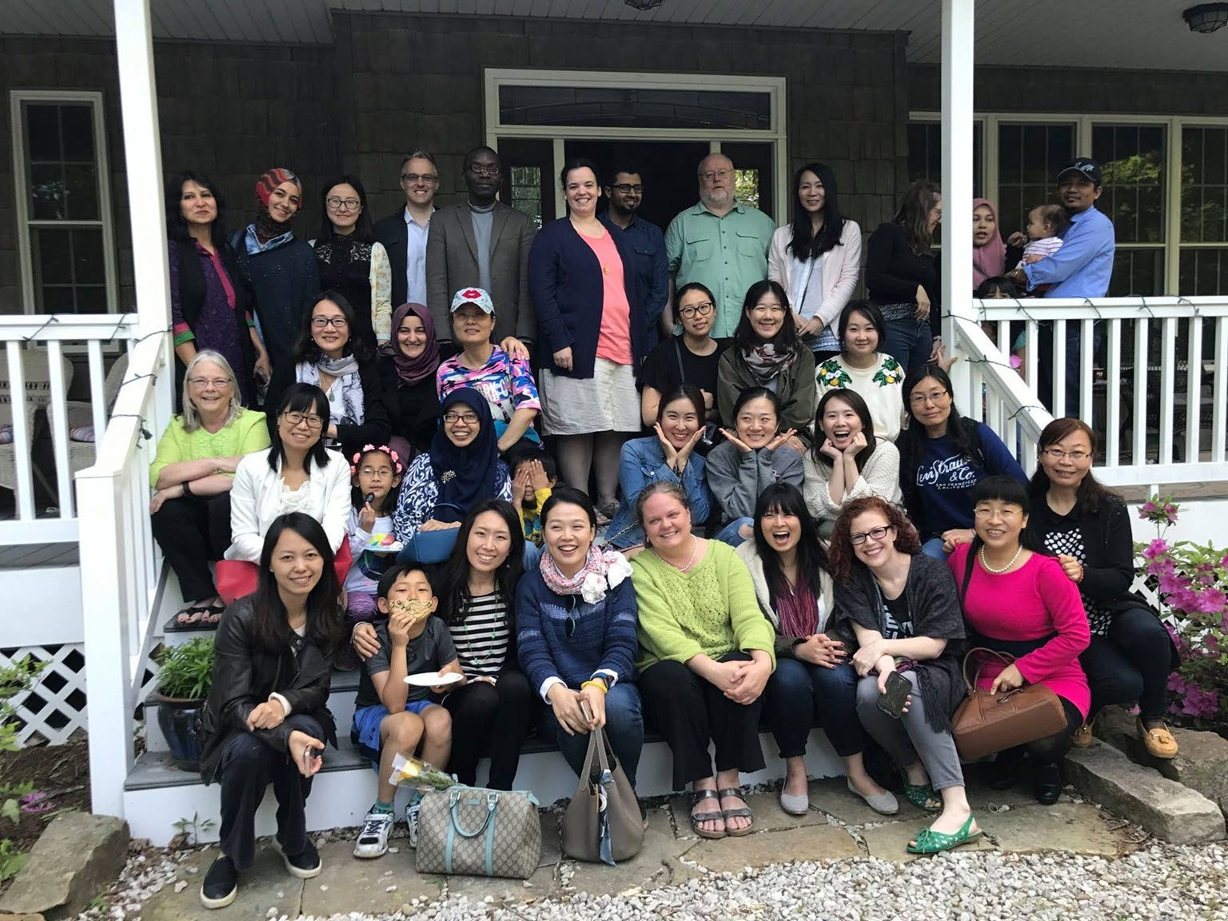
Distinguished Graduate Program (cont)
Suparna Bose, Ph.D. Student, awarded 2019 Won-Joon Yoon Scholarship

Andrew Ryfa, English Education, Indiana Association of Colleges for Teacher Education (IACTE) Outstanding Future Educator

Breanya Hogue Launched her book,
Act your age Shawn Trenell!

Beth Buchholz, Ph.D. (now graduate), 2015 Outstanding Student Research Award, Literacy Research Association

Our Graduates: International Impact

A. Chaedar Alwasilah, Ph.D. --Dean of Arts and Sciences, Indonesia University of Education
Pu Hong, Ph.D --President of Qujing University, Qujing, Yunnan Province, China
Mateus Yumarnamto, Ph.D--Deputy Dean, Widya Mandala Catholic University, Surabaya, Indonesia.
Zhong Wei, Ph.D-- Deputy Dean, Yunnan Normal University, Yunnan Province, China

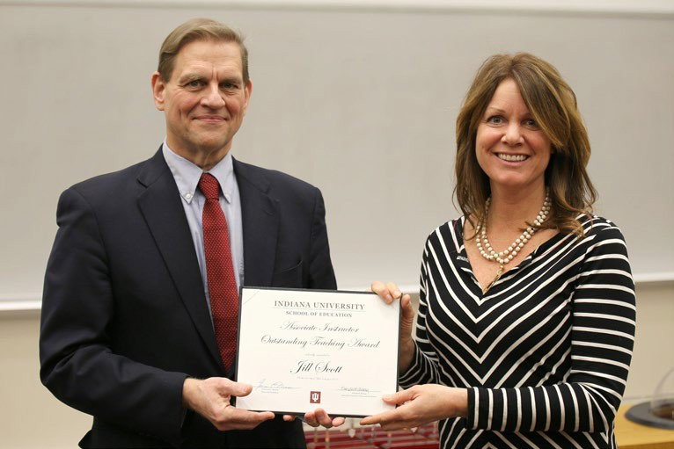
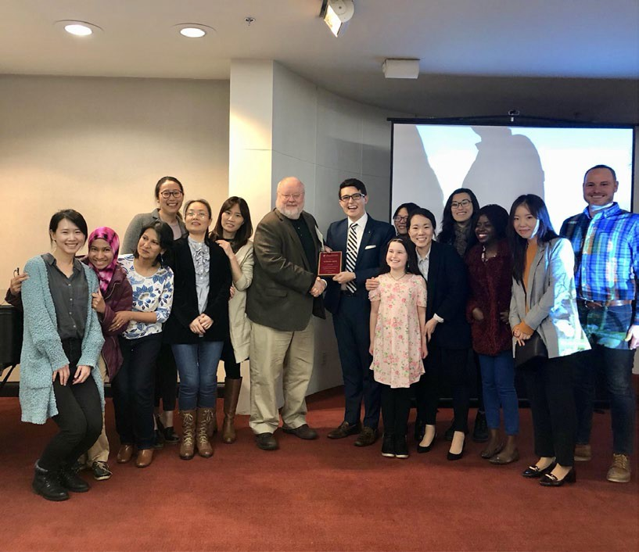
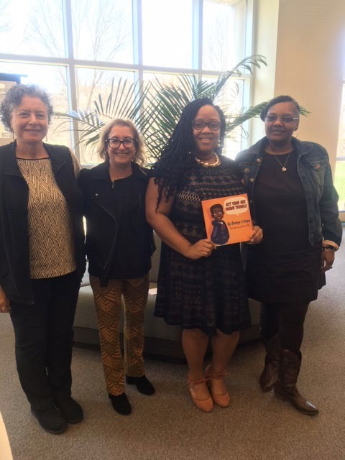
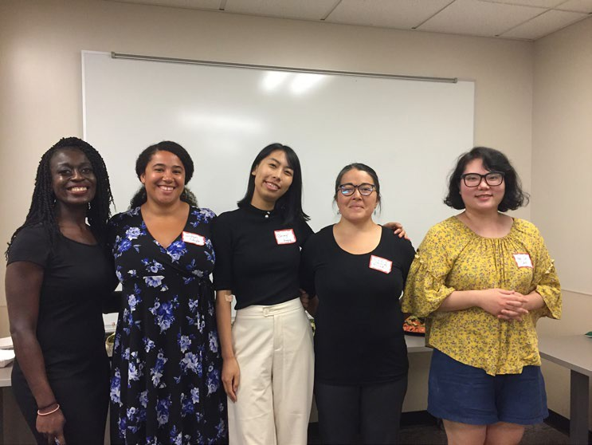
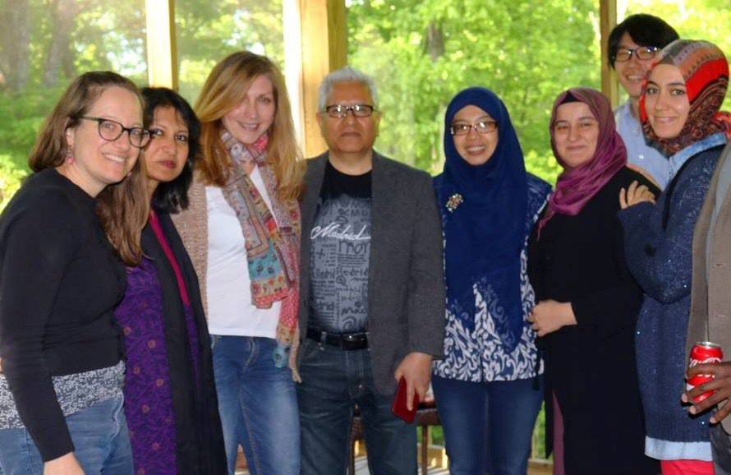
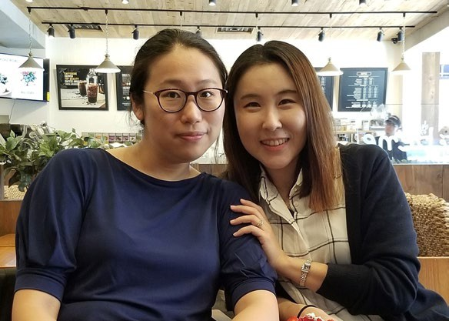
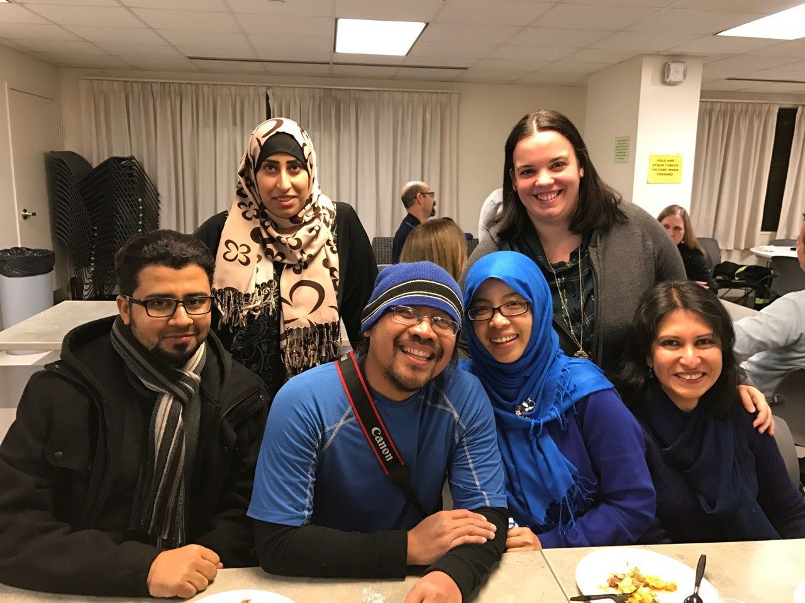
Current Students

Future LCLE Alumni

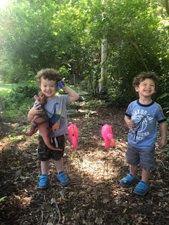
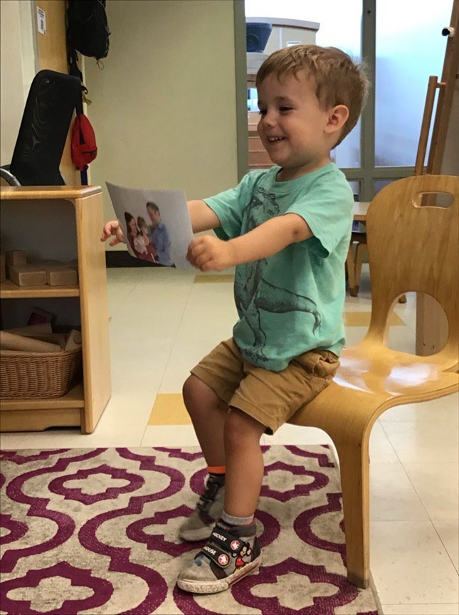


Structure of School of Education Governance and other items
Ginette Delandshere, Executive Associate Dean

Exactly What Is ‘Shared Governance”


“True shared governance attempts to balance maximum participation in decision making with clear accountability. That is a difficult balance to maintain, which may explain why the concept has become so fraught. Genuine shared governance gives voice (but not necessarily ultimate authority) to concerns common to all constituencies as well as to issues unique to specific groups.”

Gary A. Olson – The Chronicle of Higher Education, July 23, 2009 https://www.chronicle.com/article/Exactly-What-Is-Shared/47065

Policy Council Committees

- Diversity Committee
- Faculty & Budgetary Affairs
- Faculty Development
- Grad Studies, Recruitment & Financial Aid
- Grievance Hearing
- International Programs
- Learning & Teaching
with Technology Committee
- Long Range Planning Committee
- Promotion, Tenure & Contracts
- Research, Development & External Partnerships Committee
- Committee on Teacher Education
- Undergraduate Scholarship Committee
- Undergraduate Studies Committee

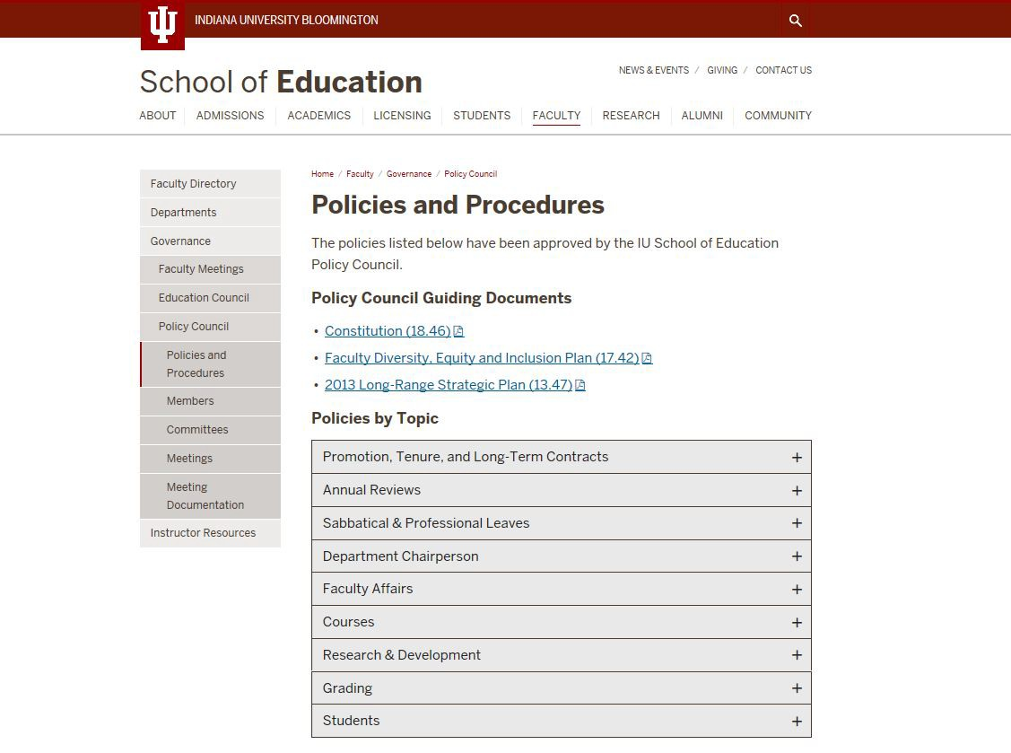

SCHOOL OF EDUCATION

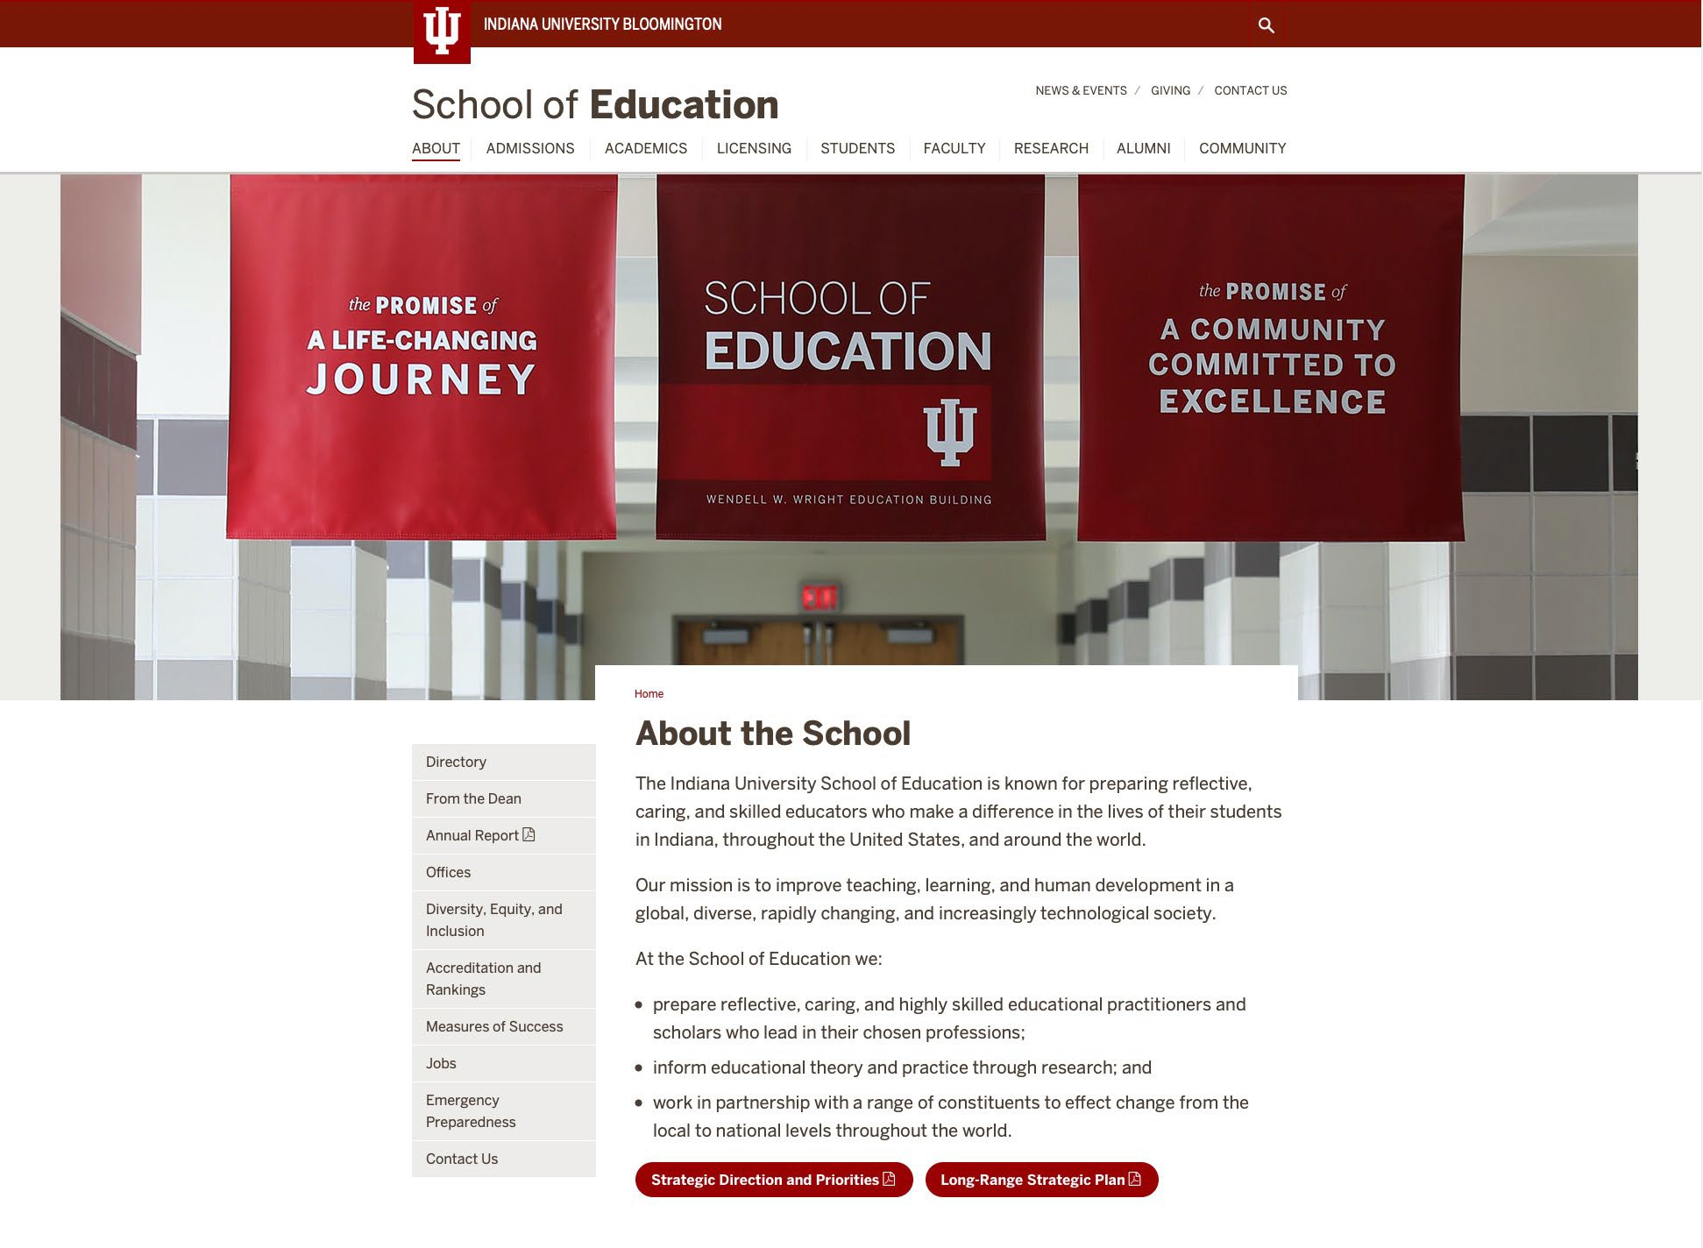

SCHOOL OF EDUCATION

Fall Enrollment/Low Enrollment Course Sections

Fall 2019
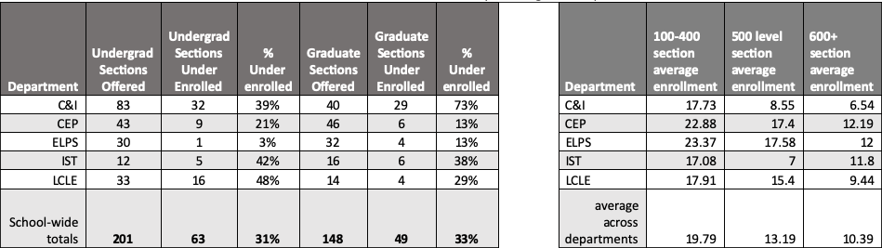
Section totals include all full semester and 1st 8 week sections which count for faculty teaching loads or paid instructors

AIs/GAs by Department

DEPT | AI | GA
CEP | 22.66 | 6
C&I | 29 | 1
ELPS | 12 | 5
IST | 7 | 4
LCLE | 5 | 2

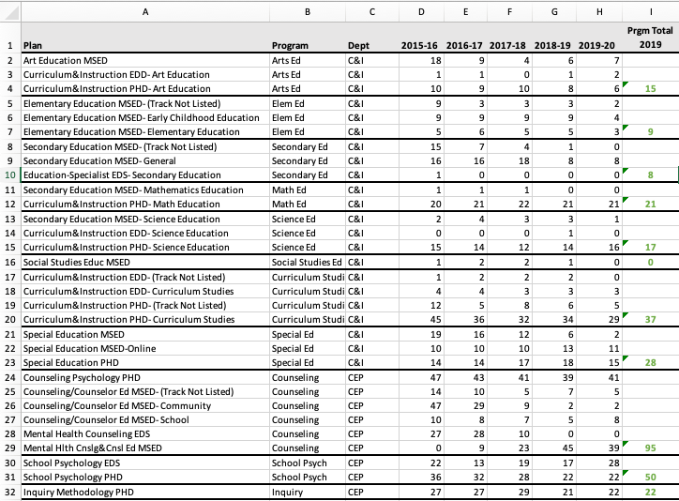
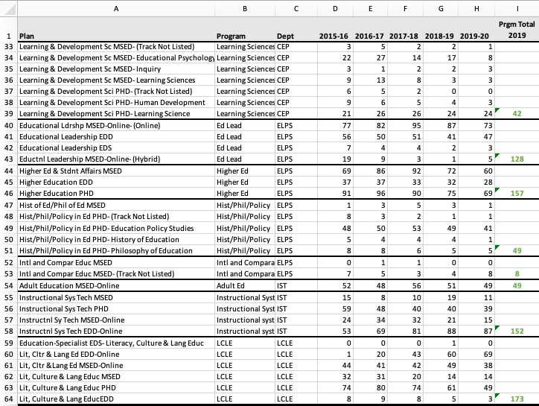

SCHOOL OF EDUCATION

Undergraduate Teacher Education Enrollment

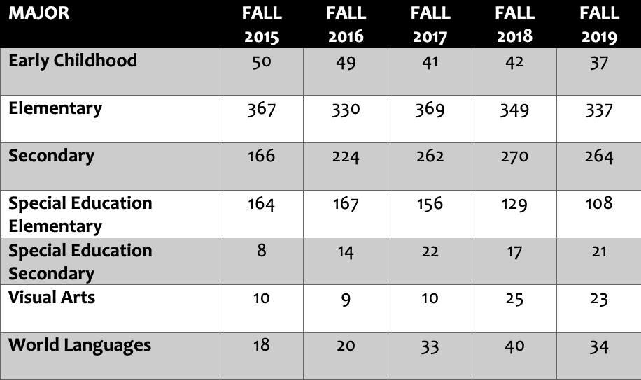

Source: https://tableau.bi.iu.edu/t/prd/views/BloomingtonEnrollmentsbySchoolandMajor/MajorsbySchoolTable?%3Aembed=y#1

Undergraduate Teacher Education Enrollment

Secondary Content Areas*
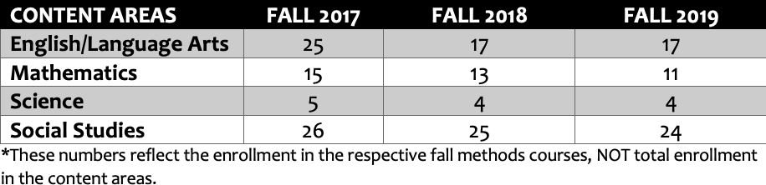

Source: https://tableau.bi.iu.edu/t/prd/views/BloomingtonEnrollmentsbySchoolandMajor/MajorsbySchoolTable?%3Aembed=y#1

Some Important Conversations to Have

- Rethinking the Ph.D. Programs in the School

- Reviewing all other programs for possible merging, reconceptualization, eliminating, and creating new programs

- School and Department Structure

- Merit Review System and Process

The University Budget Process
Jeff Buszkiewicz, Assistant Dean of Finance and Administration

RCM – Responsibility Center Management
- System by which units are wholly responsibly for managing their own revenue and expenditures

- Indiana University is really a hybrid model

  - University allocates State Appropriation
  - University tax supports campus “overhead” – assessed via formula
  - Campus sets certain rates – benefits load, pay increases, student health
  - Must prove available funding
  - Within given set of parameters however, the School makes decisions independent of campus input or approval


What Does General Fund Budget Model Look Like

Revenue
      - Tuition and fees
      - State appropriation
      - School’s portion of ICR
      - LESS: Assessments

Expenses
      - Compensation
      - Financial Aid
      - General
      - Travel
      - Transfers

RCM – Revenue Calculations

Tuition and fees
  - Undergraduate tuition fall and spring – three year average of credit hours X a fixed tuition rate
  - SOE benefits because our resident population > than campus average
  - Graduate tuition and summer undergraduate – actual tuition

  - Student tuition and fees – has decreased 6.5% from FY15 through FY19

State appropriation
  - State appropriation – increased 5.7% from FY15 through FY19
  - State Appropriation as % of revenue has increased from 20.5% to 22.5% over same period – likely unique on campus and counter to national trends

RCM – Revenue Calculations

Assessments
  - Assessments based on credit hours, square footage and head count
  - Campus-wide assessments currently scheduled to increase 5% per year
  - SOE assessments have increased 0.7% from FY15 to FY19
    - Impact a combination of volume and rate

Overall
  - Combined impact of Student Fees, State Appropriation and Assessments is a decrease in revenue from FY15 to FY19 of ($1.7M) or (6.1%)
  - Complicates cost of instruction since budgets and students in flux – variable vs. fixed cost components (Costs/students or credit hours)

General Fund Expenses
- Expenses are re-examined annually based on income generated

- Departmental budgets are relatively equal based on head count

- 85.9% of budgeted FY20 expenses are compensation related and another 9.6% is financial aid.
That totals 95.5% of total expense

- Budgeted operating deficit for FY20 is ($565.0K)

Dean’s Discussion
Lemuel Watson, Dean

Closing Remarks and Q&A

Adjourn to 2nd Floor Balcony for Lunch

